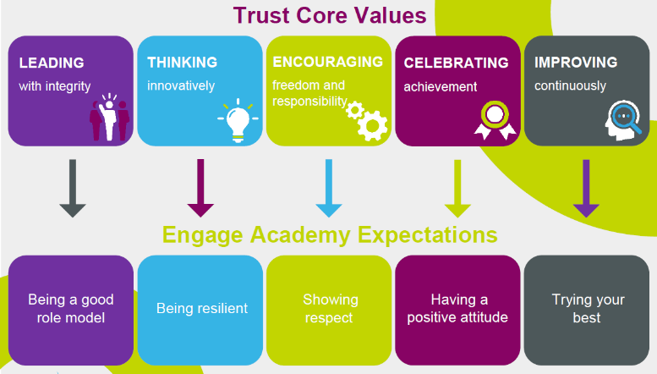 |  |  | Collective Worship Autumn Term 1 2022 |  | 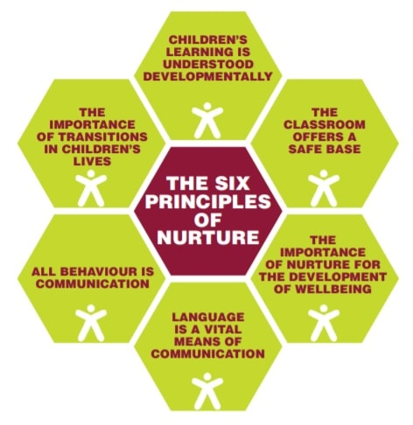
 | Monday | Tuesday |  | Wednesday | Thursday | Friday
Core themes | Weekend news  Key messages, modelling positive behaviours and Dojo reminders. | Oracy Focus  Talk on Tuesdays |  | SMSC Virtues & Character Strengths | Picture News is a weekly resource which provides a current affairs story providing meaningful links to British Values and Children’s Rights. | Reflection, consolidation of learning, recall of key moments within the week, retrieval practice and sharing work we are proud of.
05.09.22 |  | First day back focus |  | Courage Perseverance
12.09.22 |  | If you could be an animal, what would you be? Why?  Roald Dahl Day |  | Knowledge Love of Learning | Day of Democracy
19.09.22 |  | Who is your favourite person? Why? |  | Humanity Kindness  International Day of Peace | Autumn Equinox
26.09.22 | Fitness Day / Recycle Week International day of languages | If you could make a new school rule what would it be? |  | Justice Teamwork | World Heart Day  MacMillan Coffee Morning | Walk to School Month  Black History Month
03.10.22 |  | Is it better to be nice or to be right?  World Animal Day |  | Temperance Forgiveness  World Teacher Day |  | Jeans for Genes Day  World Smile Day
10.10.22 | Fire Prevention Week  Hello Yellow – Mental Health | Who has done something special for you this week? |  | Transcendence Hope
17.10.22 | Energy Saving Week | What is the bravest thing you have ever done? |  | Courage Bravery |  | Harvest

