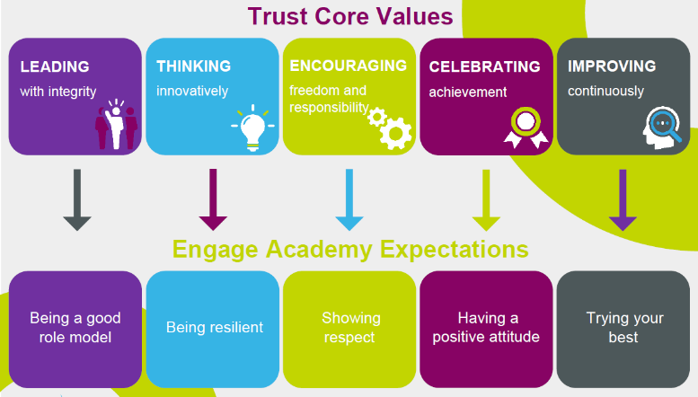 |  |  | Collective Worship Autumn Term 2 2022 |  | 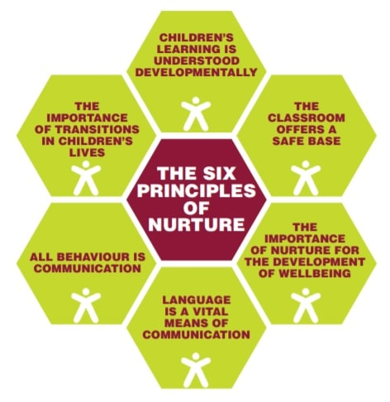
 | Monday | Tuesday |  | Wednesday | Thursday | Friday
Core themes | Weekend news  Key messages, modelling positive behaviours and Dojo reminders. | Oracy Focus  Talk on Tuesdays |  | SMSC Virtues & Character Strengths | Picture News is a weekly resource which provides a current affairs story providing meaningful links to British Values and Children’s Rights. | Reflection, consolidation of learning, recall of key moments within the week, retrieval practice and sharing work we are proud of.
31.10.22 | First day back focus | Why do people insult each other?  Introduce equality and diversity focus. |  | Wisdom & Knowledge: Perspective - You look at the big picture in order to solve problems effectively. You give other people good advice. |  | Bonfire night (5th)  Fire safety/Staying safe in the dark
7.11.22 | Road Safety week (actual date 14-19th)  https://www.brake.org.uk/road-safety-week | What impact do your words have on others?  (screwed up paper model)  13th – Kindness day |  | Humanity – Love - You enjoy loving others and being loved yourself. You value close relationships with those around you. |  | Remembrance Day
14.11.22 | Antibullying week  Odd Socks Day  https://anti-bullyingalliance.org.uk/anti-bullying-week | What does respect mean to you? How do you show respect to others? How does a lack of respect feel to a person? |  | Justice:– Leadership - You are good at making things happen by organising and leading people. You build good relationships with group members and value everyone's input. |  | Children in Need
21.11.22 | Interfaith week (actual date 14-19th)  https://www.interfaithweek.org/ | How are you different to everyone else in class? How are you similar? |  | Temperance: Self-regulation - You can control the things you say and do. You know what is right and wrong and put this knowledge into action.
28.11.22 | Maths week (actual date 14-19th)  https://mathsweekengland.co.uk/ | How is your family different to other people’s families? How is it similar? |  | Transcendence: Spirituality - You are aware of your position in the world and the bigger picture. This awareness shapes your beliefs which is turn influence your daily actions | Advent | Jeans for Genes Day  World Smile Day
5.12.22 |  | Tell me how you have shown respect to others that are different to you this week? |  | Courage: Honesty - You are genuine and speak the truth. You take responsibility for your feelings and actions.
12.12.22 |  | Discuss who has shown respect towards others this half term. |  | Courage Bravery | Hannukah (18.12.22) | Harvest

