Engage Academy

Supporting Pupils with Medical Needs and Conditions Policy
01.06.2023

1 | Summary | Supporting Pupils with Medical Needs and Conditions
2 | Responsible person | SENDCO
3 | Accountable ELT member | Vicky Woodrow
4 | Applies to | All Staff
5 | Trustees and/or individuals who have overseen development of this policy | SENDCOs across EAT
6 | Head teachers/Service Heads who were consulted and have given approval (if applicable) | N/A
7 | Equality impact analysis completed | Policy  Screened | Y/N | Template completed |  | Y/N
8 | Ratifying committee(s) and date of final approval | Learning and Achievement Committee  14.6.23
9 | Version | 1.5
10 | Available on | Every | Y/N | Trust Website  Academy Website  Staff Portal | Y/N  Y/N  Y/N
11 | Related documents  (if applicable) | N/A
12 | Disseminated to | All Engage Academy Staff
13 | Date of implementation (when shared) | June 2023
14 | Date of next formal review | May 2025
15 | Consulted with Recognised Trade Unions | N/A
16 | Adopted by Ethos Academy Trust following consultation | 14/6/23

Date | Version | Action | Summary of changes
1/06/2023 | *1.5 | Major policy revision | *Re-write of original documentation

Contents
Section | Description | Page
1. | Aims | 4
2. | Legislation and statutory responsibilities | 4
3. | Roles and responsibilities | 4 - 6
4. | Equal opportunities | 6
5. | Being notified that a child has a medical condition | 6
6. | Individual healthcare plans | 7 - 8
7. | Managing medicines | 8 - 10
8. | Emergency procedures | 10
9. | Training | 10 - 11
10. | Record keeping | 11
11. | Liability and indemnity | 11
12. | Complaints | 11
13. | Monitoring arrangements | 11
14. | Links to other policies | 11 - 12

Appendices
Appendix | Description | Page
A | Being notified a child has a medical condition  Further Advice and Resources  How this policy came about | 13-15
1 | Forms | 16-35
2 | Guidance | 36-43

1. Aims
This policy aims to ensure that:
- Pupils, staff and parents understand how Engage Academy will support pupils with medical conditions
- Pupils with medical conditions are properly supported to allow them to access the same education as other pupils, including Engage Academy trips and sporting activities
The governing board will implement this policy by:
- Making sure sufficient staff are suitably trained
- Making staff aware of pupils’ conditions, where appropriate
- Making sure there are cover arrangements to ensure someone is always available to support pupils with medical conditions
- Providing supply teachers with appropriate information about the policy and relevant pupils
- Developing and monitoring individual healthcare plans (IHPs)

The named person with responsibility for implementing this policy is Alison Ward (Head Teacher).

2. Legislation and statutory responsibilities
This policy meets the requirements under Section 100 of the Children and Families Act 2014, which places a duty on governing boards to make arrangements for supporting pupils at their Academy with medical conditions.
It is also based on the Department for Education (DfE)’s statutory guidance on supporting pupils with medical conditions at Academy.

3. Roles and responsibilities
3.1 The CEO
The CEO has a responsibility to:

- Ensure that the medical conditions policy is in line with local and national guidance and policy frameworks.
- Ensure that the policy is reviewed by the Trust annually

3.2 The head teacher
The head teacher will:
- Make sure all staff are aware of this policy and understand their role in its implementation
- Ensure that there is a sufficient number of trained staff available to implement this policy and deliver against all individual healthcare plans (IHPs), including in contingency and emergency situations
- Ensure that all staff who need to know are aware of a child’s condition
- Take overall responsibility for the development of IHPs
- Make sure that Engage Academy staff are appropriately insured and aware that they are insured to support pupils in this way
- Contact the Engage Academy nursing service in the case of any pupil who has a medical condition that may require support at the Academy, but who has not yet been brought to the attention of the Academy nurse
- Ensure that systems are in place for obtaining information about a child’s medical needs and that this information is kept up to date
3.3 Staff
Supporting pupils with medical conditions during academy hours is not the sole responsibility of one person. Any member of staff may be asked to provide support to pupils with medical conditions, although they will not be required to do so. This includes the administration of medicines.
Those staff who take on the responsibility to support pupils with medical conditions will receive sufficient and suitable training, and will achieve the necessary level of competency before doing so.
Teachers will take into account the needs of pupils with medical conditions that they teach. All staff will know what to do and respond accordingly when they become aware that a pupil with a medical condition needs help.

3.4 Parents
Parents will:
- Provide the academy with sufficient and up-to-date information about their child’s medical needs
- Be involved in the development and review of their child’s IHP and may be involved in its drafting
- Carry out any action they have agreed to as part of the implementation of the IHP, e.g., provide medicines and equipment, and ensure they or another nominated adult are contactable at all times

3.5 Pupils
Pupils with medical conditions will often be best placed to provide information about how their condition affects them. Pupils should be fully involved in discussions about their medical support needs and contribute as much as possible to the development of their IHPs. They are also expected to comply with their IHPs.

3.6 Academy nurses and other healthcare professionals
Our academy nursing service will notify the academy when a pupil has been identified as having a medical condition that will require support in school. This will be before the pupil starts at the academy, wherever possible. They may also support staff to implement a child’s IHP.
Healthcare professionals, such as GPs and paediatricians, will liaise with the academy’s nurses and notify them of any pupils identified as having a medical condition. They may also provide advice on developing IHPs.

4. Equal opportunities
Engage Academy is clear about the need to actively support pupils with medical conditions to participate in trips and visits, or in sporting activities, and not prevent them from doing so.

Engage Academy will consider what reasonable adjustments need to be made to enable these pupils to participate fully and safely on trips, visits and sporting activities.

Risk assessments will be carried out so that planning arrangements take account of any steps needed to ensure that pupils with medical conditions are included. In doing so, pupils, their parents and any relevant healthcare professionals will be consulted.

5. Being notified that a child has a medical condition
When Engage Academy is notified that a pupil has a medical condition, the process outlined below will be followed to decide whether the pupil requires an IHP.
Engage Academy will make every effort to ensure that arrangements are put into place within 2 weeks, or by the beginning of the relevant term for pupils who are new to our academy.
See Appendix A.

6. Individual healthcare plans (IHPs)
The head teacher has overall responsibility for the development of IHPs for pupils with medical conditions.

Plans will be reviewed at least annually, or earlier if there is evidence that the pupil’s needs have changed.

Plans will be developed with the pupil’s best interests in mind and will set out:

- What needs to be done
- When
- By whom
Not all pupils with a medical condition will require an IHP. It will be agreed with a healthcare professional and the parents when an IHP would be inappropriate or disproportionate. This will be based on evidence. If there is no consensus, the head teacher will make the final decision.

Plans will be drawn up in partnership with Engage Academy, parents and a relevant healthcare professional, such as the Engage Academy nurse, specialist or paediatrician, who can best advise on the pupil’s specific needs. The pupil will be involved wherever appropriate.

IHPs will be linked to, or become part of, any education, health and care (EHC) plan. If a pupil has SEN but does not have an EHC plan, the SEN will be mentioned in the IHP.

The level of detail in the plan will depend on the complexity of the child’s condition and how much support is needed. The Trust and the head teacher will consider the following when deciding what information to record on IHPs:

- The medical condition, its triggers, signs, symptoms and treatments
- The pupil’s resulting needs, including medication (dose, side effects and storage) and other treatments, time, facilities, equipment, testing, access to food and drink where this is used to manage their condition, dietary requirements and environmental issues, e.g., crowded corridors, travel time between lessons
- Specific support for the pupil’s educational, social and emotional needs. For example, how absences will be managed, requirements for extra time to complete exams, use of rest periods or additional support in catching up with lessons, counselling sessions
- The level of support needed, including in emergencies. If a pupil is self-managing their medication, this will be clearly stated with appropriate arrangements for monitoring
- Who will provide this support, their training needs, expectations of their role and confirmation of proficiency to provide support for the pupil’s medical condition from a healthcare professional, and cover arrangements for when they are unavailable
- Who in Engage Academy needs to be aware of the pupil’s condition and the support required
- Arrangements for written permission from parents and the head teacher for medication to be administered by a member of staff, or self-administered by the pupil during Engage Academy hours
- Separate arrangements or procedures required for trips or other activities outside of the normal Engage Academy timetable that will ensure the pupil can participate, e.g., risk assessments
- Where confidentiality issues are raised by the parent/pupil, the designated individuals to be entrusted with information about the pupil’s condition
- What to do in an emergency, including who to contact, and contingency arrangements

7. Managing medicines
Prescription and non-prescription medicines will only be administered at Engage Academy:
- When it would be detrimental to the pupil’s health or academy attendance not to do so and
- Where we have parents’ written consent
The only exception to this is where the medicine has been prescribed to the pupil without the knowledge of the parents.
Pupils under 16 will not be given medicine containing aspirin unless prescribed by a doctor.
Anyone giving a pupil any medication (for example, for pain relief) will first check maximum dosages and when the previous dosage was taken. Parents will always be informed.
Engage Academy will only accept prescribed medicines that are:
- In-date
- Labelled
- Provided in the original container, as dispensed by the pharmacist, and include instructions for administration, dosage and storage
Engage Academy will accept insulin that is inside an insulin pen or pump rather than its original container, but it must be in date.
All medicines will be stored safely. Pupils will be informed about where their medicines are at all times and be able to access them immediately. Medicines and devices such as asthma inhalers, blood glucose testing meters and adrenaline pens will always be readily available to pupils and not locked away.
Medicines will be returned to parents to arrange for safe disposal when no longer required.
7.1 Controlled drugs
Controlled drugs are prescription medicines that are controlled under the Misuse of Drugs Regulations 2001 and subsequent amendments, such as morphine or methadone.
A pupil who has been prescribed a controlled drug may have it in their possession if they are competent to do so, but they must not pass it to another pupil to use. All other controlled drugs are kept in a secure cupboard in the Engage Academy office and only named staff have access.
Controlled drugs will be easily accessible in an emergency and a record of any doses used and the amount held will be kept.
7.2 Pupils managing their own needs
Pupils who are competent will be encouraged to take responsibility for managing their own medicines and procedures. This will be discussed with parents and it will be reflected in their IHPs.
Pupils will be allowed to carry their own medicines and relevant devices wherever possible. Staff will not force a pupil to take a medicine or carry out a necessary procedure if they refuse, but will follow the procedure agreed in the IHP and inform parents so that an alternative option can be considered, if necessary.
7.3 Unacceptable practice
Engage Academy staff should use their discretion and judge each case individually with reference to the pupil’s IHP, but it is generally not acceptable to:
- Prevent pupils from easily accessing their inhalers and medication, and administering their medication when and where necessary
- Assume that every pupil with the same condition requires the same treatment
- Ignore the views of the pupil or their parents
- Ignore medical evidence or opinion (although this may be challenged)
- Send children with medical conditions home frequently for reasons associated with their medical condition or prevent them from staying for normal Academy activities, including lunch, unless this is specified in their IHPs
- If the pupil becomes ill, send them to the Engage Academy office or medical room unaccompanied or with someone unsuitable
- Penalise pupils for their attendance record if their absences are related to their medical condition, e.g., hospital appointments
- Prevent pupils from drinking, eating or taking toilet or other breaks whenever they need to in order to manage their medical condition effectively
- Require parents, or otherwise make them feel obliged, to attend Engage Academy to administer medication or provide medical support to their pupil, including with toileting issues. No parent should have to give up working because Engage Academy is failing to support their child’s medical needs
- Prevent pupils from participating, or create unnecessary barriers to pupils participating in any aspect of academy life, including academy trips, e.g., by requiring parents to accompany their child
- Administer, or ask pupils to administer, medicine in academy toilets

8. Emergency procedures
Staff will follow the academy’s normal emergency procedures (for example, calling 999). All pupils’ IHPs will clearly set out what constitutes an emergency and will explain what to do.
If a pupil needs to be taken to hospital, staff will stay with the pupil until the parent arrives, or accompany the pupil to hospital by ambulance.

9. Training
Staff who are responsible for supporting pupils with medical needs will receive suitable and sufficient training to do so.

The training will be identified during the development or review of IHPs. Staff who provide support to pupils with medical conditions will be included in meetings where this is discussed.

The relevant healthcare professionals will lead on identifying the type and level of training required and will agree this with the head teacher / role of individual. Training will be kept up to date.

Training will:

- Be sufficient to ensure that staff are competent and have confidence in their ability to support the pupils
- Fulfil the requirements in the IHPs
- Help staff to have an understanding of the specific medical conditions they are being asked to deal with, their implications and preventative measures
Healthcare professionals will provide confirmation of the proficiency of staff in a medical procedure, or in providing medication.
All staff will receive training so that they are aware of this policy and understand their role in implementing it, for example, with preventative and emergency measures so they can recognise and act quickly when a problem occurs. This will be provided for new staff during their induction.

10. Record keeping
Engage Academy will ensure that written records are kept of all medicine administered to pupils for as long as these pupils are at the academy. Staff will log on CPOMS when medication is administered, recording what medication was given, the dosage and the time it was administered. Parents will be informed if their pupil has been unwell at Engage Academy.
IHPs will be stored on Arbor and are accessible to all staff.

11. Liability and indemnity
Engage Academy will ensure appropriate insurance and indemnity is in place for all staff involved in the care of young people with medical conditions and those volunteers who administer medication to pupils with medical conditions.

12. Complaints
Parents with a complaint about their child’s medical condition should discuss these directly with the head teacher in the first instance. If the head teacher cannot resolve the matter, they will direct parents to the Engage Academy complaints procedure.

13. Monitoring arrangements
This policy will be reviewed and approved by the Trust annually.

14. Links to other policies
This policy links to the following policies:
- Accessibility plan
- Complaints
- Equality information and objectives
- First aid
- Health and safety
- Safeguarding
- SEND Information Report
- SEND Policy

Appendix A: Being notified a child has a medical condition

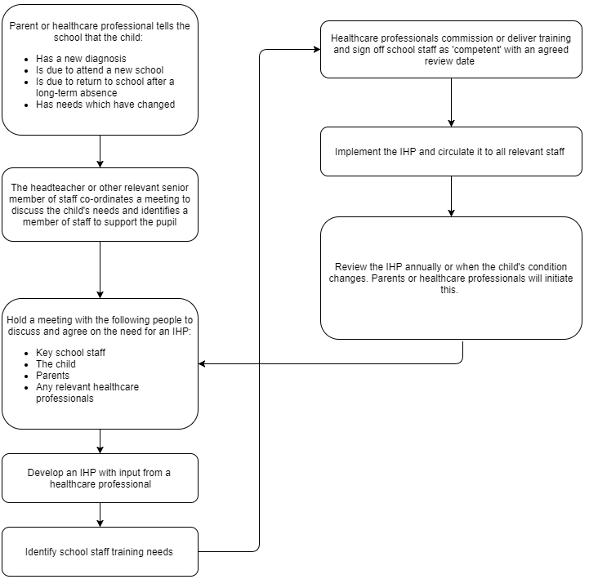

Further Advice and Resources
The Anaphylaxis Campaign  PO Box 275, Farnborough  Hampshire GU14 6SX  Phone 01252 546100 Fax 01252 377140 info@anaphylaxis.org.uk www.anaphylaxis.org.uk | Department for Education  Sanctuary Buildings  Great Smith Street  London SW1P 3BT  Phone 0870 000 2288  Textphone/Minicom 01928 794274  Fax 01928 794248 info@dfe.gsi.gov.uk  www.dfe.gov.uk
Asthma UK  Summit House  70 Wilson Street  London EC2A 2DB  Phone 020 7786 4900 Fax 020 7256 6075 info@asthma.org.uk  www.asthma.org.uk | Council for Disabled Children  National Children’s Bureau  8 Wakley Street  London EC1V 7QE  Phone 020 7843 1900 Fax 020 7843 6313 cdc@ncb.org.uk  www.ncb.org.uk/cdc
Diabetes UK  Macleod House  10 Parkway  London NW1 7AA  Phone 020 7424 1000 Fax 020 7424 1001 info@diabetes.org.uk  www.diabetes.org.uk | National Children’s Bureau  National Children’s Bureau  8 Wakley Street  London EC1V 7QE  Phone 020 7843 6000 Fax 020 7278 9512 www.ncb.org.uk
Epilepsy Action  New Anstey House  Gate Way Drive  Yeadon Leeds LS19 7XY  Phone 0113 210 8800 Fax 0113 391 0300 epilepsy@epilepsy.org.uk www.epilepsy.org.uk | Long-Term  Conditions Alliance  202 Hatton Square  16 Baldwins Gardens  London EC1N 7RJ  Phone 020 7813 3637 Fax 020 7813 3640 info@ltca.org.uk  www.ltca.org.uk

Schools Medical Conditions website contains a lot of useful, information which can be used and accessed by all childcare providers and other healthcare professionals
http://www.medicalconditionsatschool.org.uk/
How this Policy came about

The authors have used the current DfE Supporting Pupils at School with Medical Conditions (2014) as the template for this policy. They have consulted with a wide-range of key stakeholders within both Children’s Services and health settings and the policy has been approved by the stakeholders and been scrutinized by the appropriate Governance.

Medicines management North Kirklees and Greater Huddersfield CCG
General Practitioner. Greater Huddersfield
School nursing service. Locala
Paediatrician. Mid Yorkshire Trust
Paediatrician Calderdale and Huddersfield Foundation Trust

Unions:
Main teaching Unions – NASUWT; NEU, NAHT
Unison
Unite

All those consulted understand the need for any setting to welcome and support young people with medical conditions who currently attend or receive our services now or in the future. No child will be excluded or refused admission because of their medical condition subject to an appropriate risk assessment being completed and/or the potential for infectious diseases to impact on the health of fellow young people and the staff.

Appendix 1 - Forms

Form 1a | Contacting Emergency Services
Form 1b | Individual Healthcare Plan
Form 1c | Agreement to Administer Medication
Form 2 | Request for additional information from medical practitioner
Form 3 | Record of medicine administered to an individual child
Form 4 | Record of medicines administered to all pupils
Form 5 | Request for child to carry their own medication
Form 6 | Staff training record – administration of medicines
Form 7a | Allergy Action Plan
Form 7b | Medical Consent & Information
Form 8 | School Asthma Card
Form 9 | Medical Information for all Off-Site Visits
Form 10 | Medication Form for Residential Visits
Form 11a | Use of Emergency AAI Consent Form

Request for an ambulance
Dial 999, ask for ambulance and be ready with the following information

Please speak slowly and clearly and be ready to repeat information, if asked.

Our telephone number:
Give your location:

State what the postcode is:

1 | Note the time of the call
2 | Exact location of the incident on site
3 | Name of person requesting the call
4 | Name of person calling the emergency services
5 | Name of pupil / person
6 | Date of Birth
7 | Brief description of symptoms  (does the individual have a life-threatening condition e.g., is having an anaphylactic attack tell the operator the pupil has ANAPHYLAXISIS. This will prioritise the response from the  emergency services)
Form 1a Contacting Emergency Services

8 | Inform Ambulance Control of the best entrance and state that the crew will be met and taken to the casualty
9 | Inform a First Aider | ………………………………………………………
 | that an ambulance has
 | been called
 | Name of SLT member
 | who has been informed
 | Time | ………………………………………………………
10 | Which first aider is involved in the incident
11 | Arrival time of first responder or ambulance crew
12 | Is further emergency support required from the hospital or have any other professionals attended?
13 | Did anyone cover reception during the incident?
 | Parents/Carers contacted? | Yes No
14 | Name of person contacting parents/carers | …………………………………………
 | Time | …………………………………………
Return this form to a First Aider as soon as possible after the incident. Please ensure that all information has been completed. Thank you.
Form 1b- Individual Healthcare Plan
ONLY REQUIRED IF THERE IS A MEDICAL CONDITION
i.e., Asthma, Epilepsy, Diabetes, Allergies
Name of Academy:
Name of Pupil: |  | Date of Birth:
Group/Class: |  | Year:
Home Address:
Medical Diagnosis condition/symptoms/triggers/signs:
Review Date:
Daily Care Requirements:
Describe what constitutes an emergency for the child, and the action to take if this occurs:
GP Name:
GP Address: | Postcode:
 | GP Telephone no:

Clinic/Hospital Contact:
Clinic/Hospital Address: | Postcode:
 | Telephone no:
Responsible staff providing support in the academy:
Staff training needed/undertaken: Who/What/When
Other Information: Insert/attach any specialist healthcare plans
Name of medication: (as described on the container)
Dose:
Method of administration (self-administered):
When to be taken:
Arrangements for academy visits/trips/work experience, etc.:

Family Contact Information 1
Name: | Relationship to Child:
Home No: | Mobile No:
Work No:

Family Contact Information 2
Name: | Relationship to Child:
Home No: | Mobile No:
Work No:

Parent/Carer Print Name: ________________________________________________________

Parent/Carer Signature:
Date:

EAT Staff Name:

EAT Staff Signature:
Date:

Form 1C Agreement to Administer Medication
THE ACADEMY WILL ONLY GIVE YOUR CHILD MEDICINE WHEN YOU COMPLETE AND SIGN THIS FORM. THE ACADEMY HAS A POLICY THAT STATES STAFF CAN ADMINISTER MEDICINE.
Name of Academy:
Name of Pupil:
Date of Birth:
Group/Class: |  | Year:
Date for review to be initiated by:
Condition/Illness:
Medicine
Name/Type of medicine: (as described on the container)
Expiry date:
Dosage and method:
Timing:
Special precautions/other instructions:
Self-administered: Yes / No
Are there any side effects that the academy/setting needs to know about?
NB: Medicines must be in the original container as dispensed /purchased Non-Prescription Medicines (Does NOT include aspirin)
Asthma – Inhalers
The academy is allowed to buy spare salbutamol inhalers, without a prescription, for use in emergencies. These are not shared.
I give permission for my child to use one in an emergency: |  |  | Yes / No
Non-Prescription Medicines – Paracetamol (Does NOT include aspirin)
I give permission for my child to take paracetamol provided by the academy |  |  | Yes / No
I confirm that my child has used this medication before and did not suffer any allergic or other adverse reaction. |  |  | Yes / No
Ethos Academy Trust confirm that the maximum dosage will not be exceeded if they are administered.
Family Contact Information
Name: | Relationship to Child:
Home No: | Mobile No:
Work No:
I understand that I must deliver the medicine personally to:

The above information is, to the best of my knowledge, accurate at the time of writing and I give consent to academy staff administering medicine in accordance with the academy’s policy. I will inform the academy immediately, in writing, if there is any change in dosage or frequency of the medication or if the medicine is stopped.

I am aware that if my child refuses to take their medication, staff cannot force them to and I will be informed as soon as possible.

Signed: Parent/Carer

Print Name: Parent/Carer

Date:______________________________

Form 2 Request for information from Child’s GP, Hospital Consultant or Dietitian.
Parents / Carers are requested to take or send this form to either their child’s GP, hospital consultant or dietician. The information is required to enable the academy to make appropriate arrangements to ensure the health, safety and welfare of children with chronic / acute or potentially life-threatening medical conditions, including administering medication. This information is to be provided by the parents / carers who have responsibility for sharing it with the academy.
Child’s name
Date of birth
Home address
Medical condition
List any triggers / causes e.g.
allergens (be specific)
What to do if the child is experiencing or has the following symptoms?
List mild to moderate symptoms | List severe symptoms
This is a mild reaction  (List action, order of action and any medication including dosage to be taken)  1.  2.  3.  4. | (List action, order of action and any medication including dosage to be taken)  1.  2.  3.  4.
Can the child self-administer their own emergency medication? | - Yes  - Yes, with supervision  - No
Any training requirements for the academy?
(Please specify what is required and who should provide it) also consider training / support for the parents / guardians and child)
Name of person providing this information
Signature
Date
Review date
Please return to:

Form 3 Record of medicine administered to an individual child

Attach photo of

pupil here

Name of pupil
Group / Year | /
Date medication received
Quantity received
Name and strength of medication
Expiry Date
Dose and frequency of medication

Staff signature __________________________ Staff name ____________________

Person responsible for medication _______________________________________

DATE | TIME GIVEN | DOSE GIVEN | STAFF NAME | 2nd STAFF  INITIALS

Form 4 Record of medicines administered to all pupils

Date | Pupil’s  name | Time | Name of medicine | Dose given | Any reactions | Signature | Print  name  of staff

Form 5 Request for child to carry their own medicine

Parents/Carers must complete this form.
If staff have any concerns discuss this request with healthcare professionals

Child’s name
Group
Address
Name of medicine
Procedures to be taken in an emergency
Contact Information
Name
Daytime phone no.
Relationship to child

I would like my child to keep their medicine on them for use as necessary.

Signed (Parent/Carer) _________________________________________

Name (Parent/Carer) __________________________________________

Date __________________________________________

Please note that if more than one medicine is given, a separate form should be completed for each one.

Form 6 Staff training record – administration of medicines

Name
Type of training received
Date of training completed
Training provided by
Profession and title

I confirm that ………………………………………………….. (name of staff member) has received the training detailed above and is competent to carry out any necessary treatment.
I recommend that the training is updated every ___________________________ (please state how often).

Trainer’s name/signature
Date

_____

I confirm that I have received the training detailed above.

Staff signature

Date

Suggested review date ___________________________________

Form 7a Allergy Action Plan

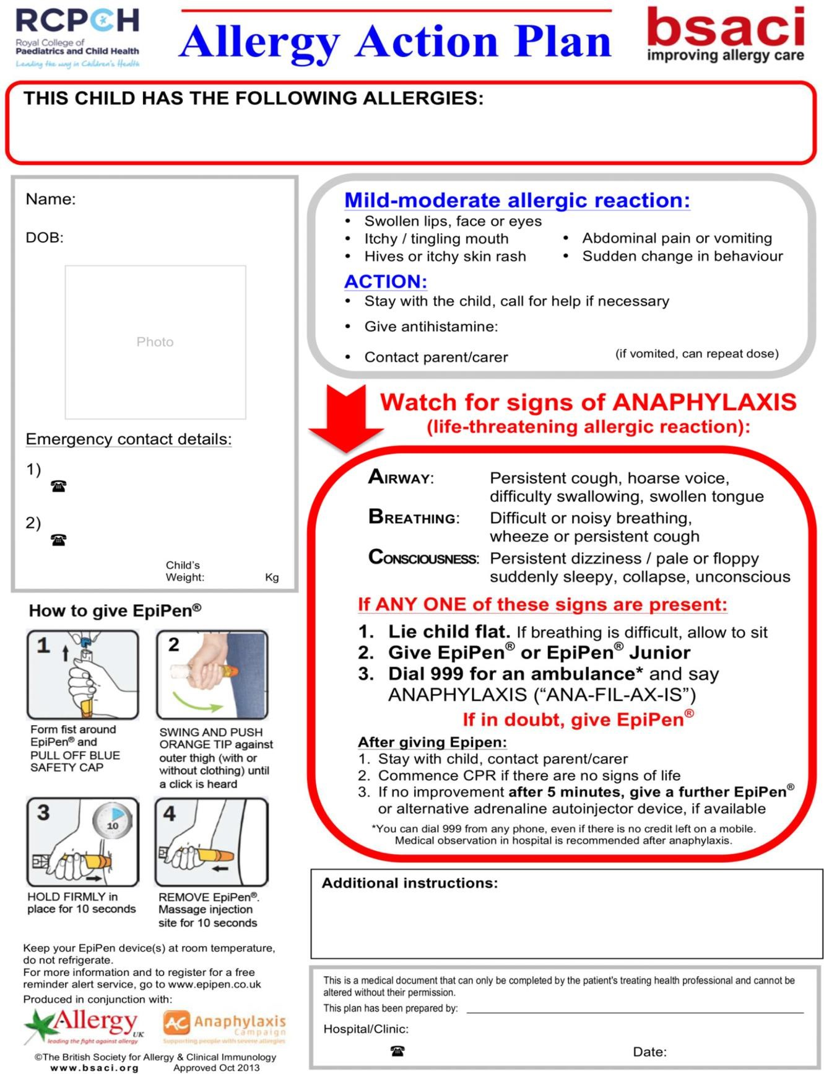

Parent/guardian name and signature: ……………………………………………
Name of Academy:
Name of Pupil:
Does your child suffer from any conditions requiring medical treatment? (i.e., asthma, epilepsy, diabetes)  Complete an Individual Healthcare Plan if medication is required in the academy | Yes / No
Condition or Illness:
Treatment:
Does your child have any identified allergies?  Please note that school dinners may contain traces of nuts  Complete an Individual Healthcare Plan if medication is required in the academy | Yes / No
Allergy:
Medicine/Treatment:
Does your child have any special dietary requirements? | Yes / No
If yes please specify:
Form 7b Medical Consent/Information

Glasses
Does your child need to wear glasses?  If yes, we have discussed making sure that they always have a pair in the academy? | Yes / No
Medical Consent
I consent to my child taking paracetamol (which I have provided and is in the original packaging, with clear directions) | Yes / No
Non-Prescription Medicines ONLY (Does not include Aspirin) Paracetamol/Calpol  I consent to EAT supplying Paracetamol/Capol sachets and administering it by a first aid trained member of staff to my child if they become unwell at the academy. My child has used this medication before and did not suffer any allergic or other adverse reaction. | Yes / No
I consent to EAT staff administering additional medication (which I have provided) to my child and understand that I am responsible for providing the academy with up-to-date information about dosage and possible side effects etc. | Yes / No
I consent for EAT to allow my child (who is diagnosed with asthma) to use the academy’s spare inhaler cases of emergencies. This is not shared. | Yes / No
I consent for my child to receive immediate treatment by a doctor and/or a hospital because of a serious accident or serious illness. | Yes / No

Parent/Carer Signature:
Date:

Parent/Carer
Print Name:

Form 8 School Asthma Card
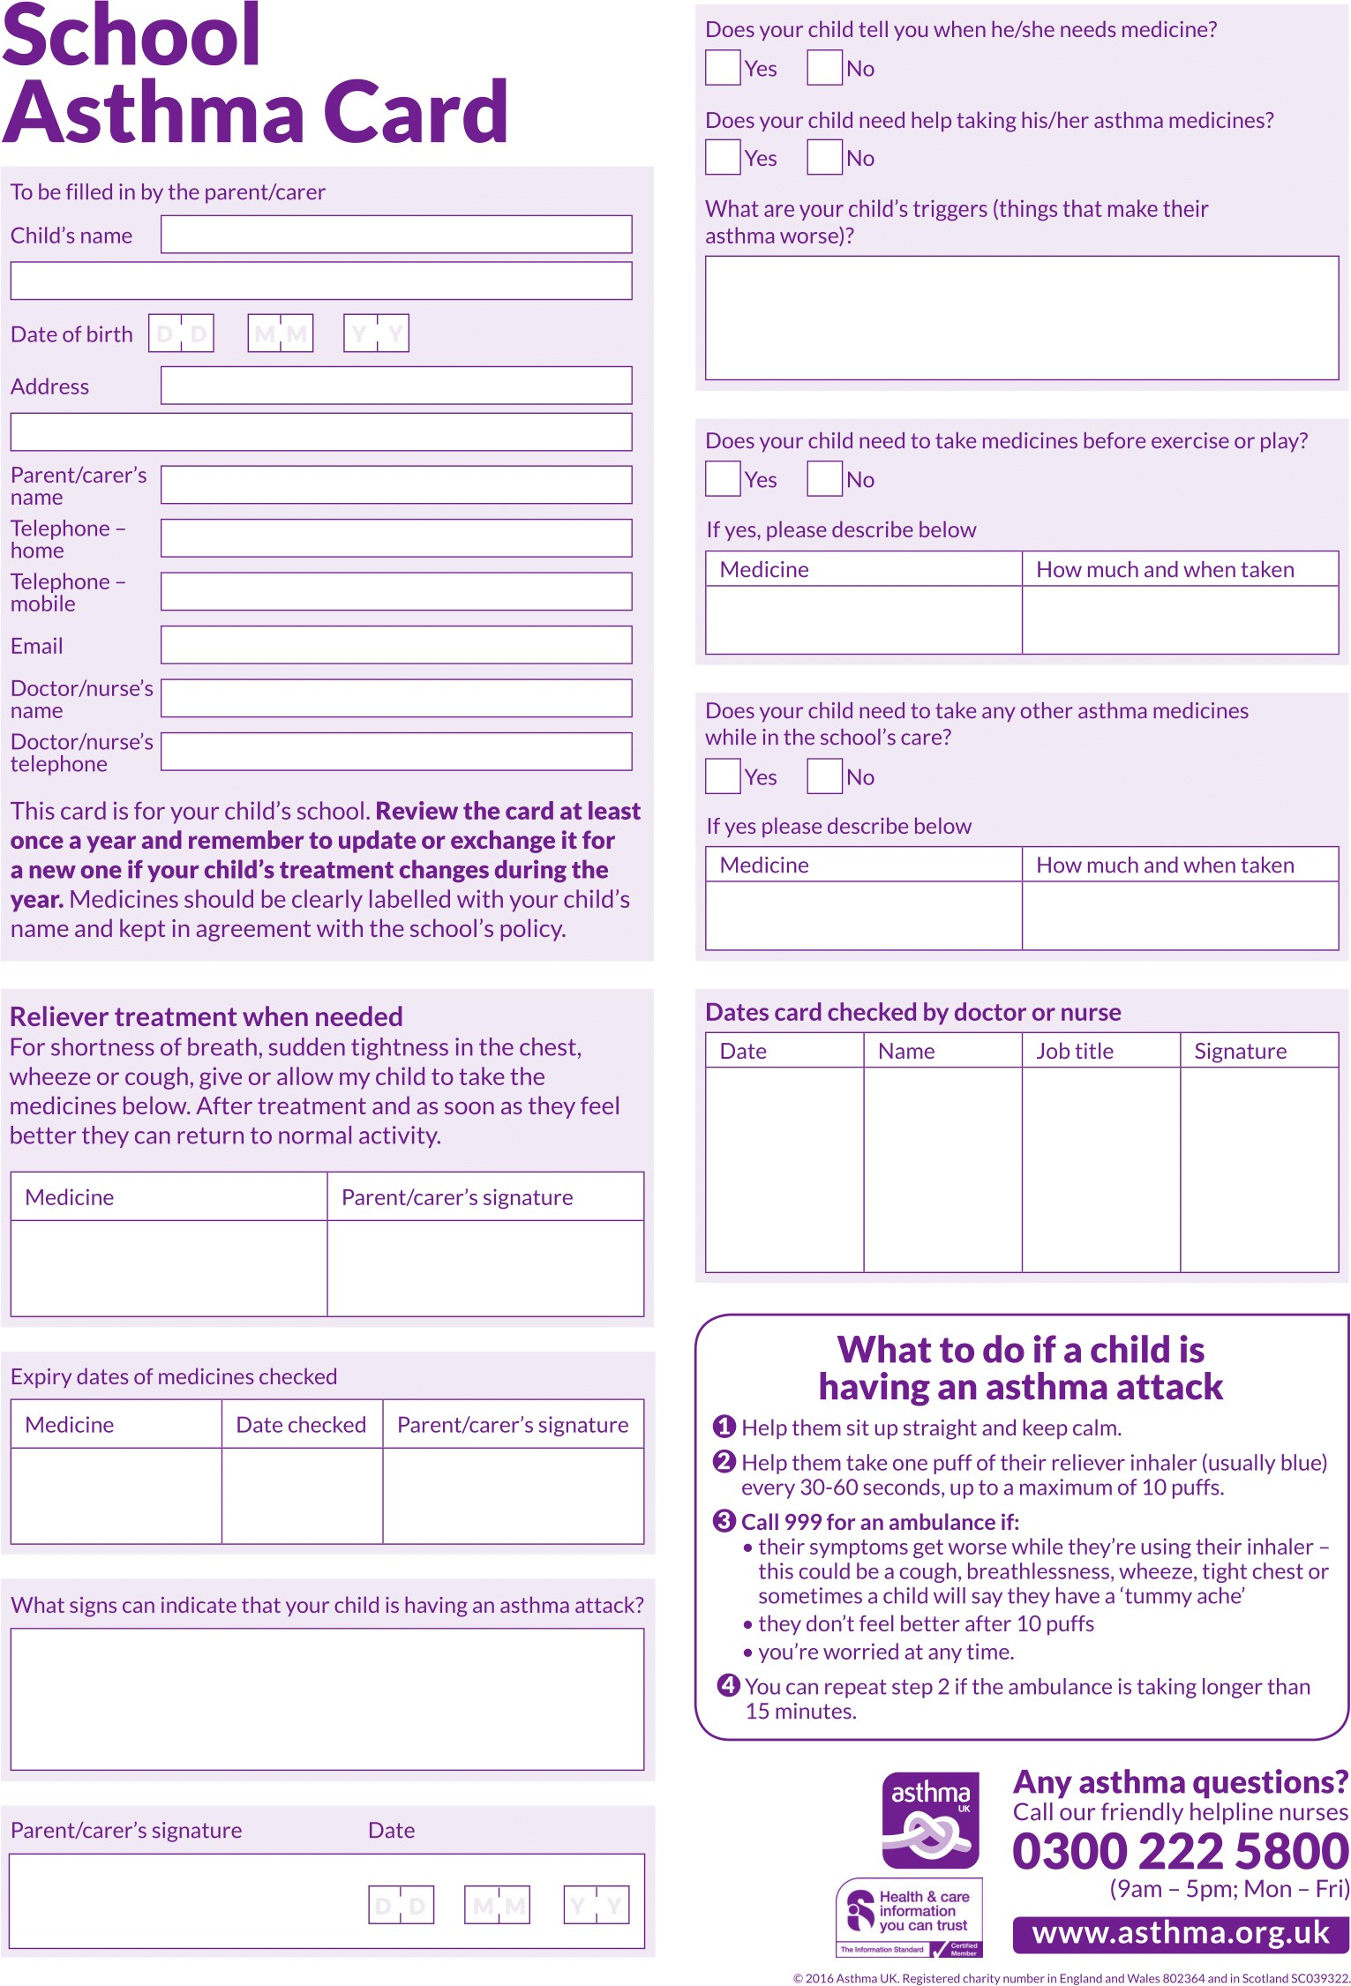

Form 9 Medical Information for all off-site visits during 2022/23

It is essential that the information provided on this form is up to date and accurate. Please notify the academy in writing of any changes to your child’s health or medication.
Child’s Full Name & Date of Birth
Group

Does your child suffer from any conditions requiring medical treatment, including medication | YES / NO
 | If YES please give details:
Does your child have an Individual Healthcare Plan | YES / NO
To the best of your knowledge has your child been in contact with any contagious or infectious diseases (within the last 4 weeks)? | YES / NO
 | If YES please give details
Does your child have any allergies? I.e., Hayfever, food allergies etc | YES / NO
 | If YES please give details:
Has your child received a tetanus injection in the last three years? | YES / NO
In an emergency if a doctor advises an anti-tetanus injection following an injury, do you agree to this? | YES / NO
Are there any additional health concerns that may make taking full part in any trip difficult in anyway? Please outline here:
Please ensure your child carries any emergency medication they need with them at all times.
Failure to do so may prevent them from attending the trip. (This includes inhalers, epi-pens etc).
This form will be kept for the whole academic year. You must inform the academy as soon as possible of any changes to your child’s medical condition or medication.
Signed ……………………………….…………………..
Name of Parent/carer………….………………..………
Date ………………………………….………….

Form 10 Medication Form for Residential Visits 2022/23

Please hand this form to the person responsible for the trip before your child departs
Child’s Name
Group
Visit or Activity
Date from |  | Date to
Name, address and telephone number of your doctor
Please label medicine clearly and put into a labelled plastic bag with your child’s name and specific instructions. This should include any travel sickness medication you give.

Day | Date | Time to be given | Name of  Medication | Amount to be administered | Administered by (member of staff on site)
Monday
Tuesday
Wednesday
Thursday
Friday
Saturday
Sunday
Staff should initial this sheet each time they administer any medication to the child named on this form. Please record any occurrences or problems relating to medication on the rear of this form and let the parents know when you return. A copy of the form should be retained by the group leader and Business Manager for future reference.
I agree that my child can be given the medication above.
Signed: ………………………………………
Name: …………………………………………….. Date: ………………………………………

Form 11a Use of Emergency Adrenaline Auto Injector Consent Form for Pupils Prescribed an AAI

For children who are showing signs of a severe allergy or anaphylaxis

I can confirm that my child has been diagnosed with an allergy and has been prescribed an adrenaline auto injector (AAI).

My child has two working, in-date adrenaline auto injector, clearly labelled with their name, which they will bring with them to the academy every day and keep with them. A spare is also kept in the main academy office.

In the event of my child displaying symptoms of a severe allergy and if their adrenaline auto injector is not available or is unusable, I consent for my child to receive the academy’s adrenaline auto injector which is kept for any emergencies.

Adrenaline Auto Injector Strength: | 0.30mg | / | 0.15mg
Signed
Name (print)
Date
Child’s name
Group
Parent / Carer address
Telephone Home/Work
Mobile

Appendix 2: Guidance

Types of Asthma Inhalers
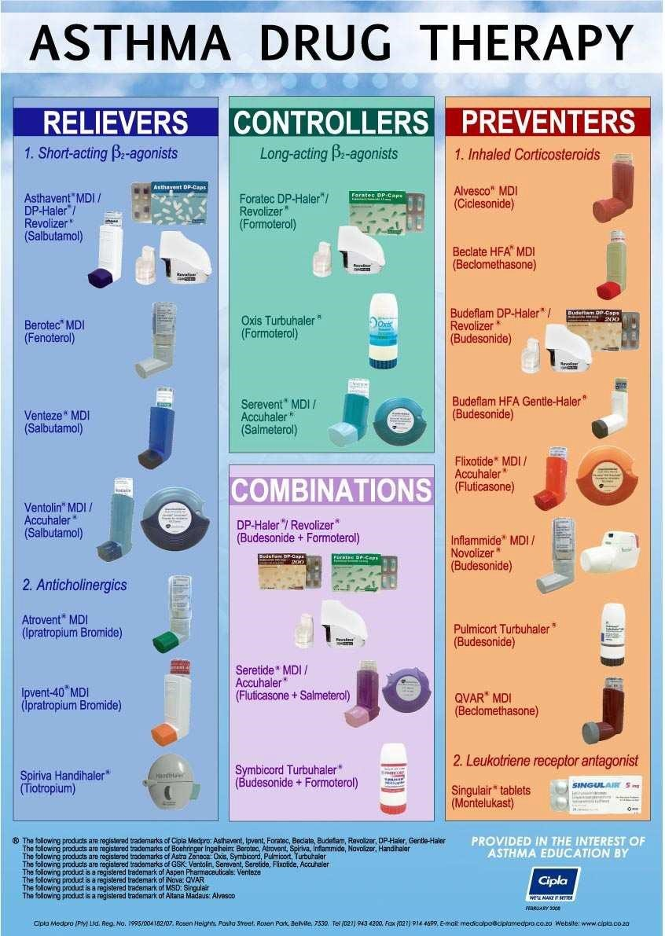

Common signs of an asthma attack include any one or more of the following:
- Coughing.
- Shortness of breath.
- Wheezing.
- Tightness in the chest.
- Being unusually quiet.
- Difficulty speaking in full sentences.
- Lips are blue.
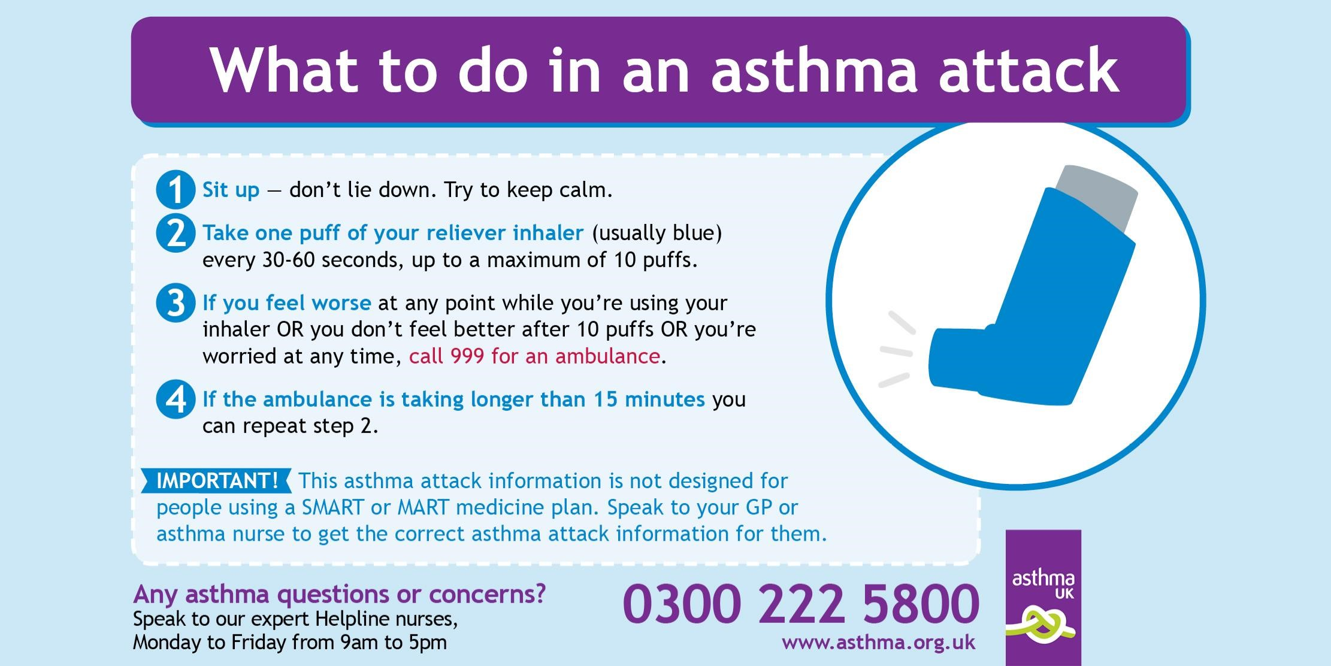
What to do during an Asthma Attack

14 Common Food Allergens
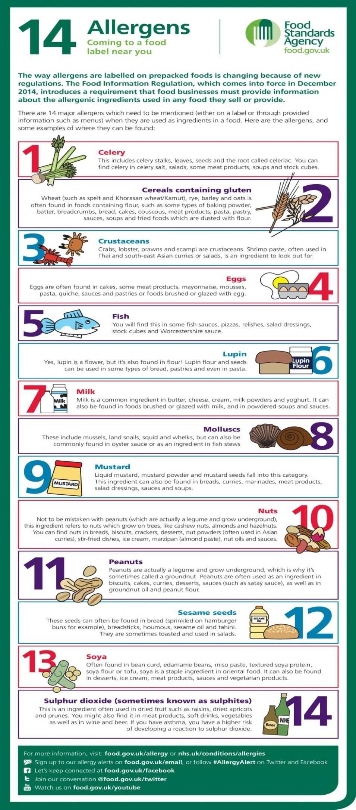

What to do during Anaphylaxis (A Severe Allergic Reaction)
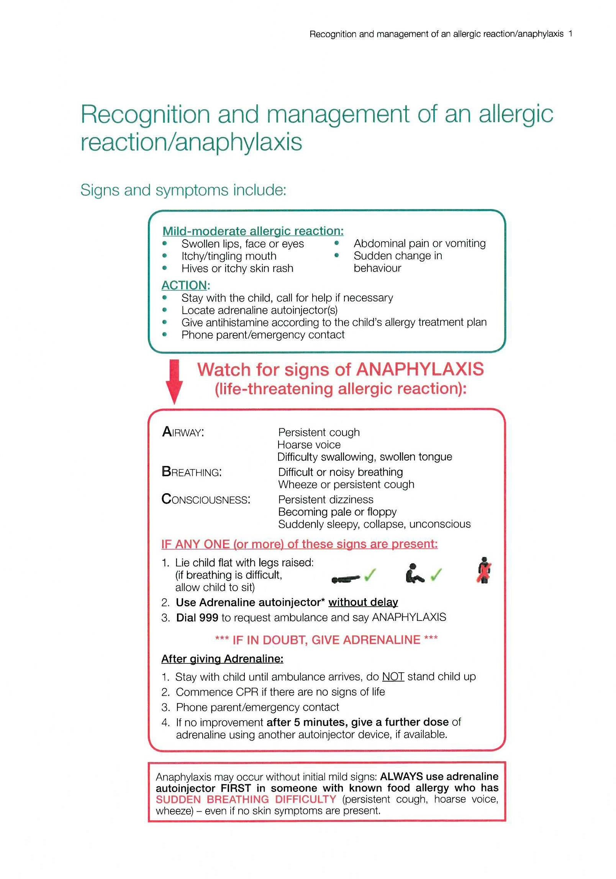

Epilepsy - What to do when someone has a seizure

Tonic-clonic (convulsive) seizures
Tonic-clonic seizures are the type of seizure most people recognise. They used to be called grand mal seizures. Someone having a tonic-clonic seizure goes stiff, loses consciousness, falls to the floor and begins to jerk or convulse. They may go blue around the mouth due to irregular breathing. Sometimes they may lose control of their bladder or bowels, and bite their tongue or the inside of their mouth.

Here’s how to help if you see someone having a tonic-clonic seizure.
DO: | - Protect them from injury (remove harmful objects from nearby)  - Cushion their head  - Look for an epilepsy identity card or identity jewellery – it may give you information about their seizures and what to do  - Time how long the jerking lasts  - Aid breathing by gently placing them in the recovery position once the jerking has stopped (see picture)  - Stay with the them until they are fully recovered  - Be calmly reassuring
DO NOT: | - Restrain their movements  - Put anything in their mouth  - Try to move them unless they are in danger  - Give them anything to eat or drink until they are fully recovered  - Attempt to bring them round
Call for an  ambulance if: | - You know it is their first seizure or  - The jerking continues for more than five minutes or  - They have one tonic-clonic seizure after another without regaining consciousness between seizures or  - They are injured during the seizure or  - You believe they need urgent medical attention

Focal seizures
You may also hear this type of seizure called a partial seizure. Someone having a focal seizure may not be aware of their surroundings or what they are doing. They may have unusual movements and behaviour such as plucking at their clothes, smacking their lips, swallowing repeatedly or wandering around.

Here’s how to help if you see someone having a focal seizure.
DO: | - Guide them away from danger (such as roads or open water)  - Stay with them until recovery is complete  - Be calmly reassuring  - Explain anything that they may have missed
DO NOT: | - Restrain them  - Act in a way that could frighten them, such as making abrupt movements or shouting at them  - Assume they are aware of what is happening, or what has happened  - Give them anything to eat or drink until they are fully recovered  - Attempt to bring them round
Call for an  ambulance if: | - You know it is their first seizure or  - The seizure continues for more than five minutes or  - They are injured during the seizure or  - You believe they need urgent medical attention

Diabetes – How to treat Hypoglycaemia (low blood sugar) or Hyperglycaemia (high blood sugar)
Treating severe hypos: seizures
When a seizure is occurring, it will not be possible for a person to take sugar. It is also not advised to feed someone when they are having a seizure as this could lead to choking.

Where possible try to ensure the person having the seizure will not hit anything and cause themselves injury.
If they are on the floor, place something soft like a pillow or article of clothing to cushion their head.
Often a seizure will pass after a few minutes and this may allow the person having the seizure to take some sugar. If the seizure persists for more than 5 minutes, call for an ambulance.
How to Treat a Hypo (low blood sugar)
Hypos are periods of low blood sugar. Although common for diabetics, a hypo can be unnerving.
With appropriate treatment the effects and length of hypos can be reduced.
Noticing you’re having a hypo | Before you can treat the hypo, you need to notice that you are low on blood sugar. The sooner you notice hypoglycaemia, the less disruptive it’s likely to be.  Typical signs of hypoglycaemia include:  - Feeling suddenly tired or weak  - Having difficulty concentrating  - Exaggerated mood changes  - Feeling dizzy  Hypos can occur at any time, pay close attention to your blood sugar levels when exercising, playing sports or during physical activity.
Check it is a hypo by blood glucose testing | Where possible, test your blood sugar to ensure it is low blood sugar as some of the signs of low blood sugar may also represent higher blood sugar (such as tiredness or mood changes).  If you cannot test and are unsure if you have low or high blood glucose, it may be best to treat it as a hypo as hypoglycaemia can quickly become dangerous if left untreated.
Act quickly | It is important that as soon as you notice or confirm you are hypo you treat the hypo immediately.  Immediate hypo treatment helps by:  - Preventing a severe hypo occurring  - Speeding up recovery  - Reducing the chances of losing hypo awareness
Treatment | Treating a hypo involves taking quick acting carbohydrate, such as a sugary drink or glucose tablets. This should be followed by a longer-acting carbohydrate, such as a cereal bar, sandwich or piece of fruit and the individual testing their blood glucose.

