Engage Academy

PHYSICAL EDUCATION

2023/24

THE CURRICULUM INTENT AND SEQUENCE

1 | THE INTENT OF THE CURRICULUM
At Engage Academy the intent of teaching Physical Education is to give children the tools and understanding required to make a positive impact in their own physical health and well-being. We want all children to experience and develop a wide variety of sports and physical skills, promoting a healthy lifestyle and a love for being active. PE can promote self-esteem through being active, problem solving and physical challenges developing respect, discipline, confidence, teamwork, boundaries and independence. It can teach children to cope with both success and failure in individual and team activities both, applying a competitive element where appropriate.

We teach the National Curriculum, supported by a clear skills and knowledge progression linked with PHSE and science. This ensures that skills and knowledge are built on from children’s starting points on arrival at Engage and sequenced appropriately to maximise learning for all. Children gain experience of a variety of fundamental skills built upon as pupils work through bronze, silver and gold. This has a focus on gross motor skills, agility, balance, coordination and physical fitness. Taking a personalised approach to learning and resources, children take part individually and in teams, participating in multi-skills activities and individual and team games and sports.

Our curriculum aims to improve the wellbeing and fitness of all children at Engage Academy, not only through the sporting skills taught, but through the underpinning values and disciplines PE promotes.

2 | THE IMPLEMENTATION OF THE CURRICULUM
At Engage Academy, the PE curriculum is structured to provide a range of sports experiences which every child participates to develop their skills and learning through team and individual games and sports. Through our provision children can aim to flourish at sports in which they have a particular interest or flair for. Children are provided with appropriate support to enable them to take part in and gain confidence in skills, developing their understanding of PE and becoming motivated to take part and maintain a healthy and active lifestyle.
PE is led by our Physical and Mental Health and Wellbeing Lead and supported by other staff in school. Pupils access at least 4 swimming lessons per term run by qualified swimming instructors.
We provide challenging and enjoyable learning through a range of sporting activities including; invasion games, net & wall games, strike and field games, gymnastics, dance, swimming and outdoor & adventure.
Children have equal opportunities to take part in a range of games, sports and physical activities within a supportive environment where effort as well as success is recognised. Children are encouraged to participate in exercise through-out the day during PE lessons, clubs, outdoor learning, structured playtimes and external visits.

3 | THE IMPACT OF THE CURRICULUM
We help motivate children to participate in a variety of sports through quality teaching that is engaging and fun. From our lessons, our children learn to take responsibility for their own physical and mental health, wellbeing and fitness. We equip our children with the necessary skills and a love for sport. The ability to remain physically active for sustained periods of time and an understanding of the importance of this in promoting long-term health and well-being.
Physical activity will promote pupils’ reengagement into the curriculum through a focus on our core values. Pupils will demonstrate SEMH progress.

Our curriculum aims to improve the wellbeing and fitness of all children at Engage Academy, not only through the sporting skills taught, but through the underpinning values and disciplines PE promotes.

4 | WHAT PHYSICAL EDUCATION LOOKS LIKE AT ENGAGE ACADEMY
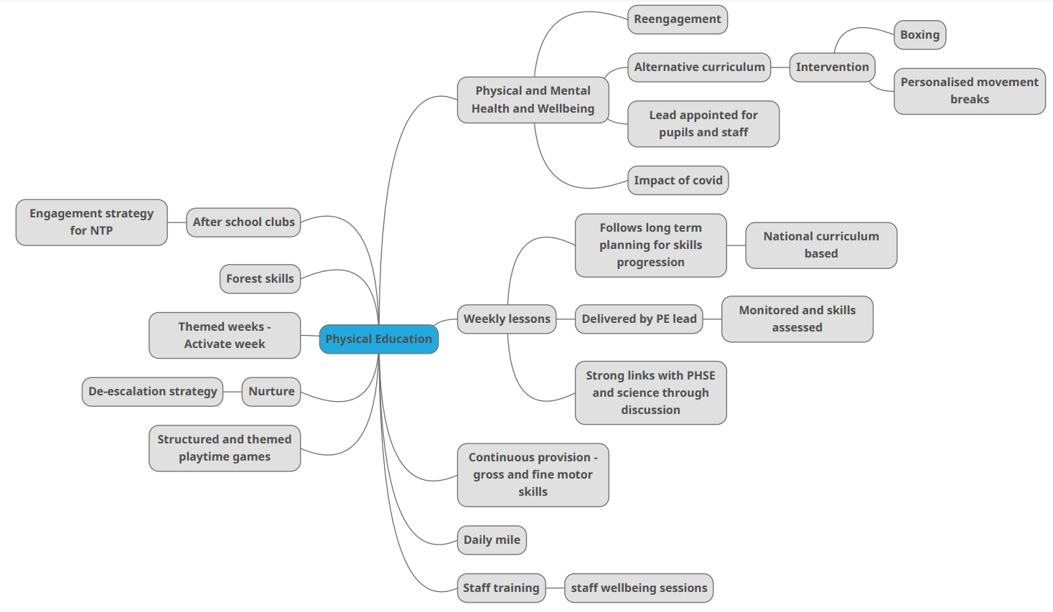

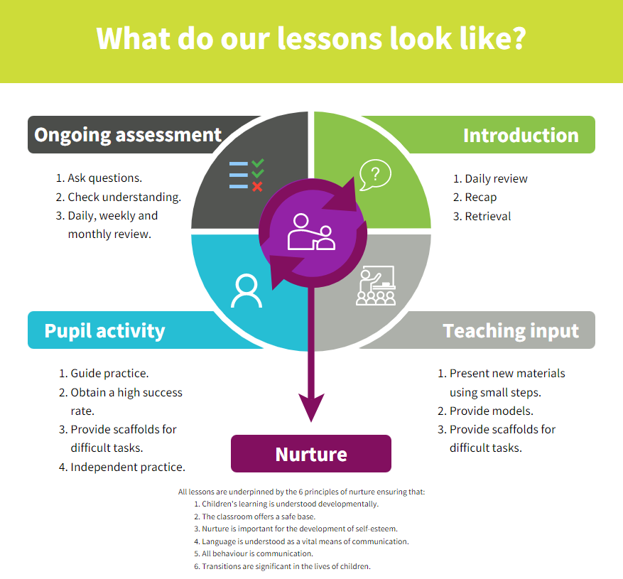
Strategies | What do we expect to see in lessons?
Daily review | Lessons begin with a recap of previously linked learning and retrieval practice.
Present new materials using small steps | New learning is built in small steps at an appropriate level, achievable and repeatable steps to build confidence, competence and retention.
Provide models | Questions are asked to check understanding. A range of questions are asked to challenge children.
Provide scaffolds for difficult tasks | The teacher models the skills first.
Guided practice | Children are given the opportunity to discuss and build on ideas with support.
Obtain a high success rate | Skills are constantly revisited and revised over time to ensure that children achieve age expected skills.
Provide scaffolds for difficult tasks | Teacher provides temporary supports and scaffolds to assist in challenging tasks. Support reduced as children become more confident.
Independent practice | Children have the opportunity to practice regular and independently to transfer the knowledge into their long term memory.
Weekly and monthly review | Constant review through discussion and ongoing assessment.

SKILLS PROGRESSION – Athletics

 | Jumping | Throwing | Running
GOLD | Improve techniques for jumping for distance.  Perform an effective standing long jump.  Perform the standing triple jump with increased confidence.  Develop an effective technique for the standing vertical jump (jumping for height) including take-off and flight.  Land safely and with control.  Measure the distance and height jumped with accuracy. Investigate different jumping techniques.  Develop the technique for the standing vertical jump.  Maintain control at each of the different stages of the triple jump.  Land safely and with control.  Develop and improve their techniques for jumping for height and distance and support others in improving their performance.  Perform and apply different types of jumps in other contexts.  Set up and lead jumping activities including measuring the jumps with confidence and accuracy. | Perform a fling throw.  Throw a variety of implements using a range of throwing techniques.  Measure and record the distance of their throws.  Continue to develop techniques to throw for increased distance.  Perform a heave throw.  Measure and record the distance of their throws.  Continue to develop techniques to throw for increased distance and support others in improving their personal best.  Develop and refine techniques to throw for accuracy. | Accelerate from a variety of starting positions and select their preferred position.  Identify their reaction times when performing a sprint start.  Continue to practise and refine their technique for sprinting, focusing on an effective sprint start.  Select the most suitable pace for the distance and their fitness level in order to maintain a sustained run.  Identify and demonstrate stamina, explaining its importance for runners.  Recap, practise and refine an effective sprinting technique, including reaction time.  Build up speed quickly for a sprint finish.  Run over hurdles with fluency, focusing on the lead leg technique and a consistent stride pattern.  Accelerate to pass other competitors.  Work as a team to competitively perform a relay.  Confidently and independently select the most appropriate pace for different distances and different parts of the run.  Demonstrate endurance and stamina over longer distances in order to maintain a sustained run.
SILVER | Use one and two feet to take off and to land with.  Develop an effective take-off for the standing long jump.  Develop an effective flight phase for the standing long jump.  Land safely and with control.  Learn how to combine a hop, step and jump to perform the standing triple jump.  Land safely and with control.  Begin to measure the distance jumped. | Throw with greater control and accuracy.  Show increasing control in their overarm throw.  Perform a push throw.  Continue to develop techniques to throw for increased distance.  Perform a pull throw.  Measure the distance of their throws. Continue to develop techniques to throw for increased distance. | Identify and demonstrate how different techniques can affect their performance.  Focus on their arm and leg action to improve their sprinting technique.  Begin to combine running with jumping over hurdles.  Focus on trail leg and lead leg action when running over hurdles.  Understand the importance of adjusting running pace to suit the distance being run.  Confidently demonstrate an improved technique for sprinting.  Carry out an effective sprint finish.  Perform a relay, focusing on the baton changeover technique.  Speed up and slow down smoothly.
BRONZE | Perform different types of jumps: for example, two feet to two feet, two feet to one foot, one foot to same foot or one foot to opposite foot.  Perform a short jumping sequence.  Jump as high as possible.  Jump as far as possible.  Land safely and with control. Work with a partner to develop the control of their jumps.  Perform and compare different types of jumps: for example, two feet to two feet, two feet to one foot, one foot to same foot or one foot to opposite foot.  Combine different jumps together with some fluency and control.  Jump for distance from a standing position with accuracy and control.  Investigate the best jumps to cover different distances.  Choose the most appropriate jumps to cover different distances.  Know that the leg muscles are used when performing a jumping action. | Throw underarm and overarm.  Throw a ball towards a target with increasing accuracy.  Improve the distance they can throw by using more power.  Throw different types of equipment in different ways, for accuracy and distance.  Throw with accuracy at targets of different heights.  Investigate ways to alter their throwing technique to achieve greater distance | Vary their pace and speed when running.  Run with a basic technique over different distances.  Show good posture and balance.  Jog in a straight line.  Change direction when jogging.  Sprint in a straight line.  Change direction when sprinting.  Maintain control as they change direction when jogging or sprinting.  Run at different paces, describing the different paces.  Use a variety of different stride lengths.  Travel at different speeds.  Begin to select the most suitable pace and speed for distance. Complete an obstacle course.  Vary the speed and direction in which they are travelling.  Run with basic techniques following a curved line.  Be able to maintain and control a run over different distances.

SKILLS PROGRESSION – Gymnastics

 |  | Acquiring and Developing Skills in Gymnastics
GOLD | Select ideas to compose specific sequences of movements, shapes and balances.  Adapt their sequences to fit new criteria or suggestions.  Perform jumps, shapes and balances fluently and with control.  Confidently develop the placement of their body parts in balances, recognising the position of their centre of gravity and where it should be in relation to the base of the balance.  Confidently use equipment to vault in a variety of ways.  Apply skills and techniques consistently.  Develop strength, technique and flexibility throughout performances.  Combine equipment with movement to create sequences.  Create their own complex sequences involving the full range of actions and movements: travelling, balancing, holding shapes, jumping, leaping, swinging, vaulting and stretching.  Demonstrate precise and controlled placement of body parts in their actions, shapes and balances.  Confidently use equipment to vault and incorporate this into sequences.  Apply skills and techniques consistently, showing precision and control.  Develop strength, technique and flexibility throughout performances.
SILVER | Choose ideas to compose a movement sequence independently and with others.  Link combinations of actions with increasing confidence, including changes of direction, speed or level.  Develop the quality of their actions, shapes and balances.  Move with coordination, control and care.  Use turns whilst travelling in a variety of ways.  Use a range of jumps in their sequences.  Begin to use equipment to vault.  Create interesting body shapes while holding balances with control and confidence.  Begin to show flexibility in movements.  Create a sequence of actions that fit a theme.  Use an increasing range of actions, directions and levels in their sequences.  Move with clarity, fluency and expression.  Show changes of direction, speed and level during a performance.  Travel in different ways, including using flight.  Improve the placement and alignment of body parts in balances.  Use equipment to vault in a variety of ways.  Carry out balances, recognising the position of their centre of gravity and how this affects the balance.  Begin to develop good technique when travelling, balancing and using equipment.  Develop strength, technique and flexibility throughout performances.
BRONZE | Create and perform a movement sequence.  Copy actions and movement sequences with a beginning, middle and end. Link two actions to make a sequence.  Recognise and copy contrasting actions (small/tall, narrow/wide).  Travel in different ways, changing direction and speed.  Hold still shapes and simple balances.  Carry out simple stretches.  Carry out a range of simple jumps, landing safely.  Move around, under, over, and through different objects and equipment.  Begin to move with control and care.  Copy, explore and remember actions and movements to create their own sequence.  Link actions to make a sequence.  Travel in a variety of ways, including rolling.  Hold a still shape whilst balancing on different points of the body.  Jump in a variety of ways and land with increasing control and balance.  Climb onto and jump off the equipment safely.  Move with increasing control and care.

SKILLS PROGRESSION – Games

 | Ball skills | Attacking and defending | Tactics, rules and competition
GOLD | Striking and hitting a ball  Use different techniques to hit a ball.  Identify and apply techniques for hitting a tennis ball.  Explore when different shots are best used.  Develop a backhand technique and use it in a game.  Practise techniques for all strokes.  Play a tennis game using an overhead serve.  Hit a bowled ball over longer distances.  Use good hand-eye coordination to be able to direct a ball when striking or hitting.  Understand how to serve in order to start a game.  Throwing and catching a ball  Consolidate different ways of throwing and catching, and know when each is appropriate in a game.  Throw and catch accurately and successfully under pressure in a game.  Travelling with a ball  Use a variety of ways to dribble in a game with success.  Use ball skills in various ways, and begin to link together.  Show confidence in using ball skills in various ways in a game situation, and link these together effectively.  Passing a ball  Pass a ball with speed and accuracy using appropriate techniques in a game situation.  Choose and make the best pass in a game situation and link a range of skills together with fluency, e.g. passing and receiving the ball on the move.  Possession and using space  Keep and win back possession of the ball effectively in a team game.  Keep and win back possession of the ball effectively and in a variety of ways in a team game.  Demonstrate an increasing awareness of space.  Demonstrate a good awareness of space. | Choose the best tactics for attacking and defending.  Shoot in a game.  Use fielding skills as a team to prevent the opposition from scoring.  Think ahead and create a plan of attack or defence.  Apply knowledge of skills for attacking and defending.  Work as a team to develop fielding strategies to prevent the opposition from scoring. | Know when to pass and when to dribble in a game.  Devise and adapt rules to create their own game.  Follow and create complicated rules to play a game successfully.  Communicate plans to others during a game.  Lead others during a game.  Consistently perform and apply skills and techniques with accuracy and control.  Take part in competitive games with a strong understanding of tactics and composition.  Perform and apply a variety of skills and techniques confidently, consistently and with precision.  Take part in competitive games with a strong understanding of tactics and composition.
SILVER | Striking and hitting a ball  Demonstrate successful hitting and striking skills.  Develop a range of skills in striking (and fielding where appropriate).  Practise the correct batting technique and use it in a game.  Strike the ball for distance.  Use a bat, racquet or stick (hockey) to hit a ball or shuttlecock with accuracy and control.  Accurately serve underarm.  Build a rally with a partner.  Use at least two different shots in a game situation.  Use hand-eye coordination to strike a moving and a stationary ball.  Throwing and catching a ball  Throw and catch with greater control and accuracy.  Practise the correct technique for catching a ball and use it in a game.  Perform a range of catching and gathering skills with control.  Catch with increasing contro and accuracy.  Throw a ball in different ways (e.g. high, low, fast or slow).  Develop a safe and effective overarm bowl.  Develop different ways of throwing and catching.  Travelling with a ball  Move with the ball in a variety of ways with some control.  Use two different ways of moving with a ball in a game.  Move with the ball using a range of techniques, showing control and fluency.  Passing a ball  Pass the ball in two different ways in a game situation with some success.  Pass the ball with increasing speed, accuracy and success in a game situation.  Possession and using space  Know how to keep and win back possession of the ball in a team game.  Occasionally contribute towards  helping their team to keep and win  back possession of the ball in a team game. | Use simple attacking and defending skills in a game.  Use fielding skills to stop a ball from travelling past them.  Use a range of attacking and defending skills and techniques in a game.  Use fielding skills as an individual to prevent a player from scoring. | Apply and follow rules fairly.  Understand and begin to apply the basic principles of invasion games.  Know how to play a striking and fielding game fairly.  Vary the tactics they use in a game.  Adapt rules to alter games.  Develop the quality of the actions in their performances.  Perform learnt skills and techniques with control and confidence.  Compete against self and others in a controlled manner.  Perform and apply skills and techniques with control and accuracy.  Take part in a range of competitive games and activities.
BRONZE | Striking and hitting a ball  Use hitting skills in a game.  Practise basic striking, sending and receiving.  Strike or hit a ball with increasing control.  Learn skills for playing striking and fielding games.  Position the body to strike a ball.  Throwing and catching a ball  Throw underarm and overarm.  Catch and bounce a ball.  Use rolling skills in a game.  Practise accurate throwing and consistent catching.  Throw different types of equipment in different ways, for accuracy and distance.  Throw, catch and bounce a ball with a partner.  Use throwing and catching skills in a game.  Throw a ball for distance.  Use hand-eye coordination to control a ball.  Vary types of throw used.  Travelling with a ball  Travel with a ball in different ways. Travel with a ball in different directions (side to side, forwards and backwards) with control and fluency.  Bounce and kick a ball whilst moving.  Use kicking skills in a game.  Use dribbling skills in a game.  Passing a ball  Pass the ball to another player in a game.  Use kicking skills in a game.  Know how to pass the ball in different ways.  Possession and using space  Use different ways of travelling in different directions or pathways.  Begin to use space in a game.  Use different ways of travelling  at different speeds and following  different pathways, directions or courses.  Change speed and direction whilst running.  Begin to choose and use the best space in a game.  Run at different speeds | Begin to use the terms attacking and defending.  Use simple defensive skills such as marking a player or defending a space.  Use simple attacking skills such as dodging to get past a defender.  Begin to use and understand the terms attacking and defending.  Use at least one technique to attack or defend to play a game successfully. | Follow simple rules to play games, including team games.  Use simple attacking skills such as dodging to get past a defender.  Use simple defensive skills such as marking a player or defending a space.  Understand the importance of rules in games.  Use at least one technique to attack or defend to play a game successfully.  Perform using a range of actions and body parts with some coordination.  Begin to perform learnt skills with some control.  Engage in competitive activities and team games.  Perform sequences of their own composition with coordination.  Perform learnt skills with increasing control.  Compete against self and others.

SKILLS PROGRESSION – Dance

 | Dance skills | Perform
GOLD | Identify and repeat the movement patterns and actions of a chosen dance style.  Compose individual, partner and group dances that reflect the chosen dance style.  Show a change of pace and timing in their movements.  Develop an awareness of their use of space.  Identify and repeat the movement patterns and actions of a chosen dance style.  Compose individual, partner and group dances that reflect the chosen dance style.  Use dramatic expression in dance movements and motifs.  Perform with confidence, using a range of movement patterns.  Demonstrate imagination and creativity in the movements they devise in response to stimuli.  Use transitions to link motifs smoothly together.  Improvise with confidence, still demonstrating fluency across the sequence.  Ensure their actions fit the rhythm of the music.  Modify parts of a sequence as a result of self and peer evaluation.  Use more complex dance vocabulary to compare and improve work.  Demonstrate strong and controlled movements throughout a dance sequence.  Combine flexibility, techniques and movements to create a fluent sequence.  Move appropriately and with the required style in relation to the stimulus, e.g. using various levels, ways of travelling and motifs.  Show a change of pace and timing in their movements.  Move rhythmically and accurately in dance sequences.  Improvise with confidence, still demonstrating fluency across their sequence.  Dance with fluency and control, linking all movements and ensuring that transitions flow.  Demonstrate consistent precision when performing dance sequences.  Modify some elements of a sequence as a result of self and peer evaluation.  Use complex dance vocabulary to compare and improve work. | Perform own longer, more complex sequences in time to music.  Consistently perform and apply skills and techniques with accuracy and control.  Link actions to create a complex sequence using a full range of movement.  Perform the sequence in time to music.  Perform and apply a variety of skills and techniques confidently, consistently and with precision.
SILVER | Begin to improvise with a partner to create a simple dance.  Create motifs from different stimuli.  Begin to compare and adapt movements and motifs to create a larger sequence.  Use simple dance vocabulary to compare and improve work.  Identify and repeat the movement patterns and actions of a chosen dance style.  Compose a dance that reflects the chosen dance style.  Confidently improvise with a partner or on their own.  Compose longer dance sequences in a small group.  Perform with some awareness of rhythm and expression.  Demonstrate precision and some control in response to stimuli.  Begin to vary dynamics and develop actions and motifs in response to stimuli.  Demonstrate rhythm and spatial awareness.  Change parts of a dance as a result of self-evaluation.  Use simple dance vocabulary when comparing and improving work. | Develop the quality of the actions in their performances.  Perform learnt skills and techniques with control and confidence.  Compete against self and others in a controlled manner.  Perform and create sequences with fluency and expression.  Perform and apply skills and techniques with control and accuracy.
BRONZE | Copy and repeat actions.  Put a sequence of actions together to create a motif.  Vary the speed of their actions.  Use simple choreographic devices such as unison, canon and mirroring.  Begin to improvise independently to create a simple dance.  Copy, remember and repeat actions.  Create a short motif inspired by a stimulus.  Change the speed and level of their actions.  Use simple choreographic devices such as unison, canon and mirroring.  Use different transitions within a dance motif.  Move in time to music.  Improve the timing of their actions. | Perform using a range of actions and body parts with some coordination.  Begin to perform learnt skills with some control.  Perform sequences of their own composition with coordination.  Perform learnt skills with increasing control.  Compete against self and others.

SKILLS PROGRESSION – Health and Fitness

GOLD | Understand the importance of warming up and cooling down.  Explain some safety principles when preparing for and during exercise.  Carry out warm-ups and cool-downs safely and effectively.  Understand why exercise is good for health, fitness and wellbeing.  Know ways they can become healthier.
SILVER | Recognise and describe the effects of exercise on the body.  Know the importance of strength and flexibility for physical activity.  Explain why it is important to warm up and cool down.  Describe how the body reacts at different times and how this affects performance.  Explain why exercise is good for your health.  Know some reasons for warming up and cooling down.
BRONZE | Carry and place equipment safely.  Recognise and describe how the body feels during and after different physical activities.  Explain what they need to stay healthy.

SKILLS PROGRESSION – Swimming

Swimming
- Put face in water and blow bubbles
- Float on back (with swimming aids if necessary) with head touching water
- Use ‘doggy paddle’ to move forward in the water (with swimming aids if necessary)
- Swim a width of the pool (approx. 10/15 metres) without putting feet down
- Swim competently, confidently and proficiently over a distance of at least 25 metres (without aids)
- Use a range of strokes effectively
- Perform safe self-rescue in different water-based situations
- Using a range of swimming skills and strokes for different purposes such as basic water polo or synchronised swimming elements.
- Swimming longer distances (above 50 metres) and for increasing amounts of time.

Curriculum overview

 | Autumn 1 | Autumn 2 | Spring 1 | Spring 2 | Summer 1 | Summer 2
B | Dance/Multi-Skills | Games - Net | Games – Team Invasion | Gymnastics | Athletics | Games – Striking and Fielding
S
G

