

Engage Academy

Maths

2026

THE CURRICULUM INTENT AND SEQUENCE

1 | THE INTENT OF THE CURRICULUM
Maths is a core subject which pupils will access daily to recall, develop and build on the knowledge and skills they require to prepare them for the opportunities and experiences ahead of them. Mathematical skill is an aspect which pupils will need when they move on from the academy and the curriculum aim is to have them engaged in mathematical skills within their learning capacity, that challenges their learning level and to understand maths can be fun.
The curriculum will address the pupils specific needs in maths and be built around the understanding of the pupils SEMH needs. This means maths will be practised daily, in one format or another for every pupil which is suited to their needs. The strand pupils are placed in means that the curriculum will be ambitious to those who need to be challenged further but also include all pupils who need to be challenged at their level.

The curriculum has three priorities;
- To engage pupils in daily maths learning,
- Challenge pupils mathematically at the appropriate level,
- Build and develop on pupils mental maths skill and speed of recall.

2 | THE IMPLEMENTATION OF THE CURRICULUM
 | Maths will be taught to a level in class that meets the specific level of the pupils and will follow the outline of strand 1, 2 or 3 below. This will incorporate the use of WRMH (White Rose Maths Hub) and follow their overviews and learning steps for pupils who can access the appropriate year groups learning for their knowledge. It may be that certain pupils have to move below their year group learning in certain steps of the overview so that gaps in knowledge can be addressed. This means that the curriculum can be fluid and address the needs of the pupil their and then. Pupils may need to follow a personalised maths learning path to re-engage them into maths learning before moving onto one of the WRMH year overviews and progress through being taught elements of the schemes learning. This means teachers will have to know pupils learning levels thoroughly to make sure the pupil is following the correct learning strand and appropriate scheme of learning.

3 | THE IMPACT OF THE CURRICULUM
 | As a result of a curriculum which holds individuals pupils needs at heart that can be fluid, pupils will be able to either re-engage in maths learning, build and develop on prior knowledge or be challenged to attain further in their maths when they join Engage academy. The learning pupils will be taking part in will flow from day to day and enable pupils to see the maths learning journey they have been on. This could be from being able to write the numbers 1-5 to writing up to 20 or from knowing only addition and subtraction methods to being confident with all three. In any way, the journey will be personal, and the pupils will be able to reflect on this. To develop the pupil’s knowledge and understanding the lesson comprises of a four-part model; recall of maths facts, arithmetic, review and consolidation of old learning and introduction of new learning. All lessons are practical and offer hands-on learning experiences. This approach cements their knowledge, so they are prepared for opportunities, and experiences ahead.

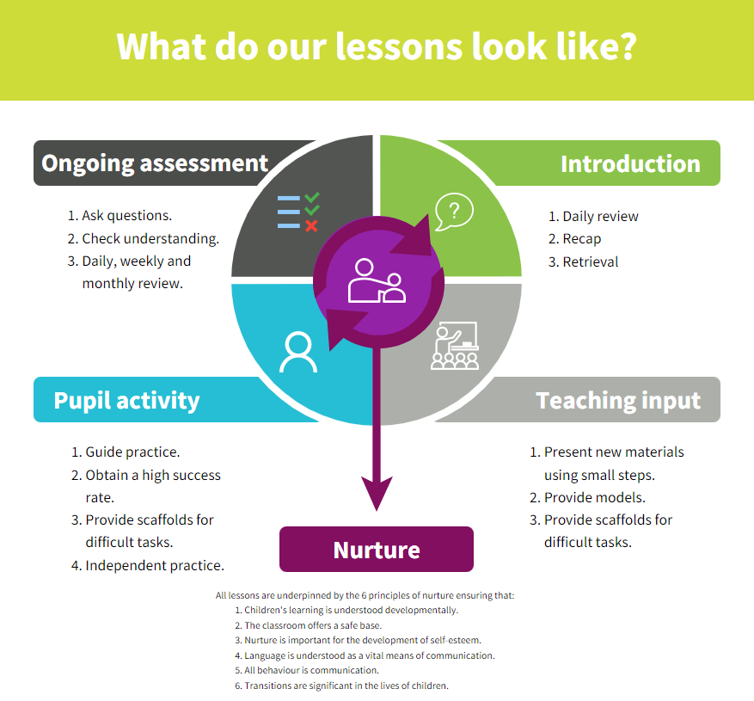
Strategies | What do we expect to see in lessons?
Daily review | Pupils are given immediate feedback by supporting adult. AFL by the teacher.
Present new materials using small steps | Teacher to guide pupils through new materials in small steps, asking for feedback and allowing pupils to attempt alongside an adult.
Provide models | Teacher to model examples to pupils. Follow concrete, pictorial and abstract learning.
Provide scaffolds for difficult tasks | Access to manipulatives and maths resources for adults to suggest or pupils to independently retrieve. Provide appropriate framework, guidance or materials for pupil to succeed with calculation. Follow concrete, pictorial and abstract learning.
Guided practice | Adult and pupil to work in tandem to answer questions to allow pupil to build confidence in learning before moving on to independent learning.
Obtain a high success rate | Supporting adult to provide instant feedback, intervention and address misconceptions so pupil can answer question successfully there and then.
Independent practice | Pupil to work without adult support once teacher has provided input.
Weekly and monthly review | Teacher to use AFL to support and guide learning that week and review short term planning.

SKILLS PROGRESSION

The skills progression of the pupils in mathematics depends on each individual pupil and the progress strand they are assessed on whilst at Engage academy. Outlined below is what is expected to be seen in progress of the pupil within the strand they are on.
1 | 2 | 3
The learners on strand one will be able to access the WRMH scheme at either ARE or a year below. This will mean they will be able to closely follow the skill progression of the WRMS and teachers should refer to the scheme guidance for each unit to support them. There will possibly be some gaps in their learning in other areas which go further below this level.  When accessing the maths lesson, the pupils will follow the structure of the lesson (as outlined in the scheme) and in each lesson, for the skill taught, move from concrete to pictorial to abstract. They then will be able to attempt reasoning and problem solving, with some pupils needing support to achieve success.  Mental maths teaching should be addressing gaps in knowledge and times tables rapid recall. | The learners on strand two may be able to access some of the WRMH scheme within their Key Stage. The pupil may exceed in some areas of maths but have large gaps in others. This will mean that the pupils won’t be able to constantly follow the same year group of learning and at times may have to dip into learning which is 2/3 years below their own year group. Pupils will be comfortable with concrete and pictorial learning and may need support with abstract.  The pupils in this strand needs the teacher to understand the pupils’ strengths and weakness and use of constant AFL to be able to make sure they are accessing the correct content to make skills progression. If this is done correctly, it could provide opportunity for the pupil to make accelerated learning and plug the gaps in their learning. Teachers will have to refer to different year group curriculums and have a understanding of the calculation policy. Teachers should still be referring to the scheme guidance for support and look at different year groups.  Pupils will need to access mental maths skills as outlined in strand 3. | The learners on strand two will be working on re-engaging with maths learning and enjoying maths learning. The pupils might be able to access some of the WRMH within or outside their Key Stage for some aspects of maths or need to complete maths work using concrete learning only and play based learning. Some pupils will be able to move onto pictorial and abstract in some areas but potentially struggle in others due to large gaps or knowledge.  Pupils on this strand will need to have daily mental maths to help secure their maths learning. This will need to progress as follows:  - Number bonds to 10,  - Number bonds to 20,  - Addition within 10,  - Number bonds to 50  - Single digit fact families  - Addition within 20,  - Counting in 2, 5 and 10’s,  - Number bonds to 100.  When pupils progress beyond these mental maths skills, the teacher should address areas which they have found during their teaching. This could be along the lines of fact families for larger numbers, times tables, adding/subtracting multiples of 10, 100, 1000 etc.  The learning for the 4 methods will be addressing phase 1-3 in the calculation policy.

The calculation policy (Appendix A) for Engage academy outlines the skills progression for place value, addition, subtraction, multiplication and division and fractions stating from Early Years through to year 6. This document is to support and help staff and parents to support the pupils when calculations and the methods being taught are the same in all classes across school and at home. This will need to be referred to in addition to WRMH scheme when teaching methods to the pupils.

Curriculum overview

Long Term Plan

Autumn Term

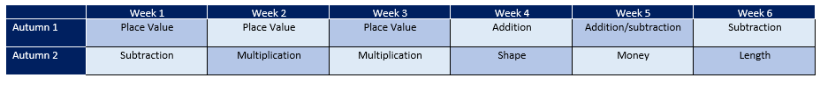

Spring Term
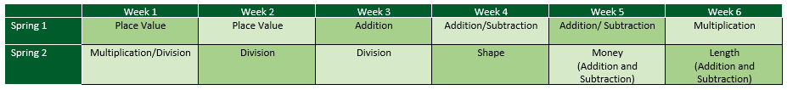

Summer Term

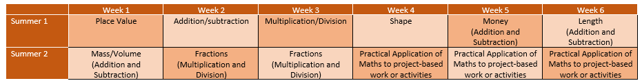

Learning Steps – Place Value (Refer to WRM for other learning steps)

Reception

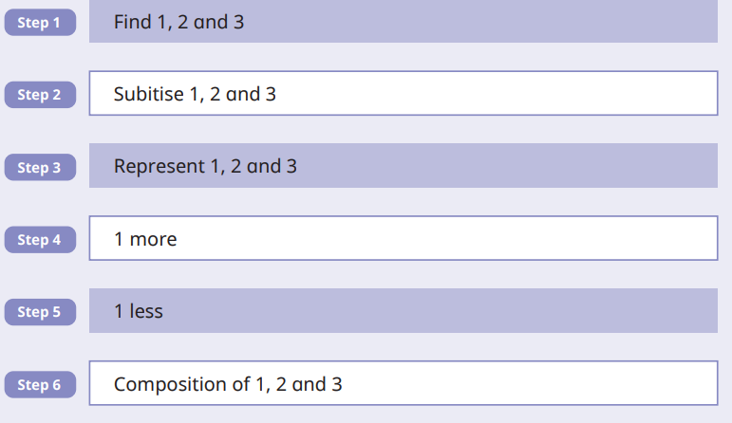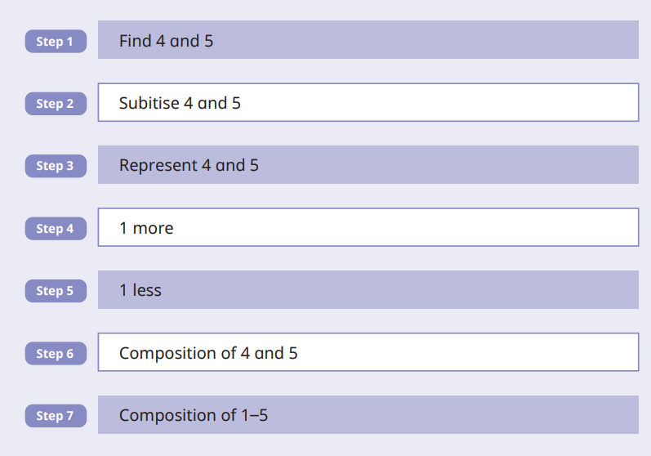

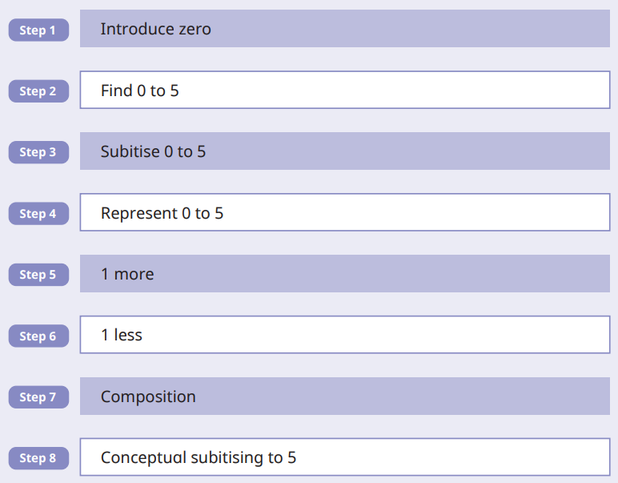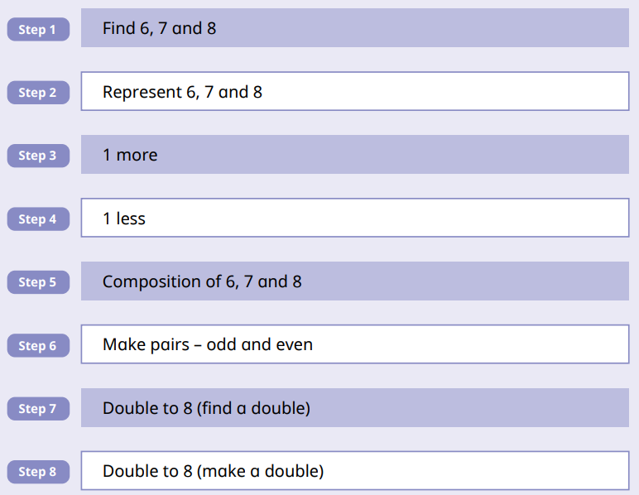


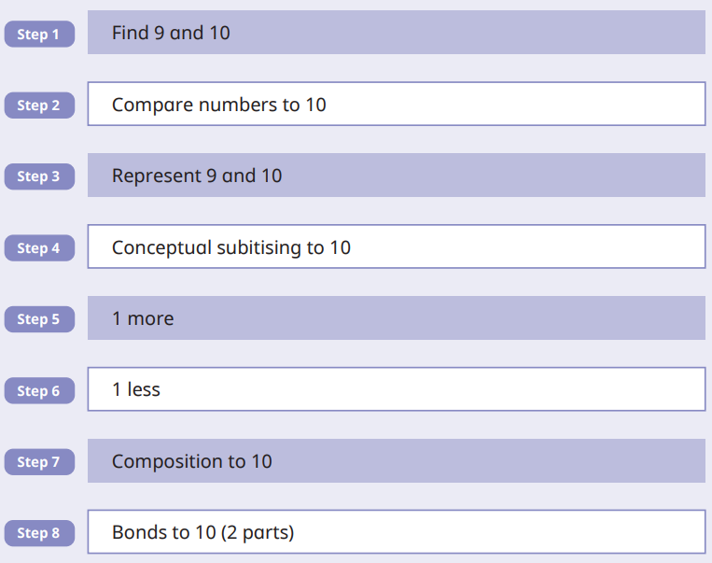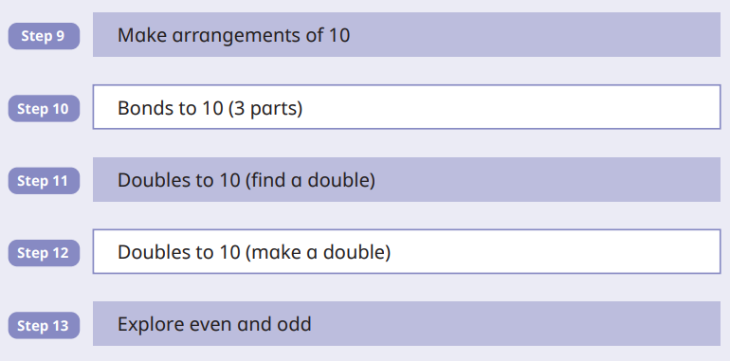

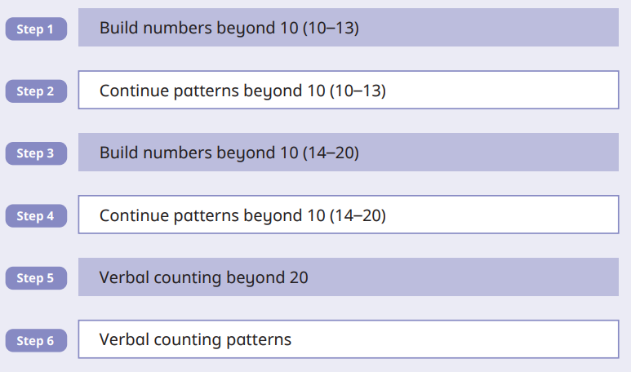

Year 1

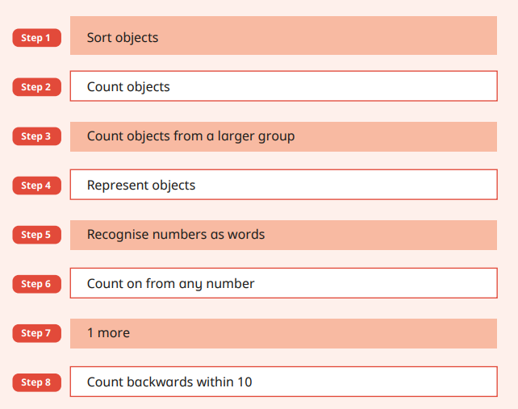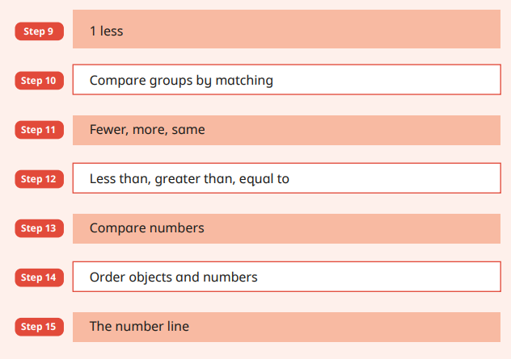

Year 2

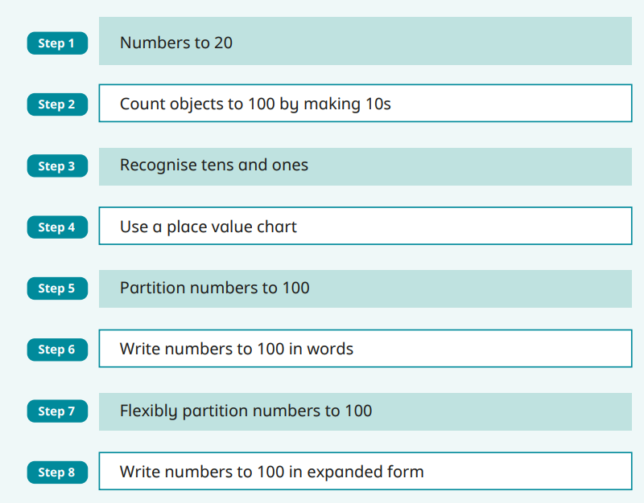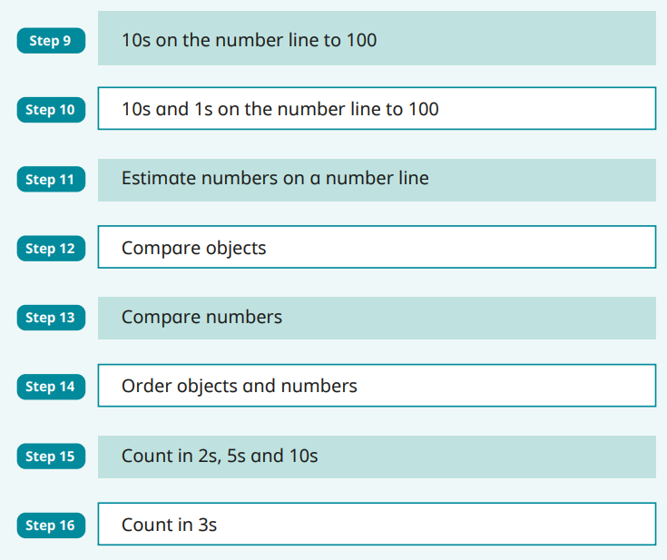

Year 3

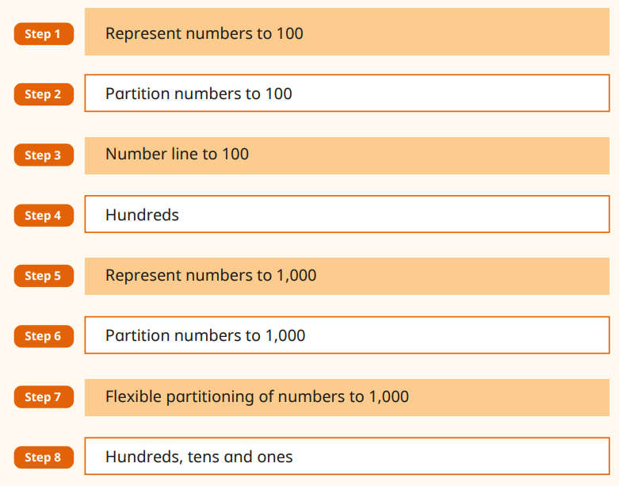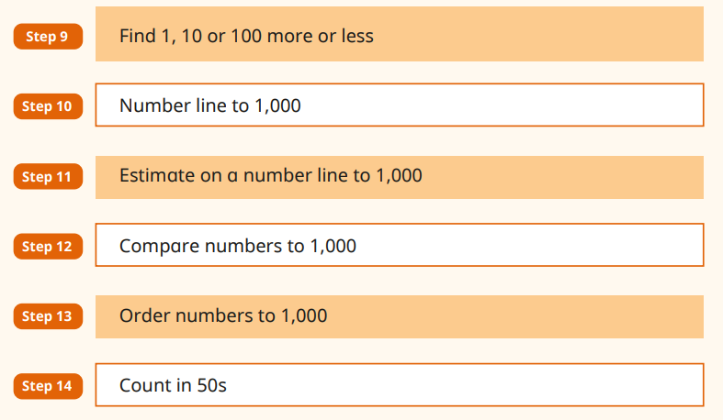

Year 4

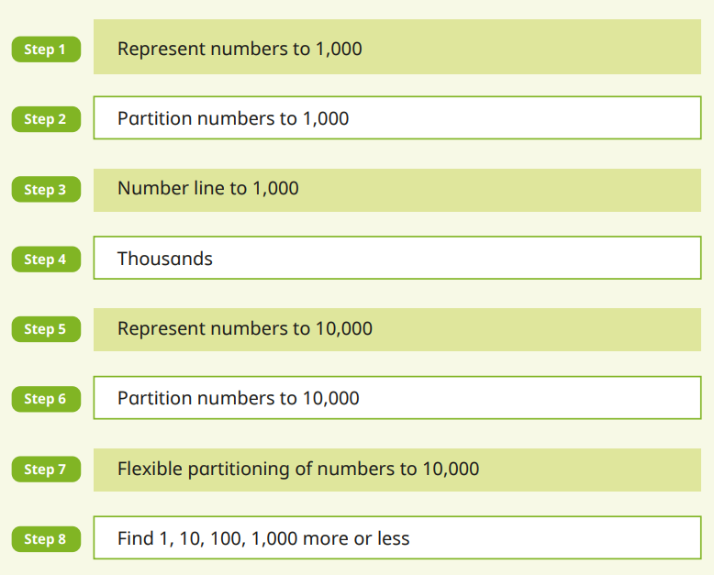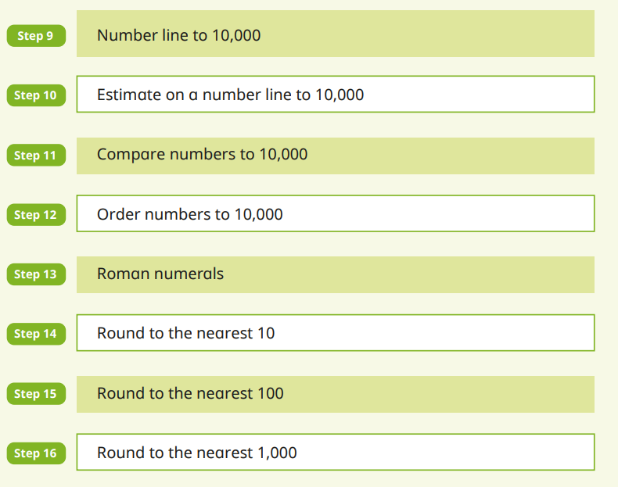

Year 5

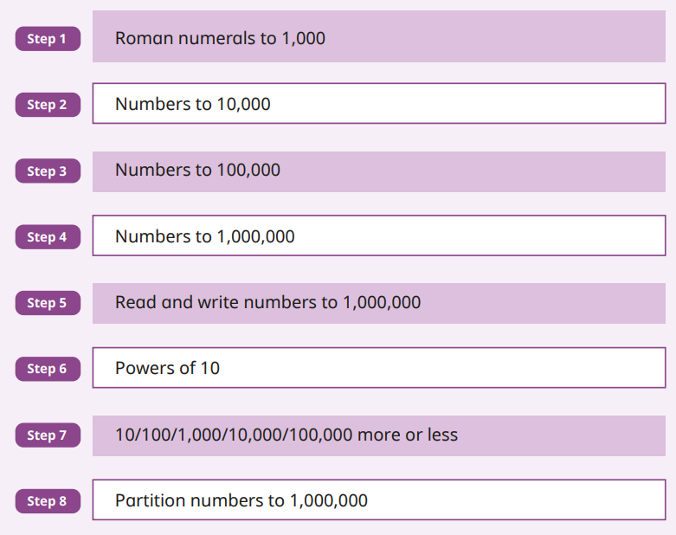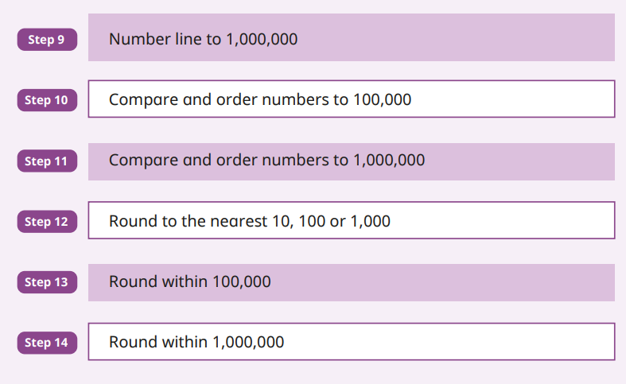

Year 6

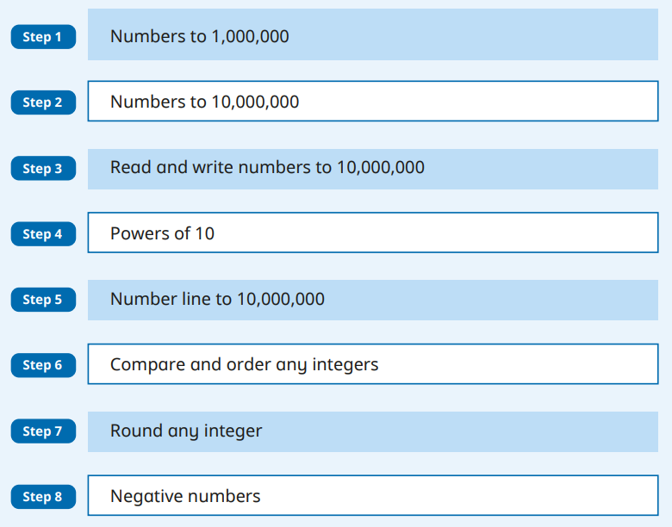

Appendix A

Progression in Teaching and Learning Calculations

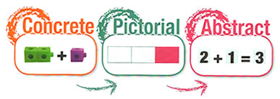

Essential thought process for calculating:

Always model with manipulatives
- Estimate first
- Can I do it in my head?
- Can I do it with practical equipment?
- Can I do it with some jottings?
- Which written method do I need?
- Have I checked my answers?
- Can use the inverse?

Concrete, Pictorial, Abstract

Involve problem solving as much as possible

Always look for real life applications

Maths Working Wall
DISPLAY IT
BUILD IT! | Use real life objects on the display which the children can see, touch and feel. Encourage them to use the objects to explore the maths concepts. | 
DRAW IT! | Show a pictorial representation of the concept. Encourage the children to draw it in their books. Making jottings and representations is a good thing! | 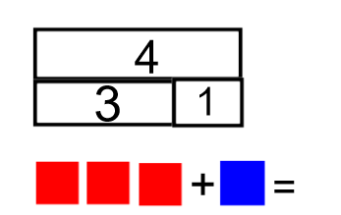
SOLVE IT! | Show the mathematical representation of the concept. | 3 + 1 = 4 4 = 1 + 3  1 + 3 = 4 4 = 3 + 1  4 – 1 = 3 3 = 4 - 1  4 – 3 = 1 1 = 4 - 3
PRACTISE IT! | Encourage the children to practice the concept.  Interactive opportunity – ask the children to respond to questions, encourage them to add and explain what they know and leave them homework to take to master the concept. | 4 + 1 = ?  5 + 2 = ?  2 + 5 = ?  1 + 4 = ?
CHALLENGE IT! | Set a challenge to be solved (Mastery materials).  Interactive opportunity – leave the manipulatives out for the children to use in their investigation/ problem solving. | 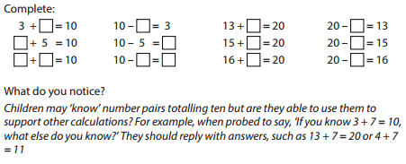
SAY IT! | Use and display the vocabulary related to the concept. | Add, addition, plus, sum, more, increase, total, altogether

Progression in the teaching of Counting – Foundation Stage

Pre-counting  A focus on the concept of more or less. Develop these concepts through comparison only and no counting is involved. | Ordering  Reciting number names in order – forwards and backwards from any starting point. | One to one correspondence  Matching number words to objects.  To help with co-ordination, move the objects as they count, use large rhythmic movements or clap as they count. | Cardinality  (knowing the final number counted is the total number of objects)  From a large amount of objects, count out a smaller group – knowing that the number they stop counting on is the total number of objects in their group.
Let the children sort groups of objects explicitly using the language of more and less.  Which group has the most?  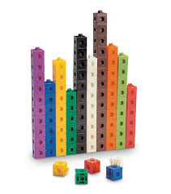  Which group has the least? | 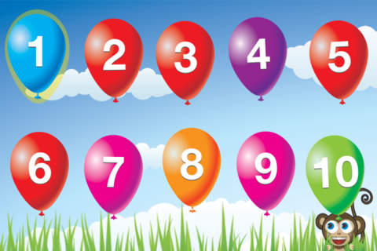  Count orally on a daily basis. Rote count to begin with so that the children are able to understand number order and can hear the rhythm and pattern. Use a drum or clap to keep the beat. | Sing counting songs such as 5 little ducks, 1,2,3,4,5…, 10 green bottles etc so that the children have visual and kinaesthetic resources.  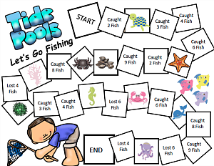  Play counting games – moving along a track, knocking down amounts of skittles etc. | Give the children real life objects i.e a fruit bowl of fruit, to count. Let them move the objects as they count them.  How many bananas are there in my fruit bowl?  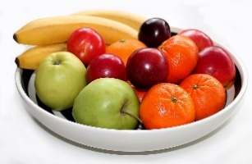

Substitising  (recognise small numbers without counting them)  Recognise numicon shape dot patterns, dot patterns on dice, patterns on playing cards and small groups of shapes stuck on to cards. | Abstraction  Counting anything – mixtures of different objects, or similar objects of very different sizes.  Children find it difficult to count objects they can’t move, touch or see (They move around) | Mastery  Children need to know that no matter what order the objects are in, there is still the same amount there. They can be rearranged and the amount doesn’t change. | End of year counting expectations  - count reliably to 20  - count reliably up to 10 everyday objects  - estimate a number of objects then check by counting  - use ordinal numbers in context eg first, second, third  - count in twos, fives and tens  - order numbers 1-20  - say 1 more/ 1 less than a given number to 20
Play flash card games, order dice displaying different numbers, order numicon and say the numbers out loud etc. | Give the children pictures and ask How many… questions.  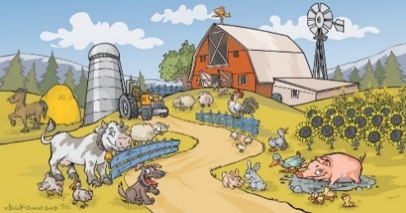  How many sheep are there? How many  ducks are there? | No matter how the 5 objects are arranged, they are still 5 objects.  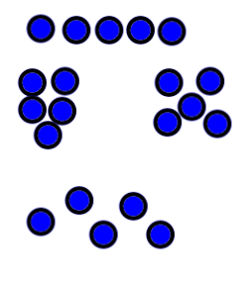

Progression in the teaching of Place Value

 | Year 1 | Year 2 | Year 3 | Year 4 | Year 5 | Year 6
Place Value | Count, read and write numbers to 100 in numerals  Identify and represent numbers using objects and pictorial representations | Count in steps of 2,3 and 5 from 0 and in 10s from any number  Read and write numbers to 100 in numerals and words  Recognise the place value of each digit in a 2-digit number  Identify, represent and estimate numbers using different representations  Compare and order numbers from 0 to 100 using < and >  Use place value facts to solve problems | Count in 4, 8, 50, 100, find 10 or 100 more or less  Read and write numbers to 1000 in numerals and words  Recognise the place value of each digit in 3-digit numbers  Identify, represent and estimate numbers using different representations  Compare and order numbers up to 1000  Use place value facts to solve number and practical problems | Count in 6,7,9,25 and 1000, find 1000 more or less than a given number  Count backwards through zero to include negative numbers  Recognise the place value of each digit in a 4-digit number  Order and compare numbers beyond 1000  Identify, represent and estimate numbers using different representations  Round any number to the nearest 10,100 or 1000  Use place value to solve problems  Read Roman Numerals up to 100 | Count on and back in steps of powers of 10 for any given number to 1,000,000  Interpret negative numbers in context  And count on an back across zero into negative numbers  Read, write, order and compare numbers to at least 1,000,000 and determine the value of each digit  Round any number up to 1,000,000 to the nearest 10,100,1000, 10,000 and 100,000  Read Roman Numerals uo to 1000 | Read, write, order and compare numbers up to 10,000,000 and determine the value of each digit  Round any whole number to a required degree of accuracy  Use negative numbers in context and calculate across zero  Solve problems involving the above

Progression in the models and images of Place Value

Objective | Concrete  BUILD IT/ USE IT! | Pictorial  DRAW IT! | Abstract  SOLVE IT!
Subitise the numbers 1-5 |   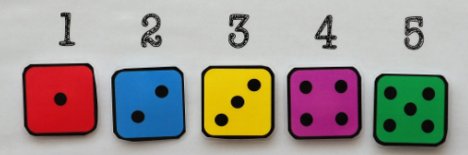   |   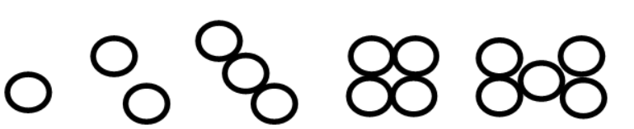
Subitise the numbers 1-10 |   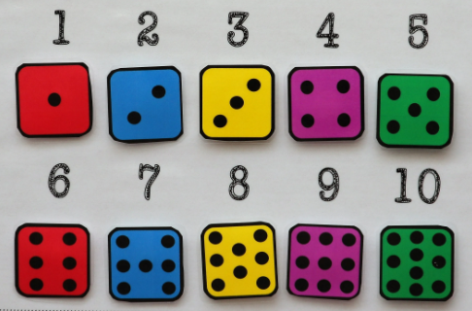

Objective | Concrete  BUILD IT/ USE IT! | Pictorial  DRAW IT! | Abstract  SOLVE IT!
Represent numbers 0- 10 with objects |   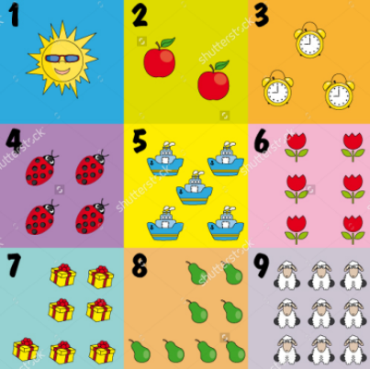   |  | 0,1, 2, 3, 4, 5, 6, 7, 8, 9, 10

Recognising the value of each digit in a 2-digit number | 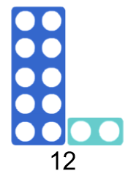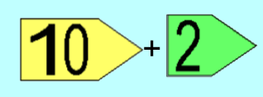  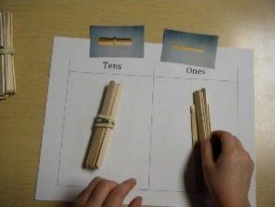  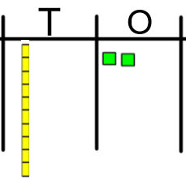 | 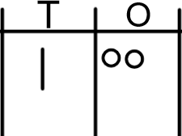 | 10 + 2 = 12  One ten and two ones  twelve

Objective | Concrete  BUILD IT/ USE IT! | Pictorial  DRAW IT! | Abstract  SOLVE IT!
Comparing and ordering 2-digit numbers | 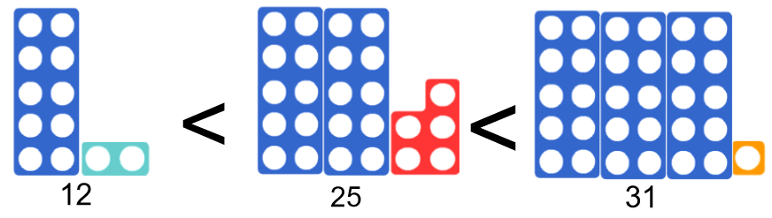  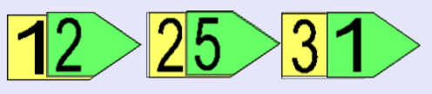  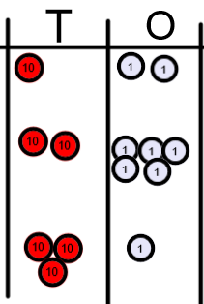 | 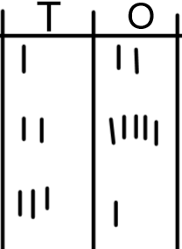 | 12 < 25 < 31  - Compare the tens first, then compare the ones!
Recognising the value of each digit in a 3-digit number | 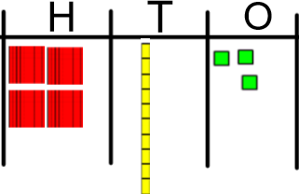  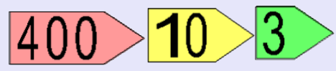 | 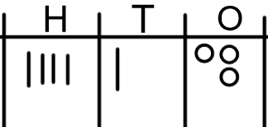 | 400 + 10 + 3  413  Four hundred and thirteen

Objective | Concrete  BUILD IT/ USE IT! | Pictorial  DRAW IT! | Abstract  SOLVE IT!
Ordering and comparing 3-digit numbers | 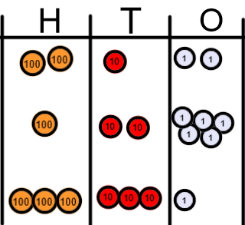  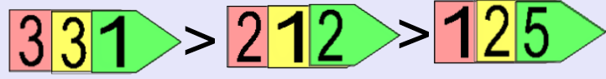 | 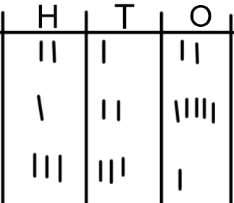 | 331 > 212 > 125  - Compare the value of hundreds  - Compare the value of tens  - Compare the value of ones
Recognise the value of each digit in a 4-digit number | 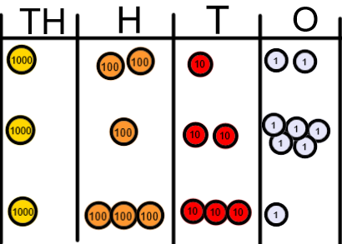 | 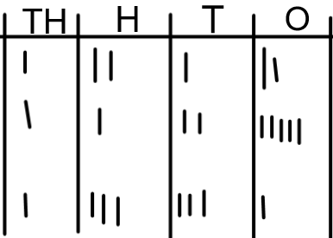 | 1000 + 200 + 10 + 2 = 1,212  1000 + 100 + 20 + 5 = 1,125  1000 + 300 + 30 + 1 = 1,331  One thousand, two hundred and twelve  One thousand, one hundred and twenty-five  One thousand, three hundred and thirty-one

Objective | Concrete  BUILD IT/ USE IT! | Pictorial  DRAW IT! | Abstract  SOLVE IT!
Rounding numbers to the nearest 10 | 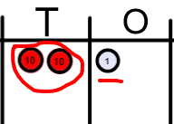  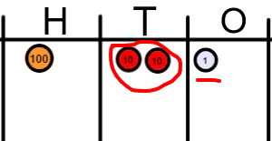 | 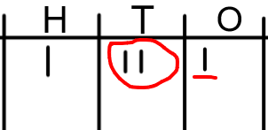 | 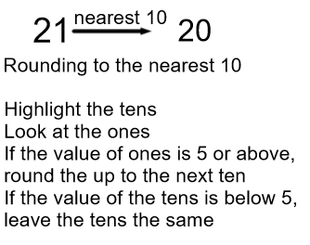    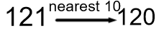
Rounding numbers to the nearest 100 | 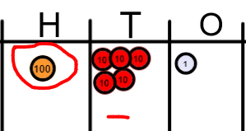  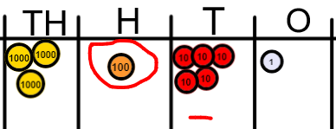 | 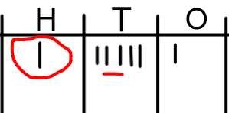  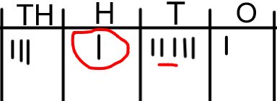 | 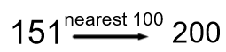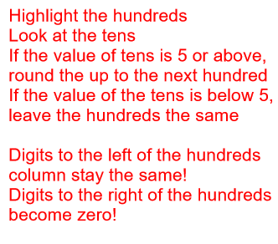  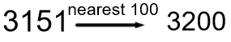

Objective | Concrete  BUILD IT/ USE IT! | Pictorial  DRAW IT! | Abstract  SOLVE IT!
Rounding numbers to the nearest 10 | 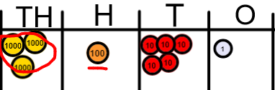  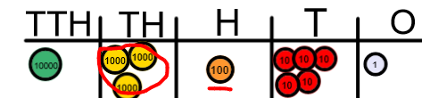 | 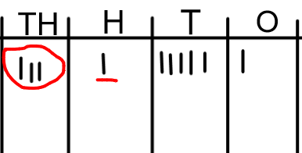  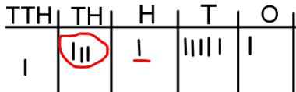 | 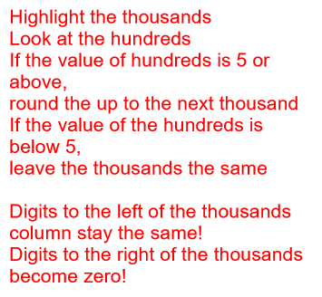  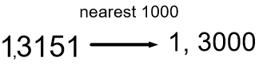  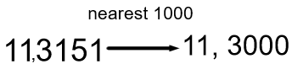
Rounding decimals to the nearest tenth (1 decimal place) | 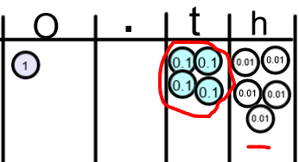 | 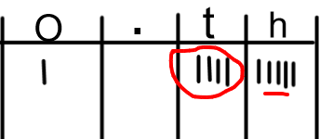 | 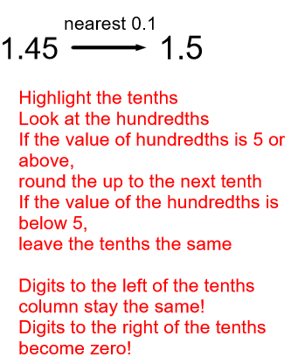

Progression in the teaching of Calculations

 | Year 1 | Year 2 | Year 3 | Year 4 | Year 5 | Year 6
Addition | Combining two parts to make a whole: part, part whole model and bar model  Add one more  Add two ones  Number bonds to 20  Solve problems (Concrete and pictorially) with missing numbers | Fluency in number bonds to 20  Related facts to 100 (e.g. 2 + 8 = 10 therefore 20 + 80 = 100) Part, part whole and bar model  Adding TO + O mentally  Adding TO + O using number line  Counting on  Adding TO + T mentally  Adding TO + T using number line  (concrete, Pictorial, Abstract)  Adding two 2 digit numbers mentally and on a number line  Begin using a column method with no re-grouping/ exchanging (Expanded/ partitioning)  Commutative law  Solve problems with inverse relationship and missing numbers | Add a 3-digit number and ones mentally  Add a 3-digit number and tens mentally  Add a 3-digit number and hundreds mentally  (Partitioning)  Column method for addition without re-grouping/ exchanging  (estimating and checking answers with the inverse)  Column method for addition with re-grouping/ exchanging ones and tens.  Solve problems including missing number problems  (Concrete, Pictorial Abstract) | Add a 4-digit number and ones mentally  Add a 4-digit number and tens mentally  Add a 4-digit number and hundreds mentally  Add a 4-digit number and thousands mentally  Column method with re-grouping/ exchanging  Use inverse operations to check  Solve multi-step problems | Add large numbers mentally  Column method with re-grouping/ exchanging  Column method with decimals (same amount of decimal places)  (Concrete, Pictorial Abstract)  Solve multi-step problems  Use rounding to check answers | Add large numbers mentally  Column method with re-grouping/exchanging.  Column method with decimals (different amounts of decimal places)  (Concrete, Pictorial Abstract)  Solve multi-step problems  Use rounding to check answers

 | Year 1 | Year 2 | Year 3 | Year 4 | Year 5 | Year 6
Subtraction | Take away ones (counting back)  Find the difference  Inverse of addition number bonds  Part, part whole and bar model  Solve problems (concrete and pictorial) including missing numbers. | Develop fluency of number bonds and inverse of addition  Subtract ones from a 2-digit number mentally and counting on, on a number line  Subtract tens from a 2-digit number mentally and on a number line  Subtract two 2-digit numbers mentally and on a number line  (Concrete, Pictorial, Abstract)  Begin the column method (expanded or partitioned) with no re-grouping/ exchanging  Solve problems (Concrete, Pictorial, Abstract) including missing numbers.  Commutative law | Subtract ones from a 3-digit number mentally  Subtract tens from a 3-digit number mentally  Subtract hundreds from a 3-digit number mentally  (Concrete, Pictorial, Abstract)  Column Subtraction without re-grouping/ exchanging  Solve problems (Concrete, Pictorial and abstract) involving missing numbers.  Use the inverse to check answers | Subtract ones from a 4-digit number mentally  Subtract tens from a 4-digit number mentally  Subtract hundreds from a 4-digit number mentally  Subtract thousands from a 4-digit number mentally  (Concrete, Pictorial, Abstract)  Column Subtraction with re-grouping/ exchanging  Use inverse operations to check answers  Solve problems (Concrete, Pictorial and abstract) involving missing numbers. | Subtract large numbers mentally  Column method for subtraction with re-grouping/exchanging  Column method with decimals (Same amount of decimal places)  (Concrete, Pictorial, Abstract)  Solve multi-step problems  Use rounding to check answers. | Subtract large numbers mentally  Column method for subtraction with re-grouping/exchanging  Column method with decimals (different amount of decimal places)  (Concrete, Pictorial, Abstract)  Solve multi-step problems  Use rounding to check answers.

 | Year 1 | Year 2 | Year 3 | Year 4 | Year 5 | Year 6
Multiplication | Doubling (CPA)  Counting in multiples  Arrays (with support)  Use CPA and Arrays with support to solve problems | Doubling (CPA)  Counting in multiples (2,5,10)  Repeated addition  Arrays  Commutative law  Solve problems using arrays and repeated addition | Consolidate counting in 2,5, 10  Counting in multiples (3,4,8)  Repeated addition (CPA)  Arrays(CPA)  Commutative law  Use known number facts and partitioning to multiply 2-digit by 1 digit numbers mentally  Progress to written grid and column method (expanded or partitioned)  Solve problems inc where n objects are connected to m objects (CPA) | Rapid recall of multiplication facts up to 12 x 12  Use known number facts to multiply mentally inc. x 0, x1 and multiplying 3 numbers  Recognise and use factor pairs  Column (or grid) multiplication  2 and 3 digit multiplied by 1 digit) (CPA)  Solve problems inc. distributive law and where n objects are connected to m objects (CPA) | Consolidate rapid recall of facts  Multiply mentally using known facts  Column multiplication (up to 4 digit numbers by 1 or 2-digit numbers)  (CPA)  Multiply decimals using column method  Identify multiples and factors  Identify prime numbers  Solve problems inc factors, multiple, squares and cubes (CPA) | Multiply mentally using known facts  Column method (4-digit by 2- digit numbers)  Solve multi-step problems inc. common factors, common multiples, and prime numbers  (CPA)
Division | Sharing objects into groups (CPA)  Solve one step problems using concrete materials with support | Relate division to multiplication facts (2, 5, 10)  Divide mentally using inverse multiplication facts  Division as grouping  Use arrays (CPA)  Use a number line (CPA)  Solve problems using arrays, repeated addition and mental methods (CPA) | Recall division facts for 3,4,8 times tables  Divide mentally using known facts inc. 2-digit by 1-digit number.  Divide 2-digit by 1-digit numbers using arrays (grouping) (CPA)progressing to the written short division method (CPA)  Solve problems inc. missing numbers and where n objects are connected to m objects. | Rapid recall of division facts for up to 12 x table  Division using known facts mentally  Division with arrays with remainders  Short division up to 3-digit by 1-digit (CPA)  Solve problems inc missing numbers (CPA) | Divide numbers mentally using known facts  Short division up to 4-digit by 1 digit number interpreting remainders appropriately for the context (CPA) | Short division  Long division up to 4-digit by 2-digit numbers interpreting remainders as whole numbers, fractions or round (CPA)  Dividing a decimal by a whole number

Progression in the teaching of Calculations
Add it!
Objective | Concrete  BUILD IT/USE IT! | Pictorial  DRAW IT! | Abstract  SOLVE IT!
Counting objects and adding one | 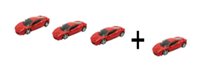  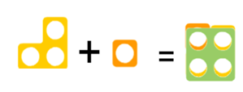 | 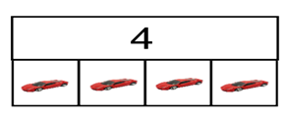 | 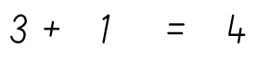
Adding two ones |   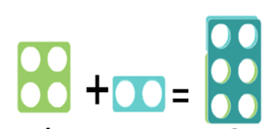 | 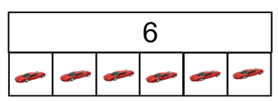 | 
Adding two numbers up to 10  Adding two numbers up to 20 | 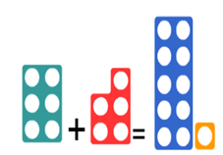 | 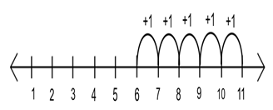  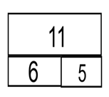 | 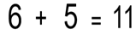

Objective | Concrete  BUILD IT/USE IT! | Pictorial  DRAW IT! | Abstract  SOLVE IT!
Adding tens and ones on a number line |  | 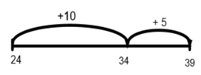  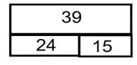 | 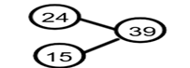  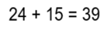
Adding two 2-digit numbers without re-grouping/ exchanging | 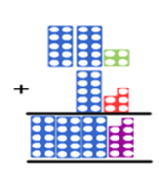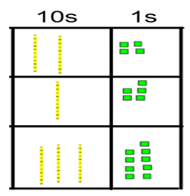 | 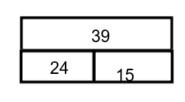 | 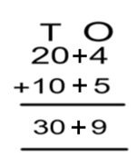
  H | T | O
Partitioning method when crossing ten (not re-grouping or exchanging) | 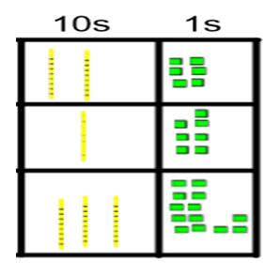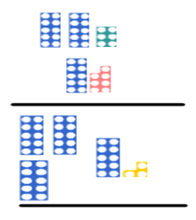 | 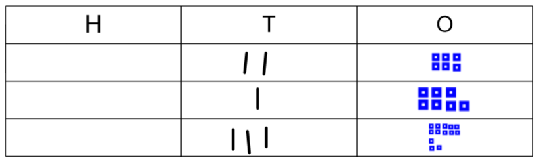 | 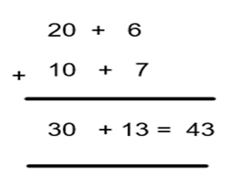

Objective | Concrete  BUILD IT/USE IT! | Pictorial  DRAW IT! | Abstract  SOLVE IT!
Adding using the column method without re-grouping/exchanging | 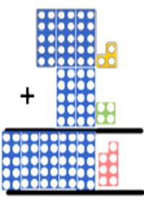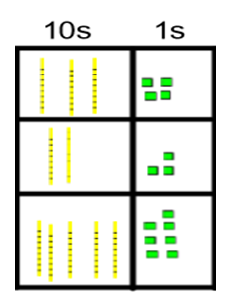 | 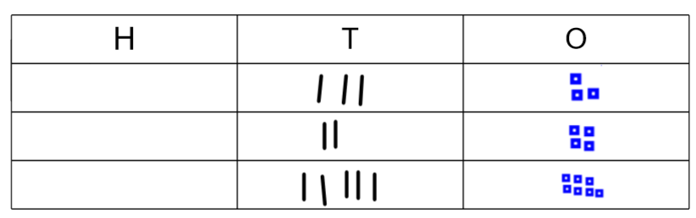  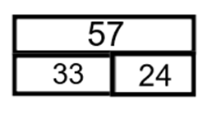 | 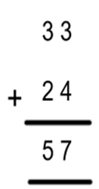
3 digit column method without re-grouping/ exchanging | 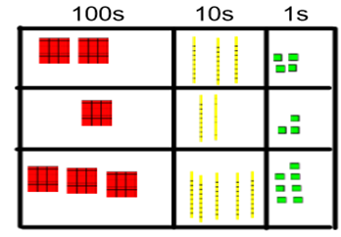 | 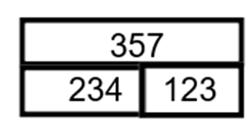  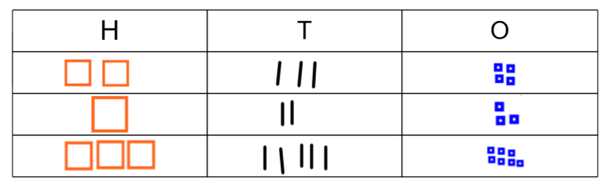 | 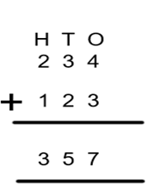

Objective | Concrete  BUILD IT/USE IT! | Pictorial  DRAW IT! | Abstract  SOLVE IT!
Column addition with re-grouping/ exchanging | 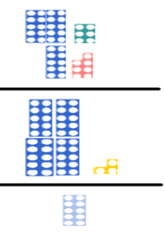  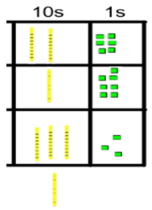  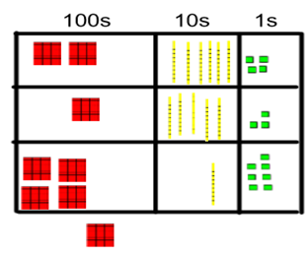 | 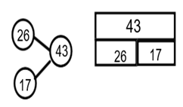  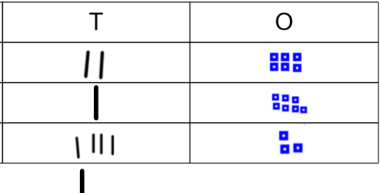  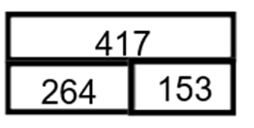 | 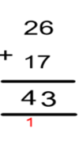  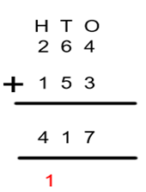
Column addition re-grouping/ exchanging ones and tens together | 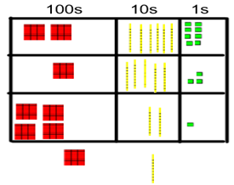 | 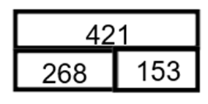 | 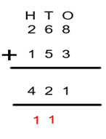

Objective | Concrete  BUILD IT/USE IT! | Pictorial  DRAW IT! | Abstract  SOLVE IT!
Applying the column method to larger numbers and adding decimals | 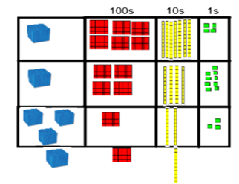  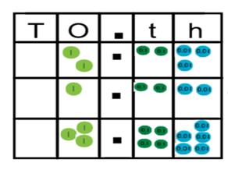 | 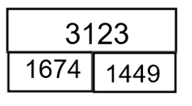 | 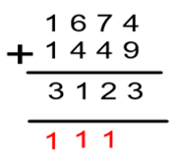  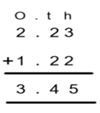

Progression in the teaching of Calculations
SUBTRACT IT!
Objective | Concrete  BUILD IT/ USE IT! | Pictorial  DRAW IT! | Abstract  SOLVE IT!
Taking away ones |   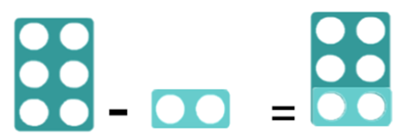 | 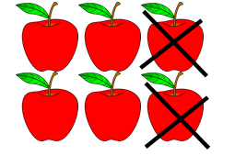  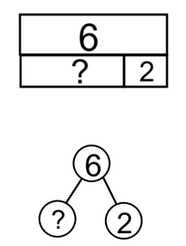 | 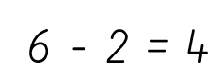
Find the difference between two numbers | 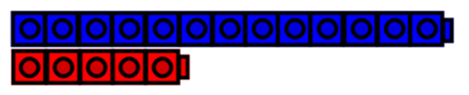 | 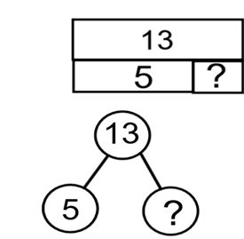  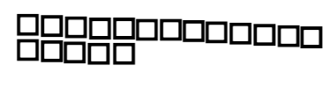 | 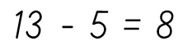

Objective | Concrete  BUILD IT/ USE IT! | Pictorial  DRAW IT! | Abstract  SOLVE IT!
Use a number line to find the difference |  | 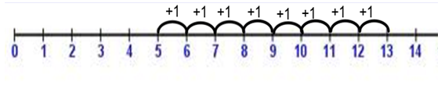
Using number bonds to 10 to make more efficient jumps on a number line | 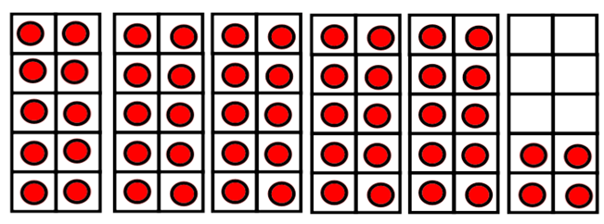 | 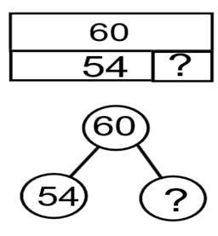  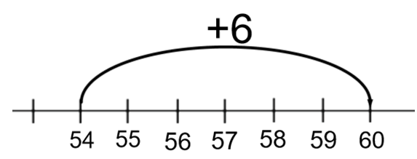 | 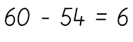
Jumping in tens and ones efficiently on a number line |  | 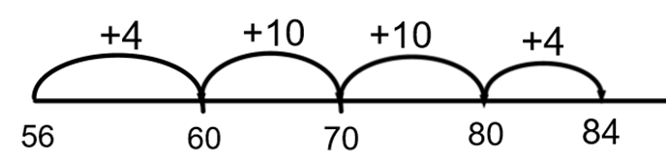  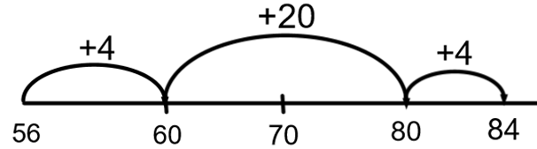 | 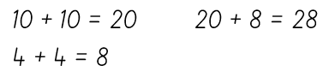  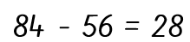

Objective | Concrete  BUILD IT/ USE IT! | Pictorial  DRAW IT! | Abstract  SOLVE IT!
Progressing towards written column method – partitioning and without re-grouping/exchanging | 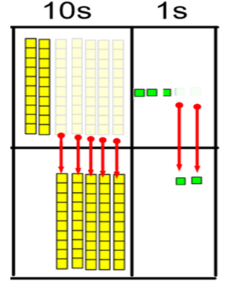 | 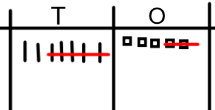 | 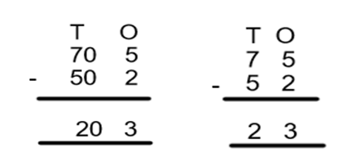
Subtracting using the column method up to 3 digit numbers without exchanging | 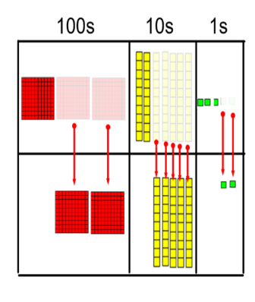 | 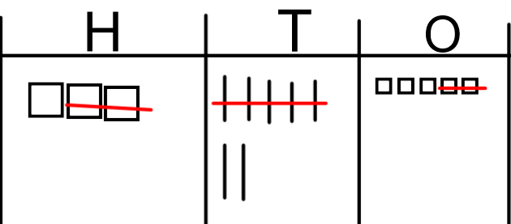 | 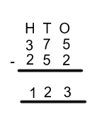

Objective | Concrete  BUILD IT/ USE IT! | Pictorial  DRAW IT! | Abstract  SOLVE IT!
Column method with re-grouping/ exchanging | 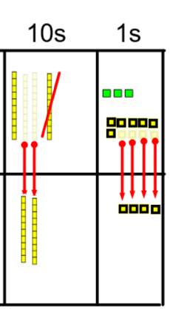 | 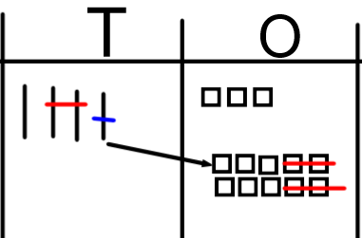 | 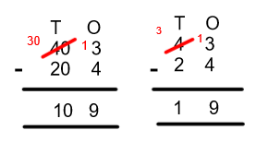
 | 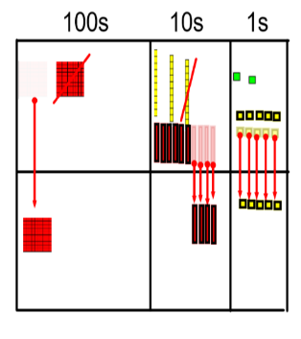 |  | 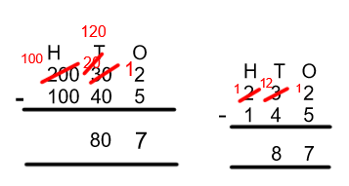
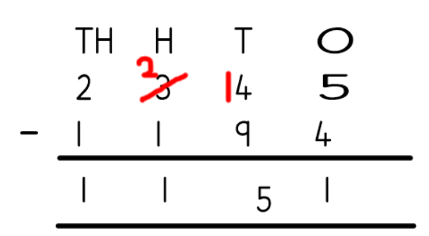
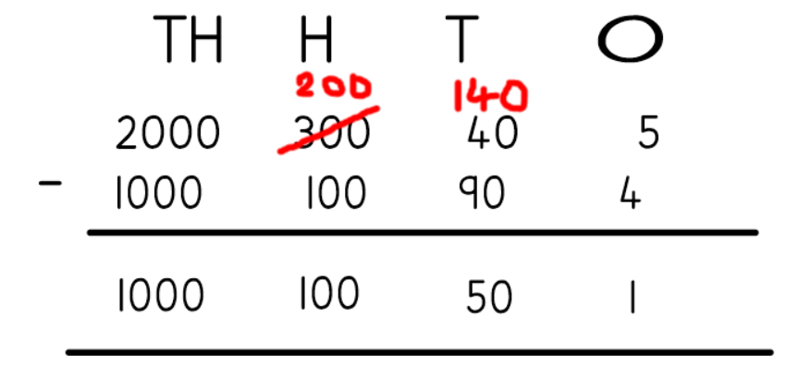

Progression in the teaching of Calculations
MULTIPLY IT!
Objective | Concrete  BUILD IT/USE IT! | Pictorial  DRAW IT! | Abstract  SOLVE IT!
Grouping in 2s,5s and 10s |  | 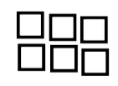 | 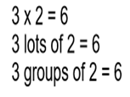
Counting in 2s, 5s and 10s | 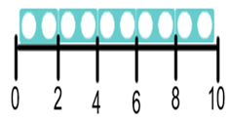  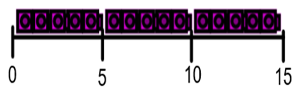 |   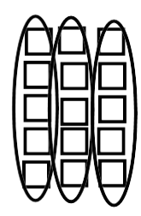 | 0,2, 4, 6, 8, 10…  …10, 8, 6, 4, 2,0  0,5,10,15…  …15,10,5,0

Objective | Concrete  BUILD IT/USE IT! | Pictorial  DRAW IT! | Abstract  SOLVE IT!
Using repeated addition | 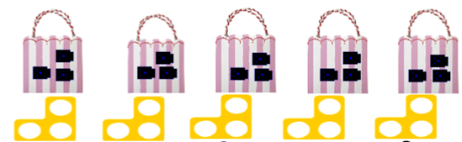 | 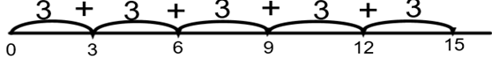  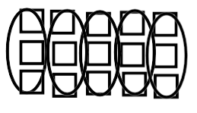 | 5 x 3 = 15
Using arrays and commutative law | 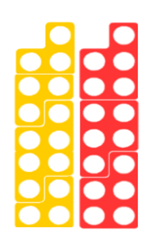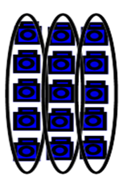  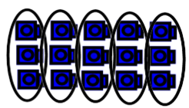 | 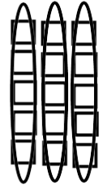  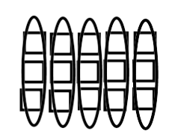 | 3 x 5 = 15  5 x 3 = 15

Objective | Concrete  BUILD IT/USE IT! | Pictorial  DRAW IT! | Abstract  SOLVE IT!
Deriving associated division facts with arrays | 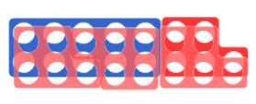    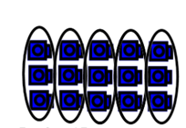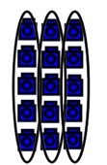 |  | 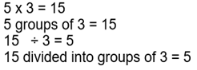  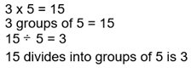
Multiplying by ten | 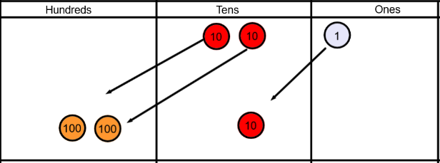 | 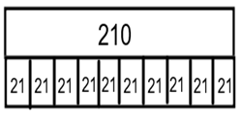  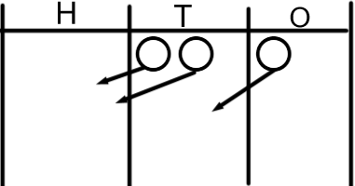 | 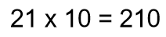

Objective | Concrete  BUILD IT/USE IT! | Pictorial  DRAW IT! | Abstract  SOLVE IT!
Multiplying by 100 | 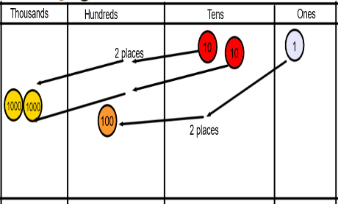 | 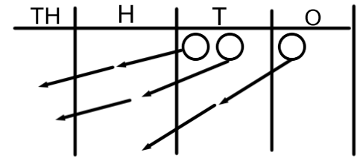 | 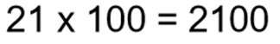
Partitioning and grid method | 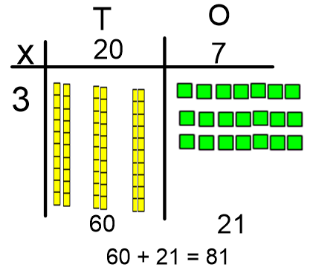 | 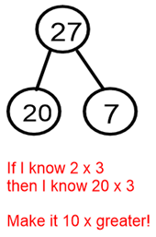  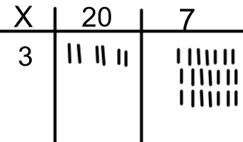 | 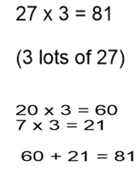

Objective | Concrete  BUILD IT/USE IT! | Pictorial  DRAW IT! | Abstract  SOLVE IT!
Multiplying 2 digit by 2 digit numbers | Use dienes as above | 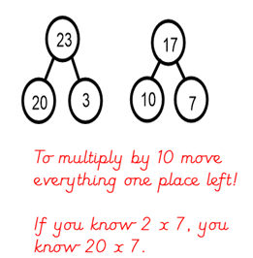  Draw the dienes as above | 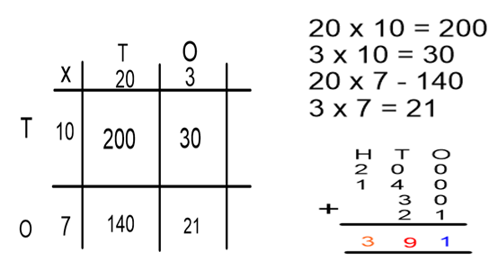
Multiplying 3 digit by 2 digit numbers – grid method |  | 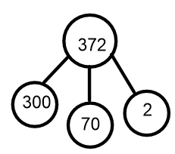  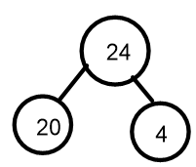 | 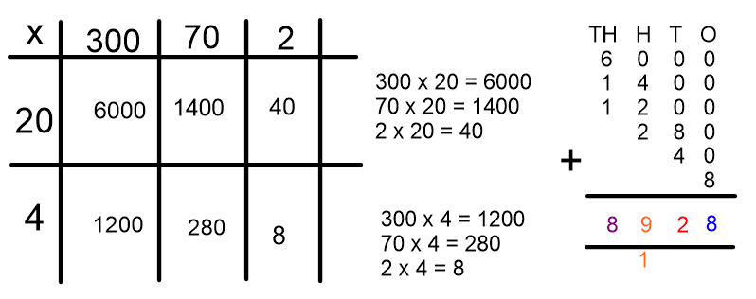

Objective | Concrete  BUILD IT/USE IT! | Pictorial  DRAW IT! | Abstract  SOLVE IT!
Efficient written column method | 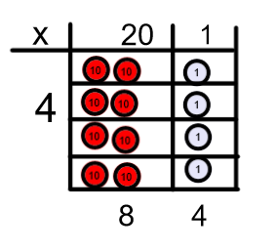 | 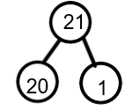  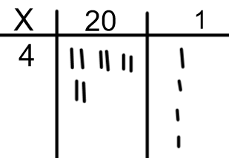 | 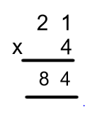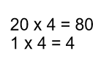
Efficient column method with re-grouping/ exchanging | 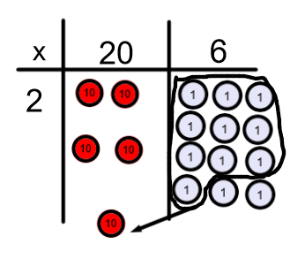  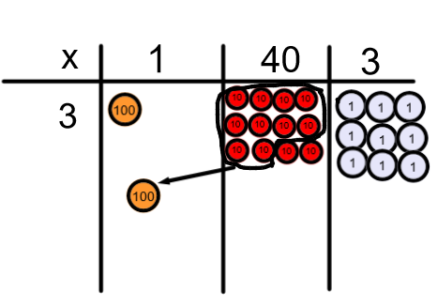 | 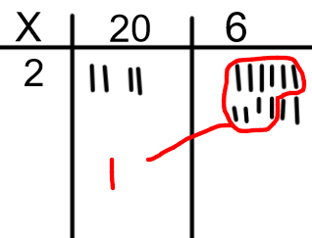  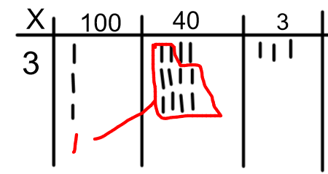 | 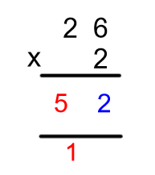  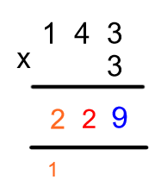

Objective | Concrete  BUILD IT/USE IT! | Pictorial  DRAW IT! | Abstract  SOLVE IT!
Efficient column method 2-digit by 2- digit  or 3 digit by 2 digit | 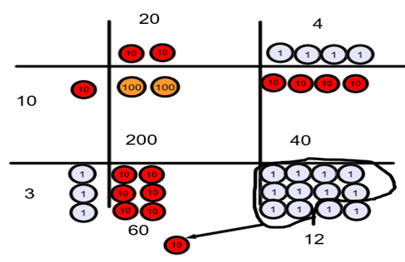 | Draw the dienes/ place value coutners as above | 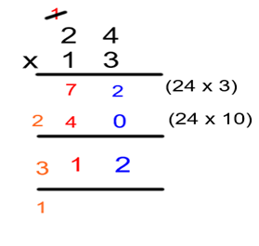
Efficient column method for multiplying decimals |  | 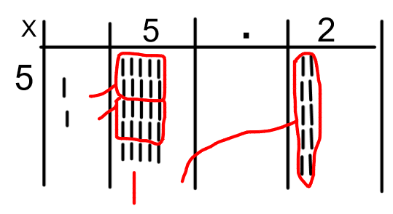 | 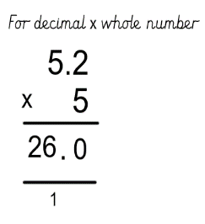  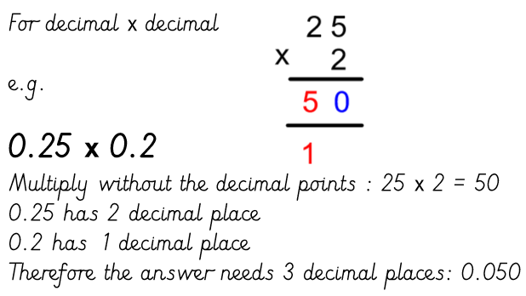

Progression in the teaching of Calculations
Divide it!
Objective | Concrete  BUILD IT/USE IT! | Pictorial  DRAW IT! | Abstract  SOLVE IT!
Sharing objects (2, 5, 10) | 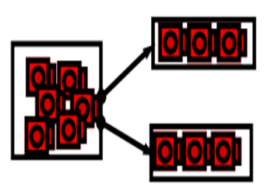 | 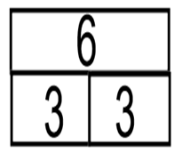   | 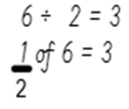
Division as grouping (2,5,10) |   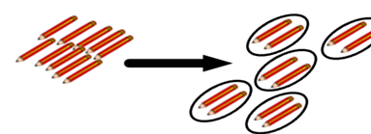 | 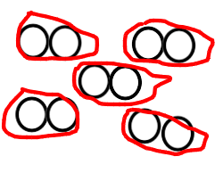  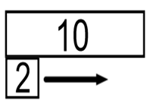 | 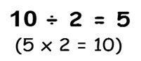

Objective | Concrete  BUILD IT/USE IT! | Pictorial  DRAW IT! | Abstract  SOLVE IT!
Using a number line for grouping | 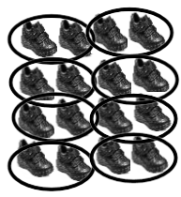 | 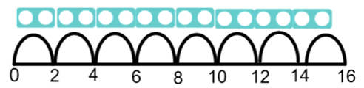  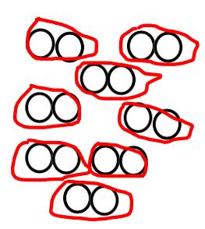 | 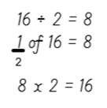
Commutative law with arrays | 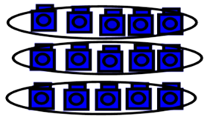 | 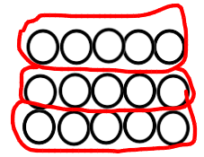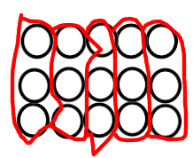 | 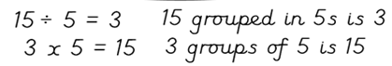  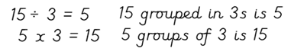
Division with remainders (Sharing) | 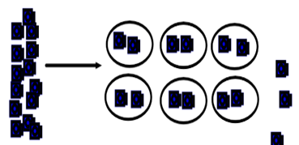 | 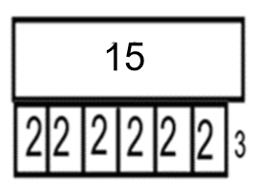  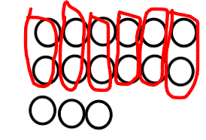 | 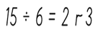

Objective | Concrete  BUILD IT/USE IT! | Pictorial  DRAW IT! | Abstract  SOLVE IT!
Division with remainders (grouping) | 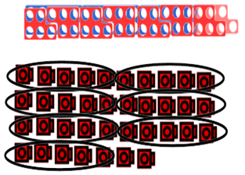 | 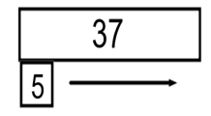  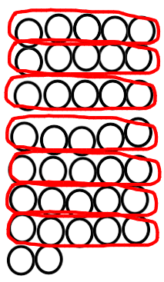 | 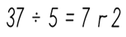
Dividing by 10 | 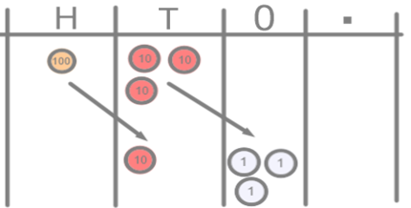 | 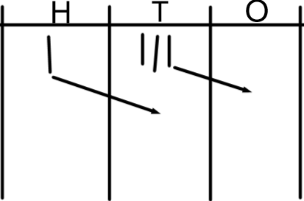 | 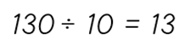
Dividing by 100 | 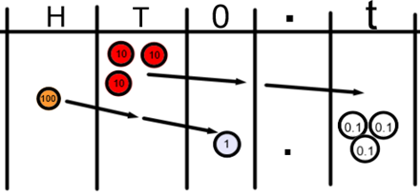 | 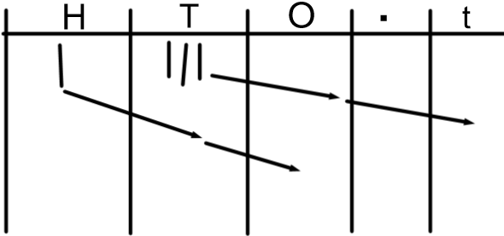 | 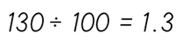

Objective | Concrete  BUILD IT/USE IT! | Pictorial  DRAW IT! | Abstract  SOLVE IT!
Short division (no remainders) | 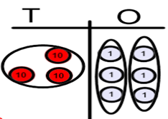   | 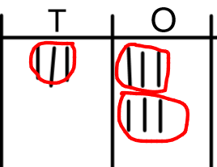 | 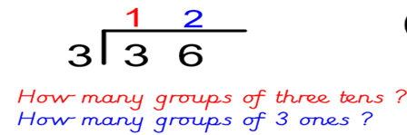
Short division with re-grouping/exchanging | 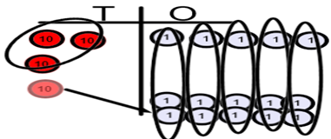 | 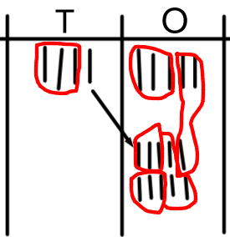 | 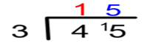  
Short division with re-grouping/exchanging | 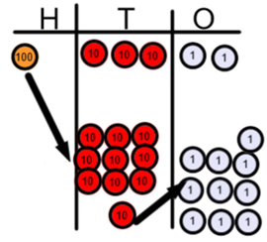 | 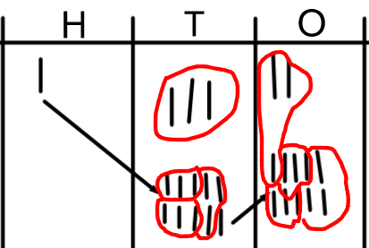 | 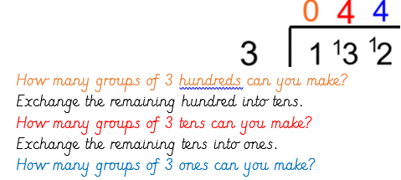

Objective | Concrete  BUILD IT/USE IT! | Pictorial  DRAW IT! | Abstract  SOLVE IT!
Short division with remainders | 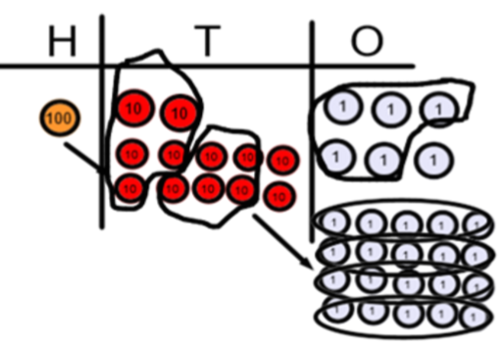 | 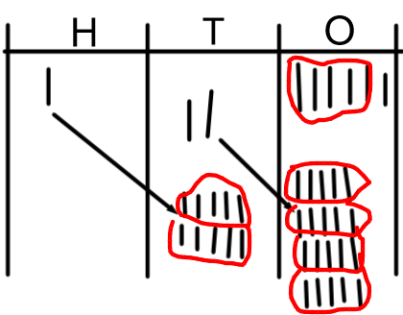 | 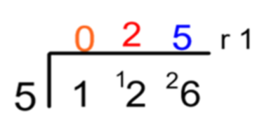  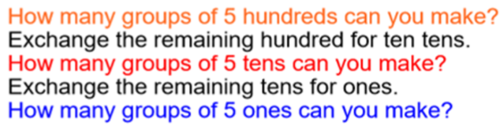
Long division (y6) | 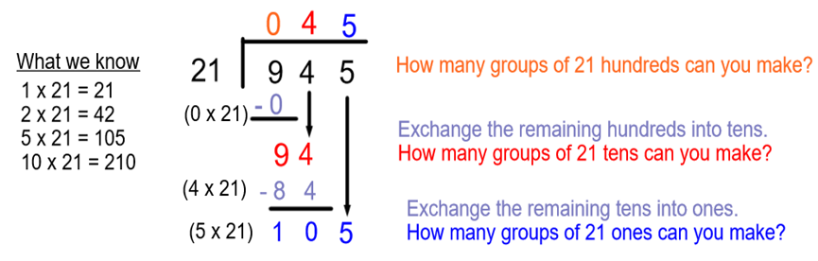

Objective | Concrete  BUILD IT/USE IT! | Pictorial  DRAW IT! | Abstract  SOLVE IT!
Dividing decimals | 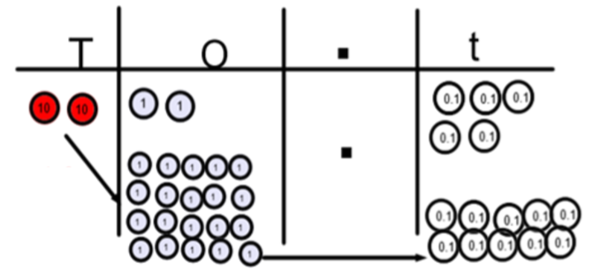 |  | 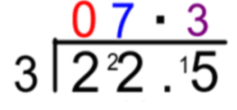  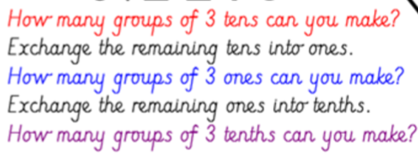
Expressing remainders as fractions |  | 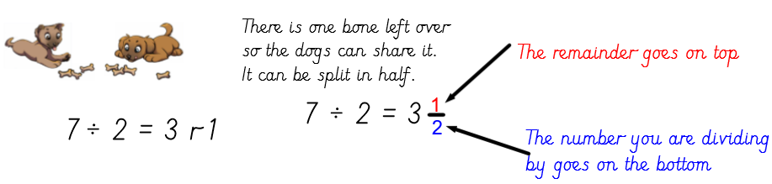

Progression in teaching Fractions

Objective | Concrete  BUILD IT/ USE IT! | Pictorial  DRAW IT! | Abstract  SOLVE IT!
Finding half of a shape | 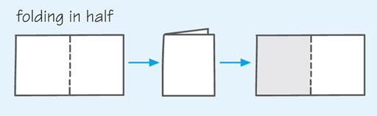 | 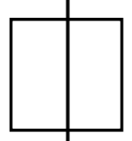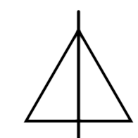 | 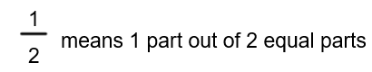
Finding a quarter of a shape | 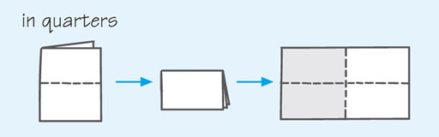 | 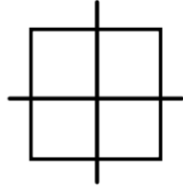 | 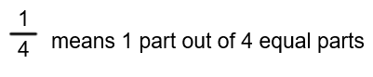
Finding half by grouping in 2s (not sharing into 2 groups)  Knowing half of even numbers to 20 |   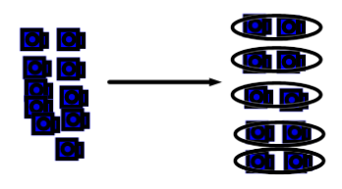 | 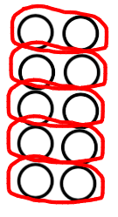  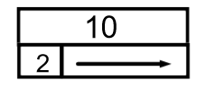 | 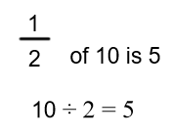

Objective | Concrete  BUILD IT/ USE IT! | Pictorial  DRAW IT! | Abstract  SOLVE IT!
Finding a quarter by grouping in 4s (not sharing into 4 groups) |  | 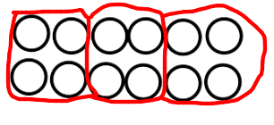  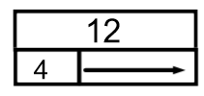 | 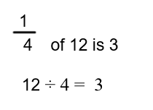
Using multiplication and division facts to find fractions of a number | 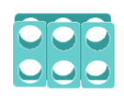 | 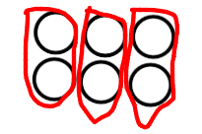  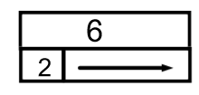 | 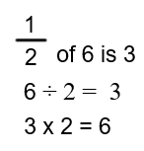
Finding other fractions of shapes |  |  | 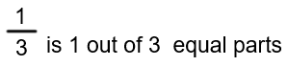

Objective | Concrete  BUILD IT/ USE IT! | Pictorial  DRAW IT! | Abstract  SOLVE IT!
Finding non-unit fractions of a number using sharing (understanding numerator and denominator) |  | 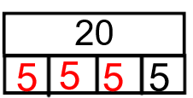  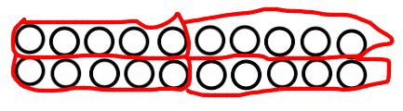 | 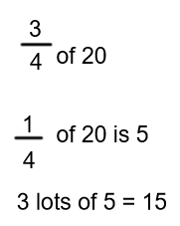
Use known number facts to find unit and non-unit fractions of amounts |  |  | 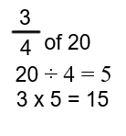

Objective | Concrete  BUILD IT/ USE IT! | Pictorial  DRAW IT! | Abstract  SOLVE IT!
Recognise simple equivalent fractions | 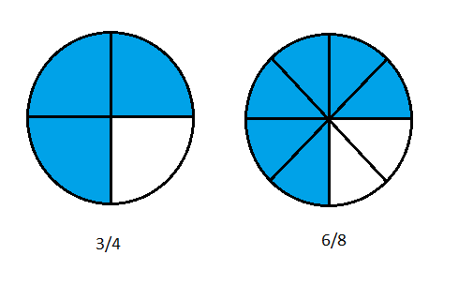  (Fraction pieces) | 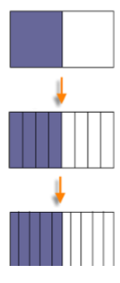  (Bar model) | 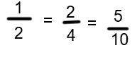
Compare and order fractions with the same denominator | 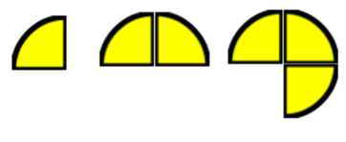  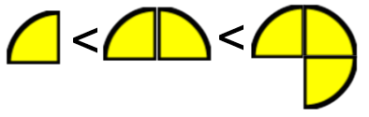 |   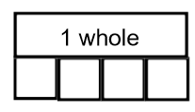 | 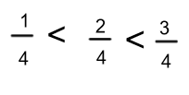

Objective | Concrete  BUILD IT/ USE IT! | Pictorial  DRAW IT! | Abstract  SOLVE IT!
Compare and order unit fractions |  | 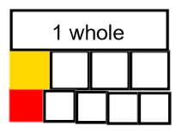 | 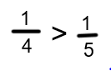
Recognising decimal equivalence for fractions – tenth and hundredths | 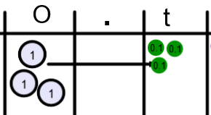 | 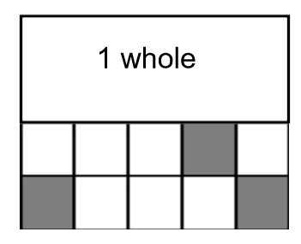  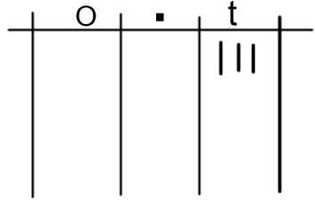  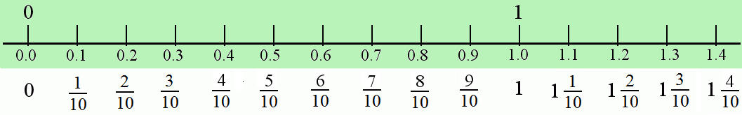 | 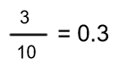

Objective | Concrete  BUILD IT/ USE IT! | Pictorial  DRAW IT! | Abstract  SOLVE IT!
Recognise decimal equivalence for fractions – half, quarter, three quarters, one fifth | 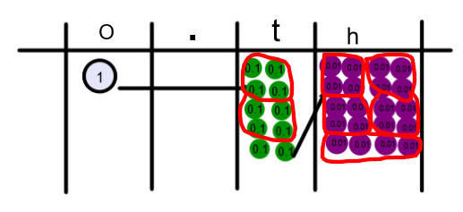 | 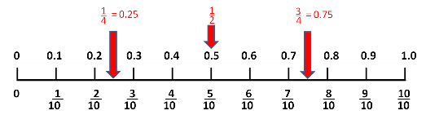  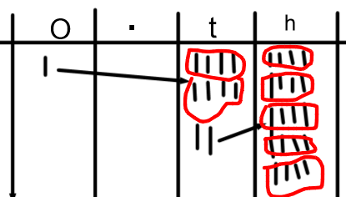 | 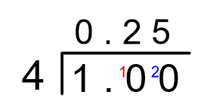  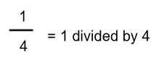  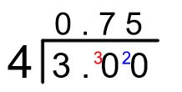  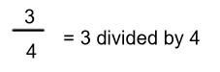
Adding fractions with the same denominator |  | 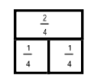   | 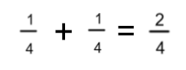

Objective | Concrete  BUILD IT/ USE IT! | Pictorial  DRAW IT! | Abstract  SOLVE IT!
Adding fractions with different denominators |  | 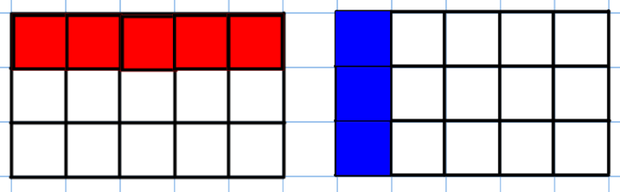  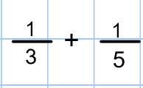 | 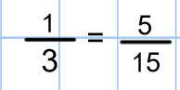  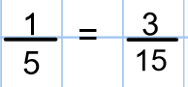  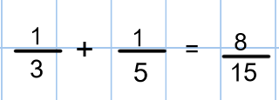
Subtracting fractions with the same denominator |  | 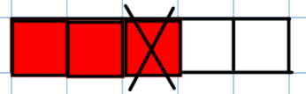 | 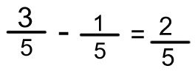

Objective | Concrete  BUILD IT/ USE IT! | Pictorial  DRAW IT! | Abstract  SOLVE IT!
Subtracting fractions with different denominators |  | 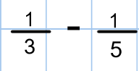  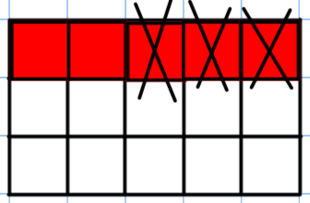 | 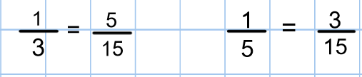  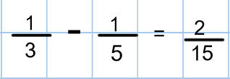
Multiplying fractions |  | 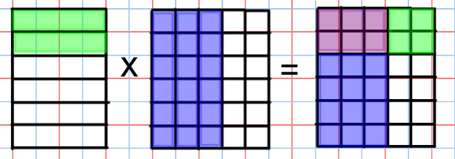 | 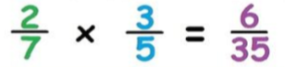  Multiply the numerators and multiply the denominators!

Objective | Concrete  BUILD IT/ USE IT! | Pictorial  DRAW IT! | Abstract  SOLVE IT!
Dividing fractions by a whole number |  | 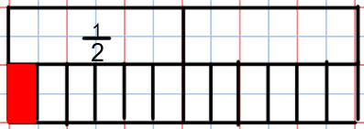  Draw the first fraction as a bar model.  Divide all parts of the bar model into equal parts determined by the whole number.  Determine your answer by determining the size of each piece. | 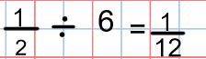  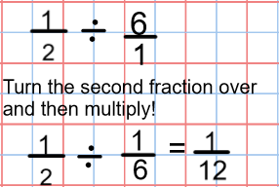
Dividing a fraction by a fraction |  | 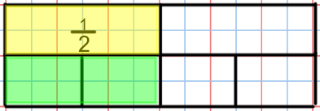  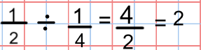  Draw the first fraction in a bar model.  Divide the whole bar into equal parts determined by the second fraction.  How many of the second fraction parts are equal to the first fraction? | 