

Engage Academy

DESIGN AND TECHNOLOGY

2025

THE CURRICULUM INTENT AND SEQUENCE

1 | THE INTENT OF THE CURRICULUM
 | At Engage Academy we intend to build a Design Technology curriculum which is inspiring, rigorous, and practical. We want our children to use creativity and imagination, to design and make products that solve real and relevant problems within a variety of contexts, considering their own and others’ needs, wants and values. We intend for all children to acquire appropriate subject knowledge, skills and understanding as set out in the National Curriculum but split into bronze silver and gold across a 2 year cycle. Pupils are taught at a level appropriate for their ability and need. It is our aim to create strong cross curricular links with other subjects, such as Mathematics, Science, Computing, and Art. We want Design and Technology to prepare our children, to give them the opportunities, responsibilities, and experiences they need to be successful in later life.
2 | THE IMPLEMENTATION OF THE CURRICULUM
Our bespoke Design and Technology curriculum is designed by identifying the key skills, knowledge and understanding required by the National Curriculum, which is then planned to ensure that the skills are taught sequentially across the key stages and that new skills build on and develop the skills taught in previous year groups. At Engage, Design and Technology is planned in learning blocks within each termly topic, so that skills can be learnt and developed to a deeper level over a sustained period of study. The children are given opportunities to evaluate their own designs and products based on a clear set of criteria. All children are given the opportunity to engage in a wide range of D&T activities which actively encourage them to embrace the subject and develop a lifelong set of skills. Design and Technology is a practical subject in which children play with and explore a wide range of products and designs often through outdoor learning. They use knowledge from this exploration to create their own designs and they then use a wide range of materials and tools to build their own products. Each of the topics are designed to be relevant, motivating and engaging for the children and inclusive of all groups of children and individuals across the school. Opportunities for evaluation throughout the topic enables children to look deeper into their learning and reflect on what they have designed and made and whether it has successfully met their own design criteria.
Pupils access weekly cooking and nutrition lessons to promote life skills and their physical health and well-being.

3 | THE IMPACT OF THE CURRICULUM
 | Our Design and Technology curriculum enables and encourages our children to become critical thinkers. They look at existing designs to analyse and assess its effectiveness and then they consider ways of redesigning and reconstructing it to improve its overall success. Through DT our children learn to take risks, become resourceful, innovative and enterprising individuals. Children learn to be passionate and excited by the designing and making of products including working with, preparing and tasting food. Learning is assessed through the analysis of the pupil’s ability to evaluate, design, make and improve their own work.
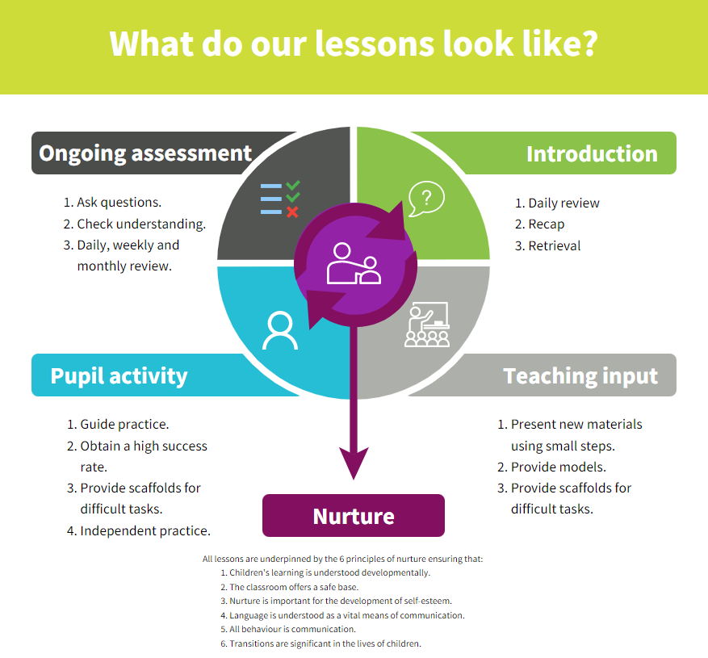
Strategies | What do we expect to see in lessons?
Daily review | Lessons begin with a recap of previously linked learning, retrieval practice or through breakfast assembly discussion.
Present new materials using small steps | New learning is build in small steps at an appropriate level, achievable and repeatable steps to build confidence, competence and retention.
Provide models | Questions are asked to check understanding. A range of questions are asked to challenge children.
Provide scaffolds for difficult tasks | The teacher models the skills first.
Guided practice | Children are given the opportunity to discuss and build on ideas with support.
Obtain a high success rate | Skills are constantly revisited and revised over time to ensure that children achieve age expected skills.
Provide scaffolds for difficult tasks | Teacher provides temporary supports and scaffolds to assist in challenging tasks. Support reduced as children become more confident.
Independent practice | Children have the opportunity to practice regular and independently to transfer the knowledge into their long term memory.
Weekly and monthly review | Constant review through discussion and ongoing assessment, retrieval practice and breakfast assembly as well as in discrete lessons.

SKILLS PROGRESSION
Gold | Design  To use research and develop design criteria to inform the design of innovative, functional, appealing products that are fit for purpose, aimed at particular individuals or groups.  To generate, develop, model and communicate their ideas through discussion, annotated sketches, cross-sectional and exploded diagrams, prototypes, pattern pieces and computer-aided design.  Create a design criteria | Make  Confidently select appropriate tools, materials, components and techniques and use them. Use tools safely and accurately.  Assemble components to make working models.  Aim to make and to achieve a quality product.  Demonstrate when make modifications as they go along.  Construct products using permanent joining techniques.  Know how more complex electrical circuits and components can be used to create functional products and how to program a computer to monitor changes in the environment and control their products.  Know how to reinforce and strengthen a 3D framework.  Understand that mechanical and electrical systems have an input, process and output.  Use finishing techniques to strengthen and improve the appearance of their product using a range of equipment including ICT. | Evaluate  To investigate and analyse a range of existing products.  To evaluate their ideas and products against their own design criteria and consider the views of others to improve their work.  To understand how key events and individuals in design and technology have helped shape the world (Year 6).
Silver | Design  To use research to design products that are fit for a purpose, aimed at particular individuals or groups.  To generate, develop, and communicate their ideas through discussion, annotated sketches and information and communication technology.  Create a design criteria | Make  Select a wider range of tools and techniques for making their product safely.  Select from and use a wider range of materials and components, including construction materials, textiles and ingredients, according to their characteristics.  Know how to measure, mark out, cut and shape a range of materials, using appropriate tools, equipment and techniques.  Start to join and combine materials and components accurately in temporary and permanent ways  Begin to use finishing techniques to strengthen and improve the appearance of their product using a range of equipment including ICT.  . | Evaluate  To investigate a range of existing products.  To evaluate their ideas and products against the design criteria and consider the views of others to improve their work.
BRONZE | Design  To design purposeful, functional and appealing products for themselves (Year 1) and others (Year 2) based on design criteria.  To generate, develop and communicate their ideas through talking, drawing, templates, mock-ups and, where appropriate, information and communication technology. | Make  Begin to select tools and materials; use correct vocabulary to name and describe them eg scissors, hole punch, needle  With help measure, cut and score with some accuracy. Learn to use hand tools safely and appropriately.  Start to assemble, join and combine materials in order to make a product.  Start to choose and use appropriate finishing techniques based on own ideas.  Select from and use a wide range of materials and components, including constructions materials, textiles (Year 2) and ingredients (Year 1), according to their characteristics. | Evaluate  To explore (Year 1) and evaluate (Year 2) a range of existing products.  To evaluate their ideas and products (Year 1) against design criteria (Year 2).
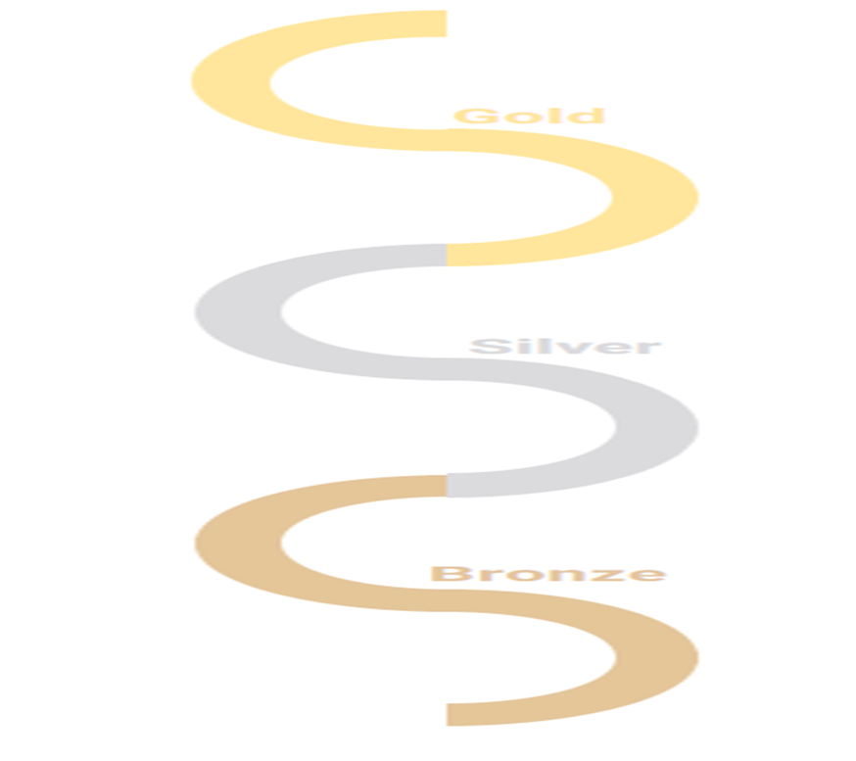
IL
SKILLS PROGRESSION – Key skills and context
Gold | To apply their understanding of how to strengthen, stiffen and reinforce more complex structures (Year 5). | To understand and use mechanical systems in their products (gears, pulleys, cams, levers and linkages) (Year 5).  Understand how mechanical systems such as cams or pulleys or gears create movement. | To understand and use electrical systems in their products (series circuits incorporating switches, bulbs, buzzers and motors) (Year 6).  To apply their understanding of computing to programme, monitor and control their products (Year 6). | To explore and produce a textile based product.  With confidence pin, sew and stitch materials together to create a product. | Cooking and Nutrition  Know that food is grown (such as tomatoes, wheat and potatoes), reared (such as pigs, chickens and cattle) and caught (such as fish) in the UK, Europe and the wider world.  Understand that seasons may affect the food available. Understand how food is processed into ingredients that can be eaten or used in cooking.  Know how to prepare and cook a  variety of predominantly savoury dishes safely and hygienically including, where appropriate, the use of a heat source.  Understand how to use a range of techniques such as peeling, chopping, slicing, grating,  mixing, spreading, kneading and baking.  Know different food and drink contain different substances – nutrients, water and fibre – that are needed for health.
Silver | To develop their understanding of how to strengthen, stiffen and reinforce structures.  Understand how to reinforce and strengthen a 3D framework | To explore and use mechanical systems in their products (gears, pulleys, cams, levers and linkages) (Year 3).  Know how mechanical systems such as cams or pulleys or gears create movement. | To explore and use electrical systems in their products (series circuits incorporating switches, bulbs, and buzzers) (Year 4).  Understand how more complex electrical circuits and components can be used to create functional products. | To explore and produce a textile based product.  Sew using a range of different stitches, to weave and knit.  Demonstrate how to measure, tape or pin, cut and join fabric with some accuracy. | Cooking and Nutrition  Understand that food is grown (such as tomatoes, wheat and potatoes), reared (such as pigs, chickens and cattle) and caught (such as fish) in the UK, Europe and the wider world.  Understand how to prepare and cook a  variety of predominantly savoury dishes safely and hygienically including, where appropriate, the use of a heat source.  Know how to use a range of techniques such as peeling, chopping, slicing, grating, mixing, spreading, kneading and baking.  Know that a healthy diet is made up from a variety and balance of different food and drink, as depicted in ‘The Eat well plate’  Know that to be active and healthy, food and drink are needed to provide energy for the body.
BRONZE | To build structures, exploring how they can be made stronger, stiffer and more stable (Year 1). | To explore and use mechanisms (levers, sliders, wheels and axles) in their products (Year 2). |  | To explore and produce a textile based product.  Demonstrate how to cut, shape and join fabric to make a simple product. Use basic sewing techniques. | Cooking and Nutrition  Understand that all food comes from plants or animals.  Know that food has to be farmed, grown elsewhere (e.g. home) or caught.  Understand how to name and sort foods into the five groups in ‘The Eat well plate’  Know that everyone should eat at least five portions of fruit and vegetables every day.  Demonstrate how to use techniques such as cutting, peeling and grating.  Demonstrate how to prepare simple dishes safely and hygienically, without using a heat source.

Curriculum overview

 | Bronze |  | Silver |  | Gold
 | Year 1 of 2 | Year 2 of 2 | Year 1 of 2 | Year 2 of 2 | Year 1 of 2 | Year 2 of 2
Aut 1 | Cooking and nutrition | Cooking and nutrition | Cooking and nutrition | Cooking and nutrition | Cooking and nutrition  Electrical systems | Cooking and nutrition
Aut 2 | Moving pictures  Cooking and nutrition | Cooking and nutrition | Cooking and nutrition  Electrical systems | Cooking and nutrition | Cooking and nutrition | Cooking and nutrition  Textiles
Spr 1 | Explore and use mechanisms  Cooking and nutrition | Designing and making structures  Cooking and nutrition | Cooking and nutrition  Structures | Cooking and nutrition | Cooking and nutrition | Cooking and nutrition
Spr 2 | Cooking and nutrition | Basic sewing techniques.  Cooking and nutrition | Cooking and nutrition | Textiles  Cooking and nutrition | Cooking and nutrition | Cooking and nutrition  Mechanical systems
Sum 1 | Cooking and nutrition | Designing and making.  Cooking and nutrition | Cooking and nutrition | Cooking and nutrition | Cooking and nutrition  Structures | Cooking and nutrition
Sum 2 | Cooking and nutrition | Cooking and nutrition | Cooking and nutrition | Mechanical systems  Cooking and nutrition | Cooking and nutrition | Cooking and nutrition

