

Engage Academy

GEOGRAPHY

2025

THE CURRICULUM INTENT AND SEQUENCE

1 | THE INTENT OF THE CURRICULUM
 | At Engage Academy, we have designed our Geography curriculum with the intent that it will inspire a sense of curiosity and appreciation of the world around them. It will equip them with a diverse knowledge and understanding of people, places, natural, human and physical geography. The curriculum progression expands from local to Engage and the surrounding local authority that pupils live to global but with comparison and contrast at each step. The curriculum will engage children with a heavy emphasis on outdoor learning where possible to bring learning to life. It will inspire them to become inquisitive learners and active global citizens with the confidence to use, and build on their cultural capital, learning and experiences.

2 | THE IMPLEMENTATION OF THE CURRICULUM
 | In order to foster children’s curiosity about the world, interest and creativity, we are enthusiastic about Geography and encourage children to explore and ask questions. At Engage Academy, Geography is taught through a topic based curriculum. We intend for all children to acquire appropriate subject knowledge, skills and understanding as set out in the National Curriculum but split into bronze silver and gold across a 2 year cycle. Pupils are taught at a level appropriate for their ability and need. Each year has a long-term plan with two to three Geography topics. Geography will be linked into some History topics, where appropriate, to develop children’s knowledge and understanding. It will also ensure all areas of the curriculum are covered in depth. Teachers are encouraged to consider opportunities available to use the school grounds and the local area for fieldwork to enable children to base learning on first hand experiences to enhance teaching and learning in Geography.

3 | THE IMPACT OF THE CURRICULUM
 | Children will have developed the geographical knowledge and skills to help them explore, navigate and understand the world around them and their place in it. Children’s knowledge and skills will develop progressively from their starting points, not only to enable them to meet the requirements of the National Curriculum but to prepare them to become competent geographers in their next step in education.

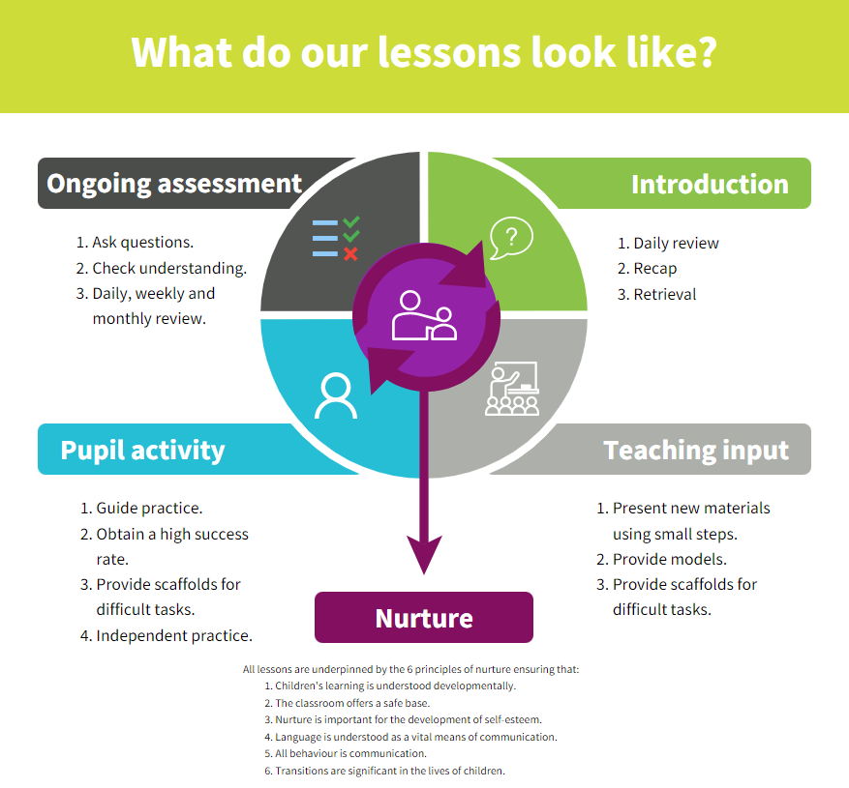
Strategies | What do we expect to see in lessons?
Daily review | Lessons begin with a recap of previously linked learning and retrieval practice.
Present new materials using small steps | New learning is built in small steps at an appropriate level, achievable and repeatable steps to build confidence, competence and retention.
Provide models | Questions are asked to check understanding. A range of questions are asked to challenge children.
Provide scaffolds for difficult tasks | The teacher models the skills first.
Guided practice | Children are given the opportunity to discuss and build on ideas with support.
Obtain a high success rate | Skills are revisited and revised over time to ensure that children achieve age expected skills.
Provide scaffolds for difficult tasks | Teacher provides temporary supports and scaffolds to assist in challenging tasks. Support reduced as children become more confident.
Independent practice | Children have the opportunity to practice regular and independently to transfer the knowledge into their long term memory.
Weekly and monthly review | Constant review through discussion and ongoing assessment.

SKILLS AND KNWOELDGE PROGRESSION
Gold | To use maps, atlases, globes, digital mapping to locate countries studied
Gold | Block 1 | Block 2 | Block 3 | Block 4
Gold | To name and locate counties and cities in UK, geographical regions and some topographical features (hills, mountains, coasts, rivers) as well as land use patterns and understand how these have changed over time. (Y5)  Use different types of fieldwork sampling (random and systematic) to observe, measure and record the human and physical features in the local area. Record the results in a range of ways. | To locate the worlds countries including Russia, North and South America concentrating on environmental regions, key physical and human characteristics, and major cities.  To identify position and significance of latitude, longitude, Artic and Antarctic Circle, The Prime/Greenwich Meridian and time zones (Y6)  To describe and understand key aspects of physical geography: biomes and vegetation belts, volcanoes and earthquakes, the water cycle | To understand geographical similarities and differences through a study of a region of UK with a region of a European Country and a region within North or South America.  To describe and understand key aspects of human geography: trade links, distribution of natural resources (energy, food, minerals, water) | To use 8 points of a compass and 8 figure grid references  To use symbols and key on OS maps to build knowledge of UK and wider world  Create maps of locations identifying patterns (such as: land use, climate zones, population densities, height of land).
Silver | To use maps, atlases, globes, digital mapping to locate countries studied
Silver | Block 1 | Block 2 | Block 3 | Block 4
Silver | To name and locate counties and cities in UK, geographical regions and some topographical features (hills, mountains, coasts, rivers) (Y4)  To use fieldwork to observe measure and record human and physical features in the local area | To locate the worlds countries, focussing on Europe, concentrating on environmental regions, key physical and human characteristics, and major cities.  To identify position of Equator, Northern Hemisphere, Southern Hemisphere, the tropics of Cancer and Capricorn (Y3)  To describe and understand key aspects of physical geography: climate zones, rivers, mountains | To understand geographical similarities and differences through a study of a region of UK with a region of a European Country  To describe and understand key aspects of human geography: types of settlement and landuse. | To use 8 points of a compass and 4 figure grid references  To use simple symbols and key on OS maps  To create maps using symbols and keys of the local area
BRONZE | To use world maps, atlases and globes to identify UK and its countries as well as any other countries studied.  To understand seasonal and daily weather patterns in UK
BRONZE | Block 1 | Block 2 | Block 3 | Block 4
BRONZE | To name and identify characteristics of the four countries and capital cities of the UK and its surrounding areas.  To study the key features of the schools surrounding environment  To use simple fieldwork and observational skills to study the geography of the school and its grounds | To name and locate the seven continents and five oceans  To understand location of hot and cold areas of the world in relation to the Equator and North and South poles | To understand geographical similarities and differences through studying the human and physical geography of a small area of the UK and a small area of a contrasting non European country. (Y1)  To use basic geographical vocabulary  referring to key physical and human features including beach, cliff, coast, forest, hill, mountain, sea, ocean, river, soil, valley, vegetation, season and weather. Human: city, town, village, factory, farm, house, office, port, harbour and shop. | 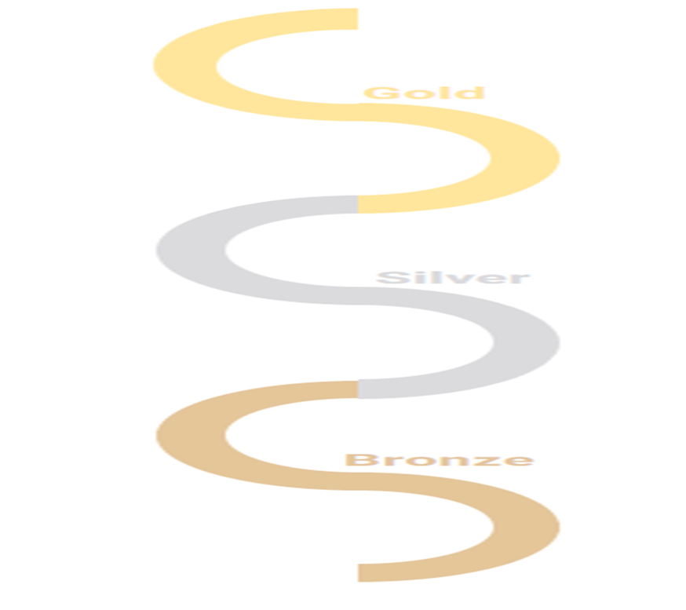  To name and identify characteristics of the four countries and capital cities of the UK and its surrounding areas.  To study the key features of the schools surrounding environment  To use simple fieldwork and observational skills to study the geography of the school and its grounds

Green highlighted objectives to be taught or consolidated through the forest schools curriculum

Curriculum overview

 | Bronze |  | Silver |  | Gold
 | Year 1 of 2 | Year 2 of 2 | Year 1 of 2 | Year 2 of 2 | Year 1 of 2 | Year 2 of 2
Block 1, 2 and 3 covered through theme days each half term linked to different countries
All objectives highlighted in green on the skills progression are revisited in forest schools across the year
Aut 1 | Our School  Our Area | Maps and Atlas Skills | UK – Cities, Counties, rivers, countries  Maps and Atlas Skills | Somewhere Settle – How cities and towns have grown  Map Skills | Geographical Resources such as food, electric  How do countries differ | Trading Nations including Fair Trade  Map Skills – Trading Routes
Aut 2
Spr 1 | Weather | Weather – UK and Beyond | Extreme Earth – Volcanoes, Earth Quakes | Weather Around the World (Climates and Changes) | Mountains Ranges– Climates, Ranges, how are they made | Weather, Erosion and Flooding
Spr 2
Sum 1 | Tour Guide To  UK (Our Country) | Tour Guide To  Australia | Tour Guide to  Europe (Italy) | Tour Guide to  South America – Rainforests | Tour Guide to  Africa (Egypt/South Africa) | Tour Guide to  Asia  (China)
Sum 2

