

Engage Academy

HISTORY

2024

THE CURRICULUM INTENT AND SEQUENCE

1 | THE INTENT OF THE CURRICULUM
The intent of our history curriculum is to deliver a learning which is accessible to all and that will maximise the outcomes for every child so that they know more, remember more and understand more. The curriculum is designed to:
- Increase and develop their historical skills, concepts, knowledge and attitudes.
- Increase their understanding of the present in the context of the past.
- Develop and use their skills in enquiry, analysis, evaluation, and argument.
- Develop their interest in the past, arousing their curiosity and motivation to learn.
- Develop a sense of identity through learning about the past

2 | THE IMPLEMENTATION OF THE CURRICULUM
 | At Engage Academy, History is taught through a topic based curriculum. We intend for all children to acquire appropriate subject knowledge, skills and understanding as set out in the National Curriculum but split into bronze silver and gold across a 2 year cycle. Pupils are taught at a level appropriate for their ability and need. Each year has a long-term plan with two to three History topics. History will be linked into some Geography topics, where appropriate, to develop children’s knowledge and understanding. It will also ensure all areas of the curriculum are covered in depth.

3 | THE IMPACT OF THE CURRICULUM
 | Children will have developed the historical knowledge and skills to help them explore, navigate and understand the world around them and their place in it. Children’s knowledge and skills will develop progressively from their starting points, not only to enable them to meet the requirements of the National Curriculum but to prepare them to become competent historians in their next step in education.

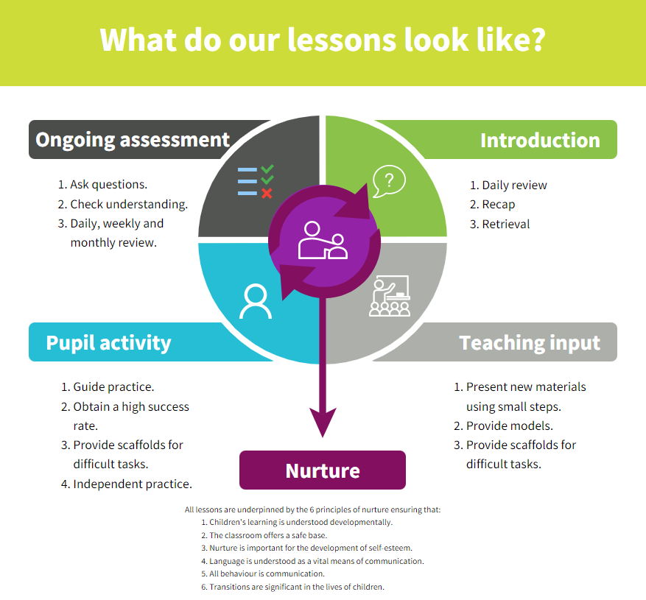
Strategies | What do we expect to see in lessons?
Daily review | Lessons begin with a recap of previously linked learning and retrieval practice.
Present new materials using small steps | New learning is built in small steps at an appropriate level, achievable and repeatable steps to build confidence, competence and retention.
Provide models | Questions are asked to check understanding. A range of questions are asked to challenge children.
Provide scaffolds for difficult tasks | The teacher models the skills first.
Guided practice | Children are given the opportunity to discuss and build on ideas with support.
Obtain a high success rate | Skills are revisited and revised over time to ensure that children achieve age expected skills.
Provide scaffolds for difficult tasks | Teacher provides temporary supports and scaffolds to assist in challenging tasks. Support reduced as children become more confident.
Independent practice | Children have the opportunity to practice regular and independently to transfer the knowledge into their long term memory.
Weekly and monthly review | Constant review through discussion and ongoing assessment.

SKILLS AND KNOWLEDGE PROGRESSION
Gold | To place events and artefacts in order on a time line.  To label time lines with words or phrases such as: past, present, older and newer.  To recount changes that have occurred in their own lives.  To use dates where appropriate.  To use appropriate historical vocabulary to communicate, including dates, time period, era, chronology, continuity, change, century, decade, legacy.  To use literacy, numeracy and computing skills to a exceptional standard in order to communicate information about the past.
Gold | Block 1 | Block 2 | Block 3 | Block 4 | Block 5 | Block 6
Gold | To have knowledge of Britain’s settlement by Anglo-Saxons and Scots  (eg. Anglo Saxon invasions, settlements, kingdoms, art and culture) | To have knowledge of Britain’s settlement by Anglo-Saxons and Scots  (eg. Anglo Saxon invasions, settlements, kingdoms, art and culture) y5 | To study an aspect or theme in British history beyond 1066. (egWWII) | To study one contrasting non European society eg Mayan civilization y5 | To study an aspect or theme in British history beyond 1066. (egWWII) | To study one contrasting non European society Ancient Egyptians
Silver | To place events, artefacts and historical figures on a time line using dates.  To understand the concept of change over time, representing this, along with evidence, on a time line.  To use dates and terms to describe events.  To use appropriate historical vocabulary to communicate, including dates, time period, era, chronology.  To use literacy, numeracy and computing skills to a good standard in order to communicate information about the past  .
Silver | Block 1 | Block 2 | Block 3 | Block 4 | Block 5 | Block 6
Silver | To know about changes in Britain from the Stone Age to the Iron Age. (eg bronze age religion – Stonehenge) y3 | To study the Roman Empire and its impact on Britain y4 | To carry out a depth study of an aspect of the local history or how a locality has changed over time (beyond 1066) y4 | To know about the achievements of early civilizations eg Ancient Egypt, The Indus Valley y3 | To carry out a depth study of an aspect of the local history or how a locality has changed over time (beyond 1066) | To study Ancient Greece and their influence on the western world y4
BRONZE | To place events and artefacts in order on a time line.  To label time lines with words or phrases such as: past, present, older and newer.  To recount changes that have occurred in their own lives.  To use dates where appropriate.  To use words and phrases such as: a long time ago, recently, when my parents/carers were children, years, decades and centuries to describe the passing of time.  To show an understanding of the concept of nation and a nation’s history.  To show an understanding of concepts such as civilisation, monarchy, parliament, democracy, and war and peace.
BRONZE | Block 1 | Block 2 | Block 3 | Block 4 | Block 5 | Block 6
BRONZE | To find out about personal history. | To know about significant national events beyond living memory – Great fire of London | To have studied the lives of significant individuals in Britain’s past who have contributed to our nation’s achievements. | To find out about family history. | To know about significant national events beyond living memory – first aeroplane flight. | To have studied the lives of significant individuals in Britain’s past who have contributed to our nation’s achievements.
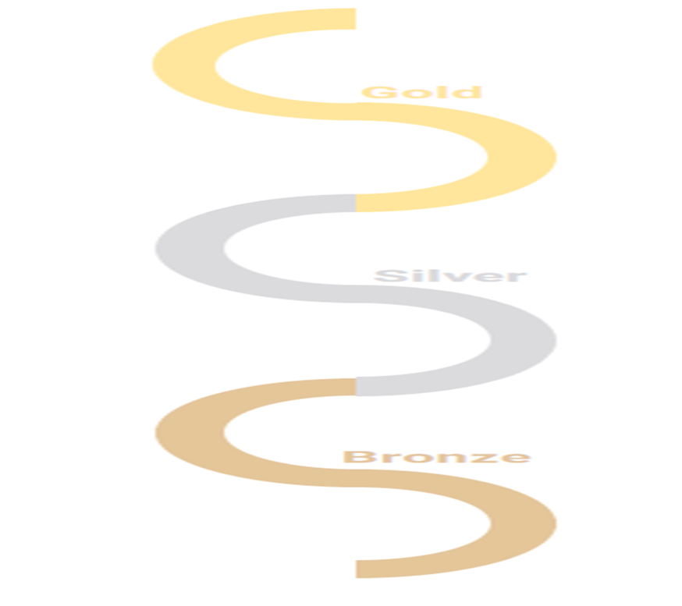
SK
Curriculum overview

 | Bronze |  | Silver |  | Gold
 | Year 1 of 2 | Year 2 of 2 | Year 1 of 2 | Year 2 of 2 | Year 1 of 2 | Year 2 of 2
Aut 1
Aut 2 | Significant Individuals Mary Seacole | Significant individuals: Rosa Parks | Significant individuals: Dame Jocelyn Barrow | Significant individuals: Claudia Jones | Significant individuals: Nelson Mandela | Significant individuals: Martin Luther King
Spr 1
Spr 2 | Travel and Transport | The History of Toys | Romans | Vikings and Saxons  Anglo Saxons and Scots | Ancient Egypt | World War II
Sum 1
Sum 2 | Great Fire of London | Kings and Queens | Crime and Punishment

