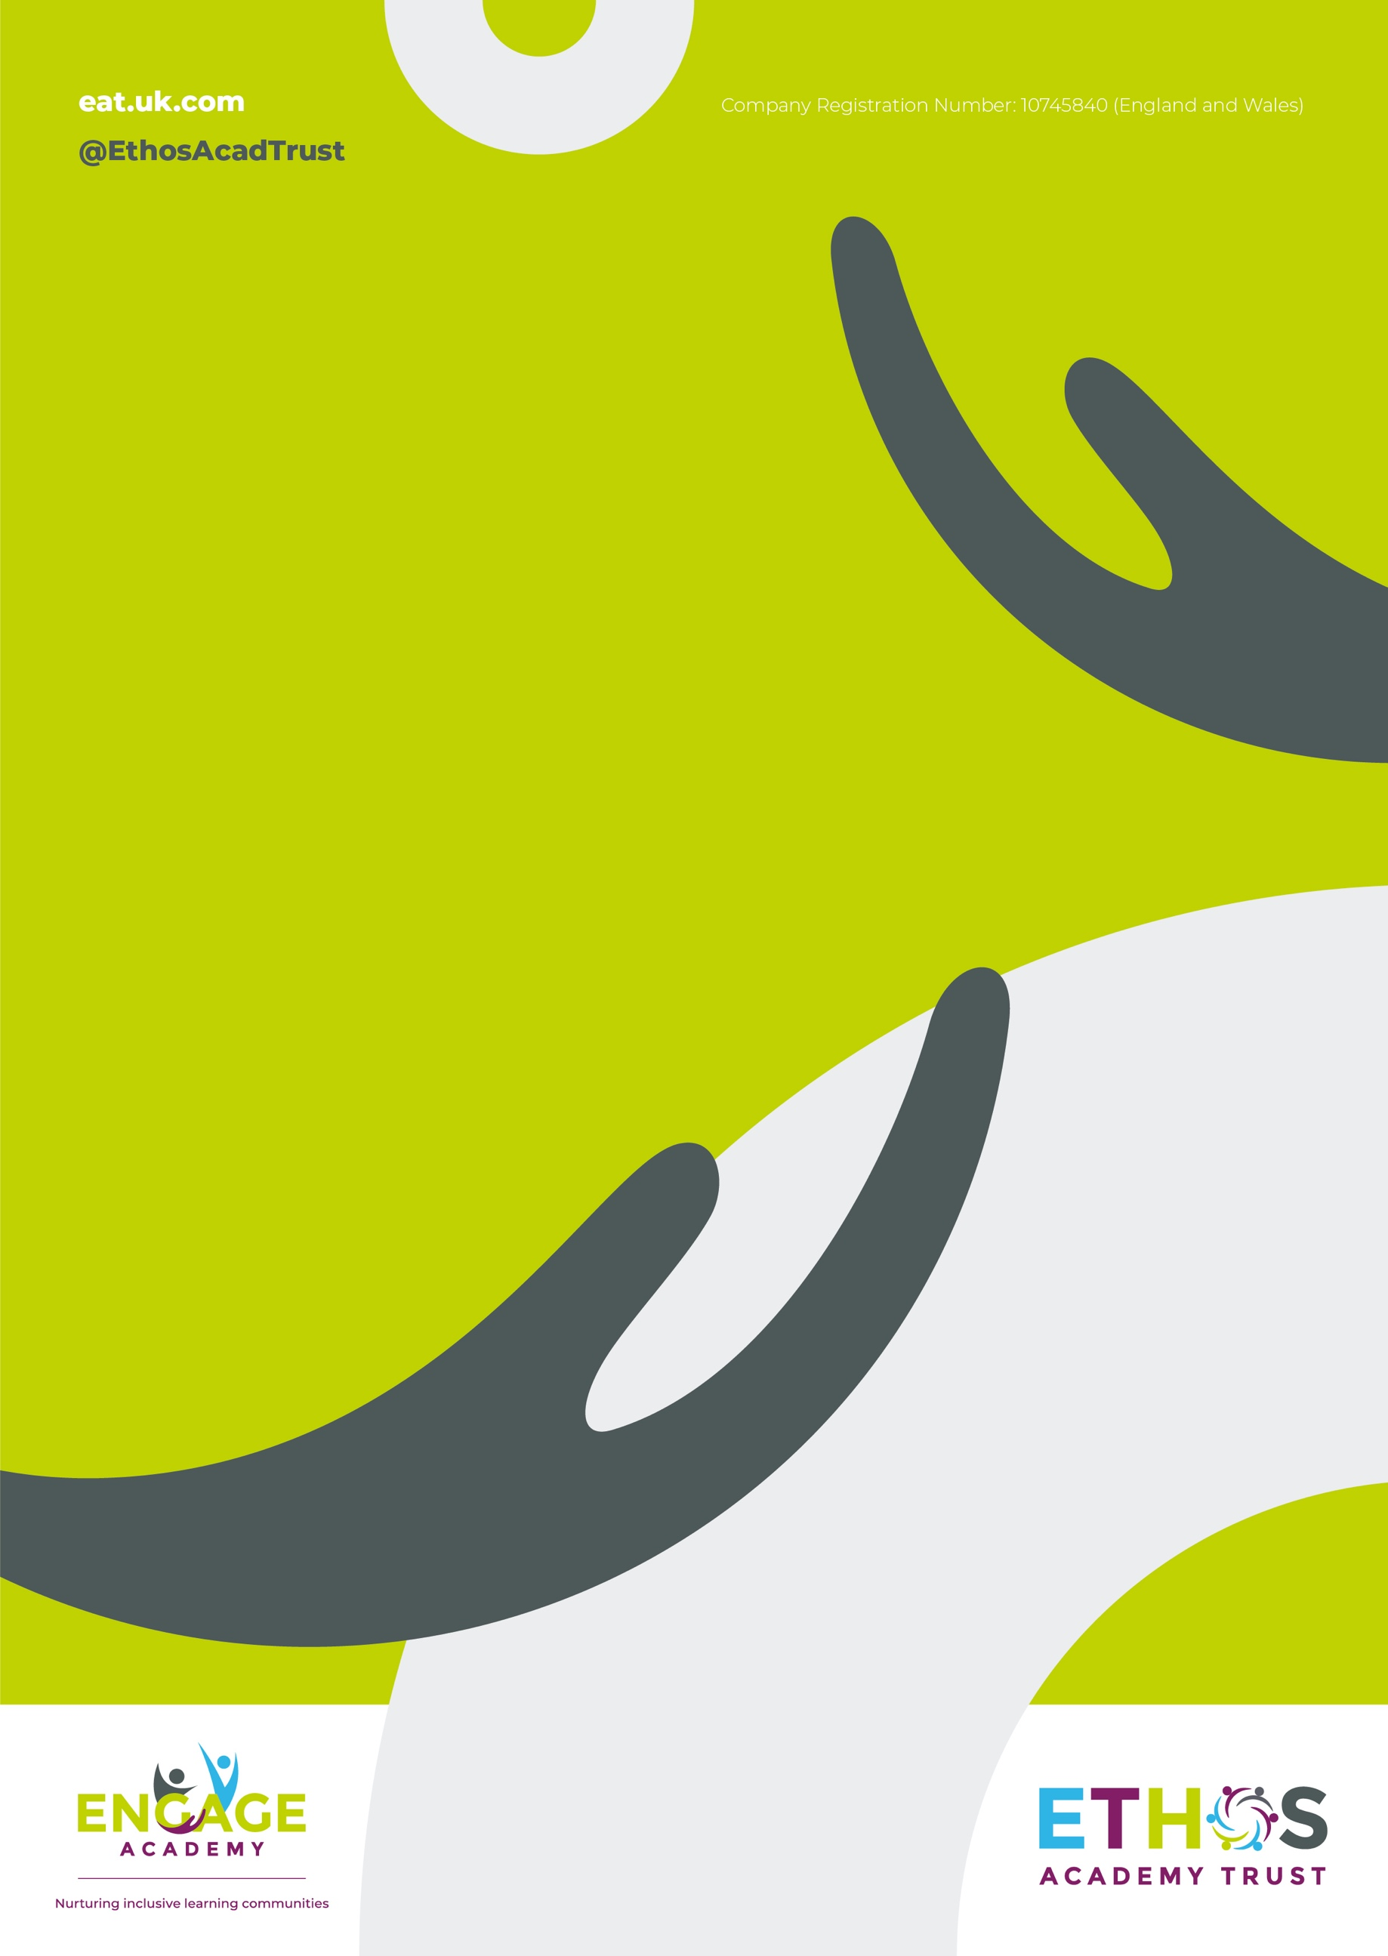

Engage Academy

PSHE Curriculum Intent and Sequence

2026

THE CURRICULUM INTENT AND SEQUENCE

1 | THE INTENT OF THE CURRICULUM
At Engage Academy, PSHE is a whole-school approach that equips pupils with the knowledge, skills and attributes needed to stay healthy, safe and prepared for life in modern Britain. Through high-quality, evidence-informed RSHE, pupils develop morally, socially, mentally and physically, and are prepared for the opportunities and responsibilities of adulthood.
Our curriculum is underpinned by the myHappymind approach, which promotes emotional literacy, resilience, self-regulation and positive mental wellbeing. It is structured around three core themes:
• Health and Wellbeing
• Relationships
• Living in the Wider World
Content is carefully sequenced from EYFS to Year 6, ensuring progression and full coverage of statutory requirements. Our approach is engaging, inclusive and responsive, with a strong emphasis on pupil voice, parental engagement and a consistent whole-school ethos that promotes respect, diversity and personal development.

2 | THE IMPLEMENTATION OF THE CURRICULUM
PSHE at Engage Academy is delivered through a structured, progressive programme that is embedded across lessons, assemblies and wider school life. In KS1 and KS2, pupils build on EYFS foundations to develop knowledge and skills related to relationships, personal responsibility, safety (including online), physical and mental wellbeing, and understanding change, including puberty.
The curriculum is driven by the myHappymind programme:
Meet Your Brain, Celebrate, Appreciate, Relate and Engage. These modules are taught progressively and revisited to deepen understanding, forming the foundation of pupils’ emotional development. This is complemented by myHappymind Plus, which ensures comprehensive coverage of PSHE, including healthy lifestyles, relationships, economic wellbeing and digital resilience.
Learning is sequenced as a spiral curriculum, allowing pupils to revisit key concepts with increasing depth. Lessons are delivered by trained staff using engaging, discussion-based and reflective approaches, including journals and practical activities. Additional time is built in for consolidation and the delivery of statutory RSE content. Teaching is inclusive and adaptive, ensuring all pupils, including those with SEND, access a safe, supportive environment where sensitive topics can be explored confidently.

3 | THE IMPACT OF THE CURRICULUM
Our PSHE curriculum develops confident, resilient and respectful pupils who are well-prepared for the next stage of their education and for life beyond school. Pupils demonstrate strong emotional literacy, an ability to manage their wellbeing, and a clear understanding of how to build positive relationships and stay safe in a range of contexts.
Assessment begins with baseline activities to identify pupils’ prior knowledge, skills and attitudes, recognising that experiences vary widely. Ongoing formative assessment, including pupil voice, observation and recorded learning, is used to monitor progress and inform teaching.
As pupils progress, they show increasing confidence in discussing key issues, greater empathy and respect for others, and the ability to apply their learning in real-life situations. Evidence of impact is seen through pupil discussions, behaviour, wellbeing and engagement. Regular feedback from pupils, staff and parents ensures the curriculum remains relevant, inclusive and effective.

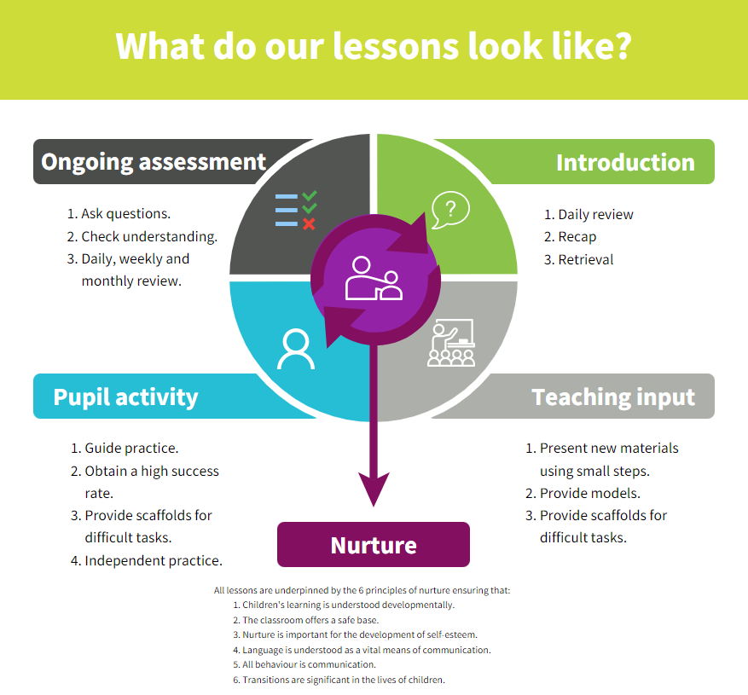
Strategies | What do we expect to see in lessons?
Daily review | Lessons begin with a recap of previously linked learning, retrieval practice or through breakfast assembly discussion.
Present new materials using small steps | New learning is build in small steps at an appropriate level, achievable and repeatable steps to build confidence, competence and retention.
Ask questions | Questions are asked to check understanding. A range of questions are asked to challenge children.
Provide models | The teacher models the skills first.
Guided practice | Children are given the opportunity to discuss and build on ideas with support.
Obtain a high success rate | Skills are constantly revisited and revised over time to ensure that children achieve age expected skills.
Provide scaffolds for difficult tasks | Teacher provides temporary supports and scaffolds to assist in challenging tasks. Support reduced as children become more confident.
Independent practice | Children have the opportunity to practice regular and independently to transfer the knowledge into their long term memory.
Weekly and monthly review | Constant review through discussion and ongoing assessment, retrieval practice and breakfast assembly as well as in discrete lessons.

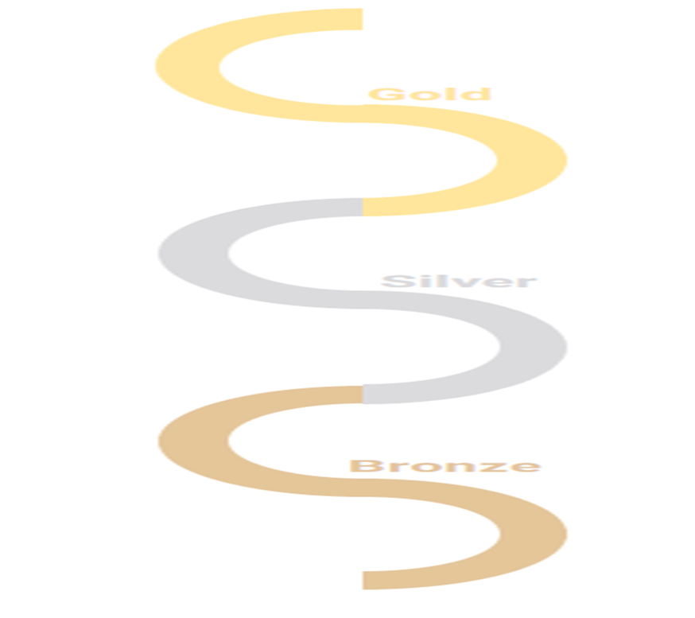
SKILLS PROGRESSION – Living in the Wider World

Gold | Pupils should be taught to:  • Give examples of anti-social behaviour  • Explain how anti-social behaviour can affect others  • Explain how anti-social behaviour can affect themselves  • Explain what identities (national, regional, religious and ethnic) they belong to  • Explain how different identities create a community  • Talk about the lives and values of identities other than their own  • Talk about local groups that support the community  • Explain the importance of helping others in the community  • Tell you why finance plays an important part in people’s lives  • Tell you why taxation is needed to help a society work  • Tell you about specific types of taxation  • Explain why some people pay more tax than others, and some none at all.  • Explain why taxation may be higher at some times than others | Pupils should be taught to:  • Tell you why it is important to ‘shop around’  • Explain what ‘interest’ is on a loan and the need to pay money back on a regular basis  • Explain what ‘debt’ is and the harm that this can cause  • Explain what ‘enterprise’ is.  • Explain the benefits that enterprise has for society such as choice.  • Explain why laws are made and by whom  • Explain the difference between a law and a rule  • Explain what happens if laws are broken  • Explain that Human Rights laws have been made to protect people from harm  • Understand the role of pressure groups in campaigning for Human Rights across the world  • Start to express opinions of their own on what they see and read in the media based on what they have learnt and understand
Silver | Pupils should be taught to:  • Tell you things they spend money on  • Tell you why it is good to save money  • Explain what a budget is  • Prioritise items to spend money on in a weekly budget  • Explain the importance of budgeting  • Explain what you can do if you need to borrow money  • Tell you what a loan is  • Understand how ‘interest’ can have both positive and negative impacts  • Tell you a way of generating money  • Demonstrate enterprising ideas  • Explain what a Human Right is  • Give an example of some of the Rights of Child (as set out by the UN)  • Explain why the Rights of the Child are important  • Tell you who to speak to if they need help in school  • Tell you who they can speak to outside of school if they need help  • Explain the difference between opinion and fact  • Participate in a debate  • Give opinions in a debate  • Use evidence to back up opinions.  • Listen to others’ points of view  • Respect other people’s views | Pupils should be taught to:  • Identify what the earth’s resources are used for (electricity, heating, food, paper, fuel etc.)  • Identify that there is a limited supply of the earth’s resources  • Recognise that if one group of people use all the resources there are not enough for others and how this relates to the environment  • Describe or demonstrate what can be done in school to help environmental sustainability (e.g. paper recycling, saving water, composting, saving energy)  • Give an examples of their own family/community customs or traditions  • Explain why these are important or special  • Identify different traditions that relate to birth, growing up and food  • Compare their own traditions to those of people in other places and say how they are similar or different  • Identify how we show respect for the views and beliefs of others  • Give reasons and practical examples for why different rules are needed in different situations  • Give reasons for why rules and laws are made and why they are important  • Identify what might happen if rules and laws are broken  • Work with others to develop and agree rules
BRONZE | Shared Responsibilities:  - Describe how they would like their classroom to be  - Explain who/what they are responsible for  - Explain what rules mean and how they help  - Give suggestions for class rules  - Explain why important to carry out responsibilities  Communities:  - Identify different groups they belong to  - Describe what it's like to be part of group  - Explain what is special about groups  - Identify people who work in community  Money:  - Identify different kinds of money  - Explain how money is obtained  - Give examples of choices about spending/saving  - Identify how people keep track of money  - Explain importance of keeping money safe

SKILLS PROGRESSION – Relationships
Gold | Pupils should be taught to:  • Children play and work cooperatively, taking turns with others.  • Take account of one another’s ideas about how to organise their activity.  • Show sensitivity to others’ needs and feelings, and form positive relationships with adults and other children.  • Recognise when people are trying to gain power or control  • Demonstrate ways they could stand up for themselves and their friends in situations where others are trying to gain power or control | Pupils should be taught to:  • Identify positive and negative actions in themselves  • Identify how different emotions make them feel  • Identify how different actions affect others (positive and negative)  • Have the strength to say how they feel  • Identify ways of supporting others  • Identify ways to help others understand how they or others are feeling.  • Give examples of ways to work together with others  • Explain how to stay safe when using technology to communicate with their friends  • Recognise and resist pressures to use technology in ways that may be risky or cause harm to themselves or others
Silver
BRONZE | Families:  - Identify special people in their lives  - Understand what makes them special  - Describe ways people care for each other  - Show kindness to others  - Share with others  Friendships:  - Understand self-regulation  - Understand empathy and compassion  - Identify things that cause conflict  - Demonstrate how to use problem solving to resolve conflicts  Respectful Relationships:  - Play and work cooperatively  - Take account of one another's ideas  - Show sensitivity to others' needs and feelings  - Form positive relationships
SKILLS PROGRESSION – Health and Wellbeing
Gold | Pupils should be taught to:  • Discuss that body shapes are different and that no one body shape is better than another.  • Understand that there may be pressure exerted to fit one body shape. • Describe their favourite healthy foods, and understand why that this choice is important.  • Evaluate when alcohol is being used responsibly, anti-socially or being misused.  • To understand the negative effects of drugs and tobacco.  • Describe how the media can influence how people think and feel.  • Understand what negative pressure is like, and be able to say why they would not exert it themselves.  • Tell an adult the best way to deal with peer group pressure.  • Understand how to use their mobile phone responsibly.  • Say where they would access advice and support from if they felt pressured. • Understand how to manage risk and keep themselves safe.  • Describe their right to privacy. | Pupils should be taught to:  • Respect and value their body  • Describe how boys’ and girls’ bodies change during puberty  • Express how they feel about the changes that will happen to them during puberty  • Tell you that the physical changes that will take place during puberty may affect their feelings towards others.  • Explain things they can do by themselves now that they couldn’t in KS1  • Identify responsibilities they have at home and at school  • Explain what the word risk means  • Carry out a simple risk assessment for a task  • Identify ways that they can keep themselves safe at home, in school and in the local area  • Explain how to stay safe online and what to do if something goes wrong.  • Know how and when to make a 999 call • Carry out simple basic first aid procedures.  • Talk about their own short, medium and long term goals.  • Tell you about a time when they used strategies to achieve something difficult.
Silver
BRONZE | Mental Wellbeing:  - Identify how they change as they grow up  - List a range of feelings  - Use descriptive vocabulary to explain feelings  - Recognise it's important to share feelings  - Identify some ways to respond to how others are feeling  Physical Health:  - Identify some ways of taking care of themselves daily  - List favourite foods and which are healthy  - Describe how physical activity and sleep help them  - Describe how to take care of dental health  Growing and Changing:  - Identify how they change as they grow  - Identify how they become more independent  - Know what they are good at  - Know how it feels when there is change or loss  Keeping Safe:  - Describe simple steps to keep themselves safe  - Identify adults who help keep them safe  - Describe ways of keeping safe around household products  - Demonstrate understanding of right to be safe
SKIL
Curriculum overview

 | Autumn 1 | Autumn 2 | Spring 1 | Spring 2 | Summer 1 | Summer 2
Bronze | • About different feelings that humans can experience  • How to recognise and name different feelings  • How feelings can affect people's bodies and how they behave  • About what keeping healthy means; different ways to keep healthy  • Simple hygiene routines that can stop germs from spreading  • About why sleep is important and different ways to rest and relax  • About what rules are, why they are needed  • About the different groups they belong to  • About the different roles and responsibilities people have in their community  • That everyone has different strengths | Anti-Bullying  • Know what to do if teasing and bullying is happening.  • Know that hurtful teasing and bullying is wrong.  • Learn how to ask for help if they are worried about something.  • Learn about different kinds of feelings  Feelings  • Understand a range of feelings in themselves and recognise how other people are feeling.  • Know that feelings can be hurt | Health & Hygiene  • Learn about some of the things that keep our bodies healthy (physical activity, sleep, rest, healthy food.)  • Learn about making healthy choices.  • Learn about basic personal hygiene routines and why these are important.  Managing Feelings  • Learn simple strategies to manage their own feelings. | Community  • Learn about the groups and communities that they belong to.  • Learn about the people that work in their community.  • Learn how to get their help, including in an emergency.  Money  • Learn about where money comes from, what it is used for and to keep it safe. | Caring & Sharing  • Be able to talk special people in their lives.  • Know about the importance of people to care for us.  • To be able to demonstrate listening to others and playing cooperatively.  Respecting Others  • Understand the importance for respect for the differences and similarities between people. | Staying Safe  • Learn about rules for keeping safe (in familiar and unfamiliar situations.)  • Learn that household products, including medicines, can be harmful if not used correctly.  Growing Up  • Learn about growing, changing and becoming more independent.  • Learn to recognise what they are good at and set simple goals for the future.  • Learn about how it feels when there is change or loss.

Silver | Rules & Responsibility  • Learn about the values and customs of people around the world.  • Learn that rules and laws keep people safe.  Learn about taking part in making and changing rules.  • Learn about responsibilities, rights and duties (at home, school and environmentally.) • Learn what it means to part of a community.  • Learn what anti-social behaviour is and how it can affect people.  Well-Being  • Learn that everyone (including children) have human rights.  • Learn about the UN declaration on the Rights of the Child.  • Learn about how to get help or support.  • Learn how to discuss and debate issues concerning health and well-being. | Collaboration •Demonstrate the ability to listen and respond respectfully to a wide range of people.  •Demonstrate working collaboratively toward shared goals.  Friendships  • Understand what makes a positive, healthy relationship.  • Understand how to maintain good friendships.  • Understand how actions can affect ourselves and others.  • Understand how to recognise bullying either to themselves or others. | Feelings  • Learn about a wider range of feelings, both good and not so good.  • Understand that people can experience conflicting feelings at the same time.  • Learn about describing their feelings to others.  Healthy Lifestyle  • Learn about what makes a ‘balanced lifestyle’ and a ‘balanced diet’  • Learn about the benefits of a balanced diet.  • Learn about what is meant by a ‘habit.’  • Learn how habits can be hard to change.  • Learn about drugs that are common in everyday life (medicines, caffeine, alcohol and tobacco) | Sustainability  • Learn about the sustainability of the environment across the world.  Managing Money  • Learn about ways of managing money (budgeting and saving.)  • Learn what is meant by ‘interest’ and ‘loan.’  • Learn what it means to be enterprising. | Problem Solving  •Demonstrate the ability to share their views and opinions with others.  • Understand about solving disputes and conflict amongst themselves and their peers how to respond and ask for help.  •Demonstrate negotiation and compromise strategies to resolve disputes and conflict.  Similarities & Differences  • Understand about what makes a ‘family’ and that it each family is unique.  • Understand that differences and similarities between people exist, but understand everyone is equal.  • Appreciate the difference and diversity of people living in the UK | Health & Hygiene  • Learn that simple hygiene routines can prevent the spread of bacteria and viruses.  • Learn how the spread of infection can be prevented.  Learn about people who help them stay healthy and safe.  • Learn about the importance of school rules for health and safety.  • Learn about how to get help in an emergency.  • Learn about keeping safe in the local environment.  • Learn about keeping safe online.  Choices  • Learn about making choices in relation to health. • Learn about opportunities they have to make their own choices about food.  • Learn how to make informed choices that contribute to a ‘balanced lifestyle.’  • Learn about what influences their choices. • Learn that images in the media do not necessarily reflect reality.
Gold | Society  • Learn how anti-social behaviour can affect well-being.  Learn to appreciate the range of national, regional, religious and ethnic identities of people living in the UK.  • Learn about the lives, values and customs of people living in other places.  • Learn how resources are allocated and the effect this has on individuals, communities and the environment. • Learn how different groups/individuals that support the local community.  Human Rights  • Learn why and how laws and rules are made.  • Learn how to take part in making and changing rules.  • Learn that human rights overrule any beliefs, ideas or practices that cause harm.  • Learn that harmful practices are against British law and in  contradiction to human rights.  • Learn about the role of voluntary, community and pressure groups.  • Learn to be critical of what they see and read in the media. | Discrimination  • Understand what is meant by ‘stereotypes.’  •Understand about discrimination, teasing, bullying and aggressive behaviour and its effect on others.  Diversity  • Understand the factors that make people the same or different.  • Know how to challenge ‘stereotypes’ and how to handle, or respond to anti-social or aggressive behaviours.  • Demonstrate skills to maintain positive relationships  • Demonstrate the ability to appreciate different points of view and making their own decisions.  •Demonstrate the ability to respectfully listen to others but raise concerns and challenge points of view when necessary | Responsibility • Learn about independence, increased responsibility and keeping safe.  • Learn strategies for managing risk. • Learn about the skills needed in an emergency: - what to do in an emergency - basic emergency aid • Learn about strategies for managing personal safety - local environment. • Learn about strategies for managing personal safety – online.  • Learn about different ways of achieving and celebrating personal goals.  • Learn how having high aspirations can support personal achievements.  Health & Hygiene  • Learn about different influences on food and diet. • Learn that this can affect how people feel about themselves about who is responsible for their health and wellbeing.  • Learn skills to help make their own choices about food about positively and negatively affects health and wellbeing (including mental and emotional health.)  • Learn about harmful habits and the risks and effects of legal and illegal substances (in relation to drug, alcohol and tobacco education.) | Taxation  • Learn how finance plays an important part in people’s lives.  • Learn that people pay ‘tax’ to contribute to society.  Enterprise  • Learn how to be a ‘critical customer’  • Learn what is meant by ‘interest’, ‘loan’ and ‘debt.’  • Learn about the importance of looking after money, including managing loans and debts.  • Learn what it takes to set up an ‘enterprise.’  • Learn what enterprise means for work and society. | Collaboration • Appreciate the consequences of their actions on themselves and others.  •Understand how to give helpful feedback and support to others.  Relationships • Know about the law around marriage and civil partnerships. • Know that marriage is between two people who willingly agree and to force anyone into marriage is illegal. | Changing Feelings  • Learn how to further describe the range and intensity of their feelings to others.  • Learn the kinds of change that happen in life and the feelings associated with this.  • Learn the correct names for the main parts of the body of boys and girls  • Learn about the roles and responsibilities of parents and carers for babies. • Learn about the changes that happen at puberty.  • Learn how to manage the changes that happen at puberty and after puberty such as personal management & forming relationships.  Outside Pressures & Privacy  • Learn how images in the media can distort reality.  • Learn about different influences on behaviour, including peer pressure and media influence.  • Learn what to consider before sharing pictures of themselves and others online.  Learn where to get help advice and support.  • Learn how to keep safe and well when using a mobile phone.  • Learn how to resist unhelpful pressure and asking for help.  • Learn about managing risk in familiar situations and keeping safe • Learn about feeling negative pressure and how to manage this.

