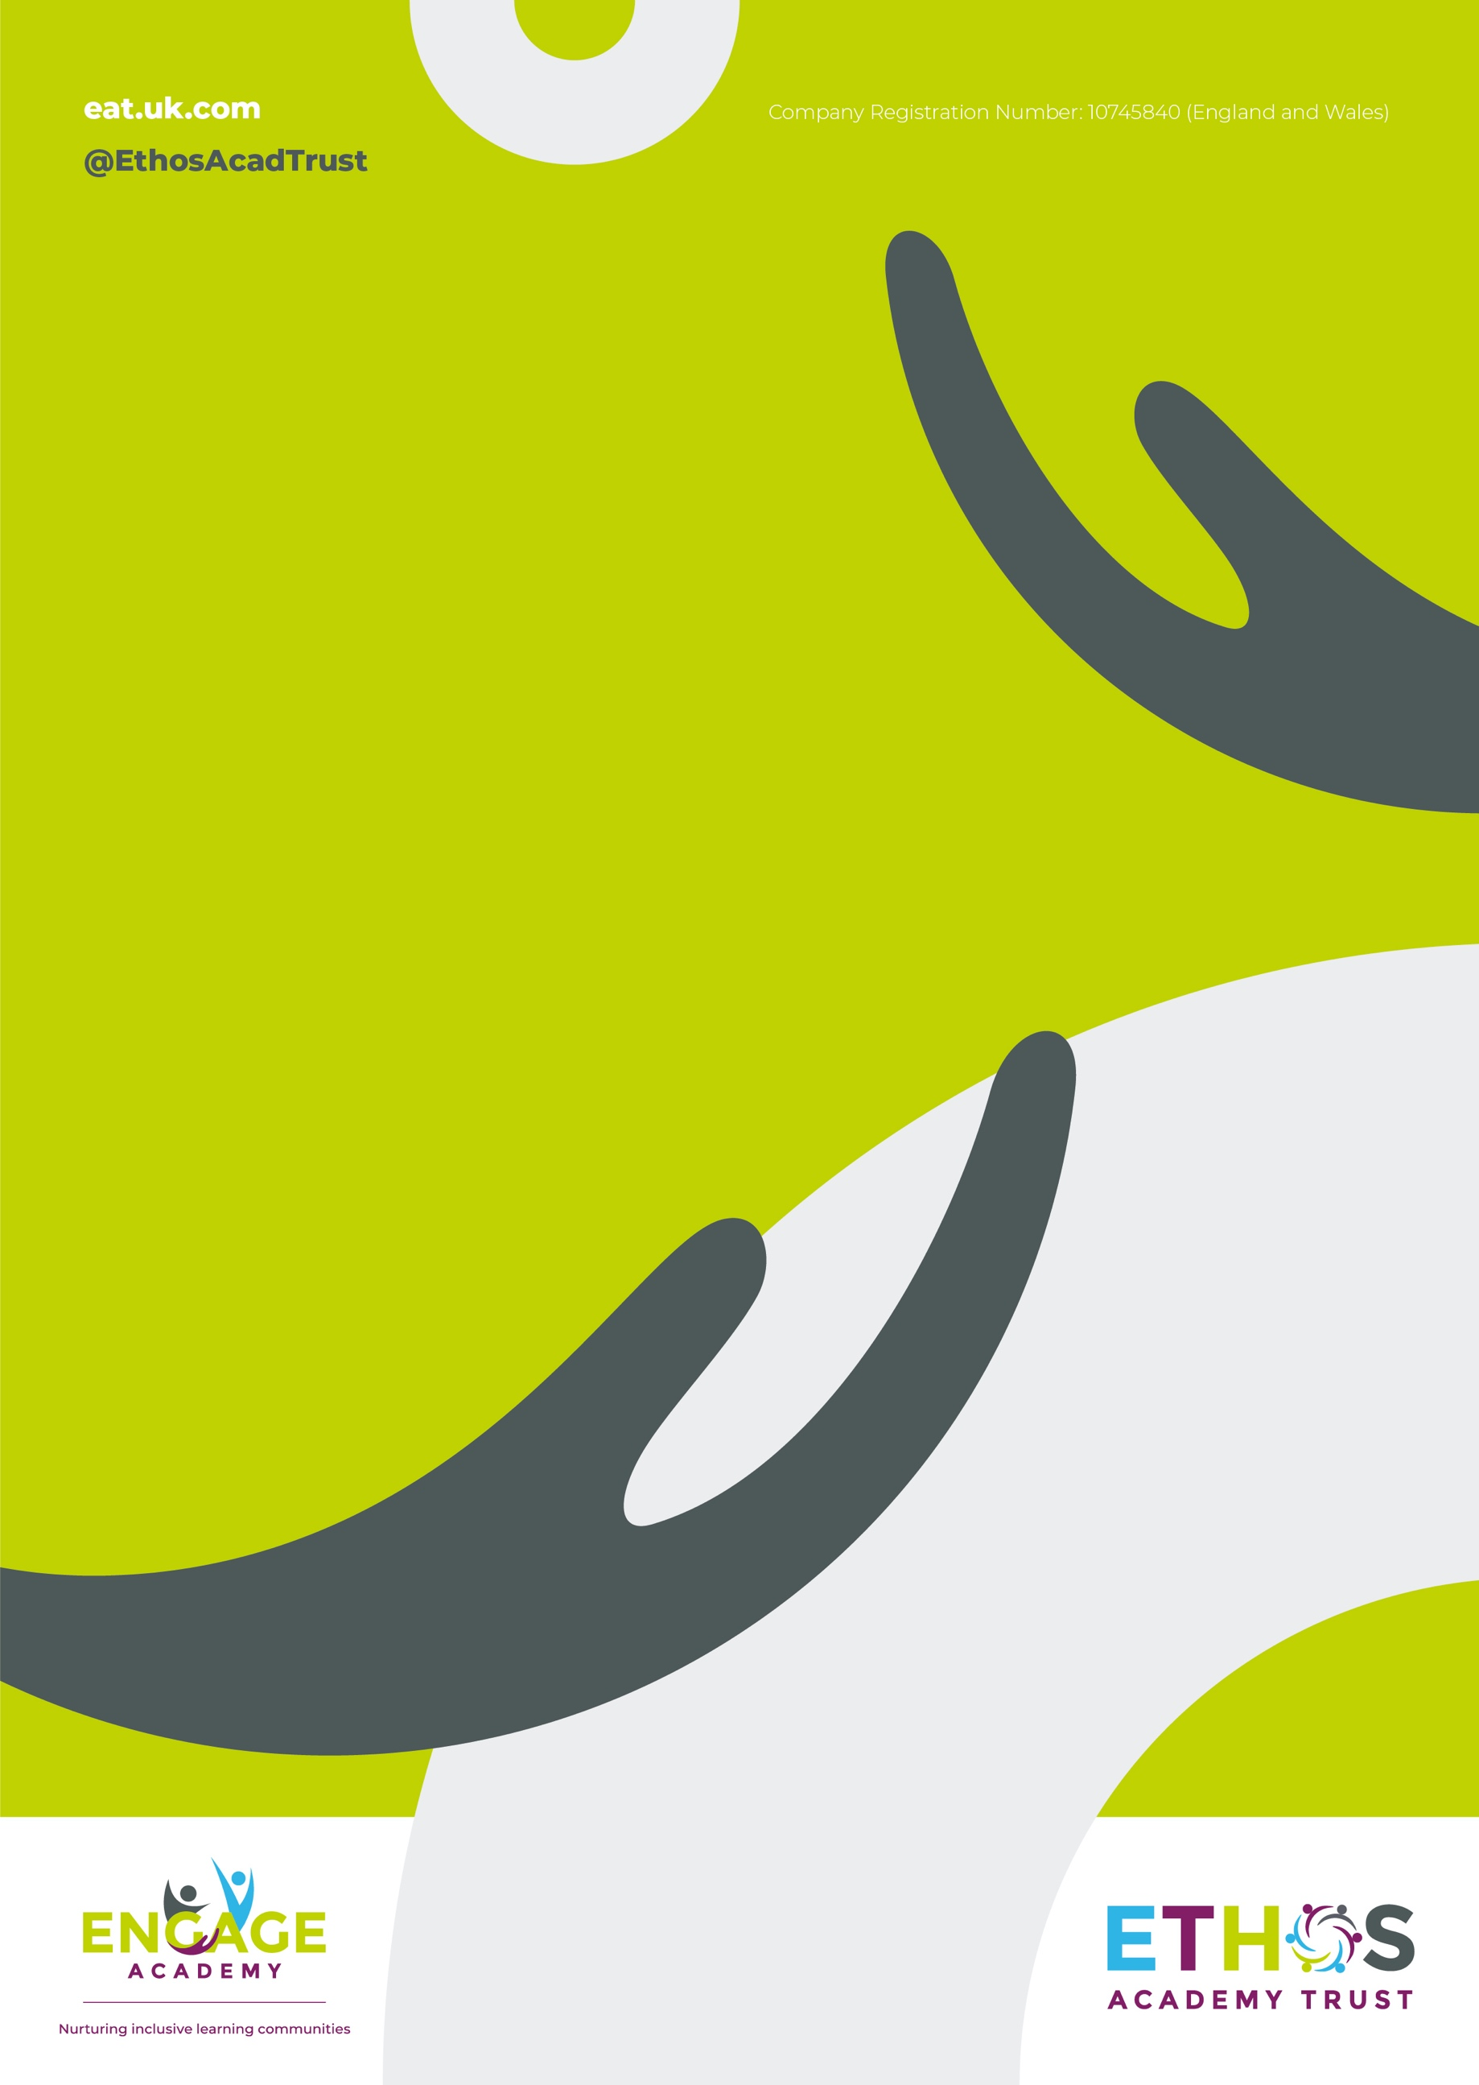

Engage Academy

RELIGIOUS EDUCATION

2022

THE CURRICULUM INTENT AND SEQUENCE

1 | THE INTENT OF THE CURRICULUM
 | Our RE lessons are intended to offer a broad and rich RE curriculum to allow for coverage of the areas prescribed; to allow for a variety of ways to explore religions, their community and personal development and wellbeing. The lessons have an intention of providing a high quality, coherent and progressive experience of the subject, with scope for cross-curricular learning. Through each unit, children will know about and understand a range of religions and world views. They will be able to identify, investigate and respond to a variety of issues. SMSC, personal growth and community cohesion are featured throughout each non-statutory strand and are there to ensure opportunities for children to develop positive attitudes and values and to reflect on and relate their learning in RE to their own experiences. The intent is to make sure that children understand the relevance of RE in today’s modern world and how it affects our lives.

2 | THE IMPLEMENTATION OF THE CURRICULUM
 | In KS1, children begin to look at other religions, focusing on celebrations and rituals. In KS2, we offer a wider range of learning opportunities about the world’s religions including deeper understanding of the origin of those religions and their key stories and teachings. Throughout both key stages, emphasis on personal growth and community cohesion is evident, allowing for personal development for the children from KS1 to the end of KS2. RE is taught through a combination of discreet lessons, collective worship breakfast assemblies and as necessary through discussion. We intend for all children to acquire appropriate subject knowledge, skills and understanding as set out in the National Curriculum but split into bronze silver and gold across a 2 year cycle. Pupils are taught at a level appropriate for their ability and need.

3 | THE IMPACT OF THE CURRICULUM
 | Children will have a better understanding of the religions that make up the UK landscape and how they can learn from and work alongside each other to create community cohesion. All children will be more informed about their position in the world, and the decisions they can make impacting their future. All children in school will be able to talk confidently about their wellbeing, moral and cultural development for the society in which they live. The RE curriculum will promote inquisitive minds, respect, tolerance and understanding for all those around them including themselves. This evidence will be seen through using the correct vocabulary, explanations and respectful opinions, as well as cross-curricular evidence, for example religious and cultural art work, drama, craft and presentations. Impact will be seen by all teachers and children enjoying the experience of teaching and learning RE and understanding how it can help them in their future.

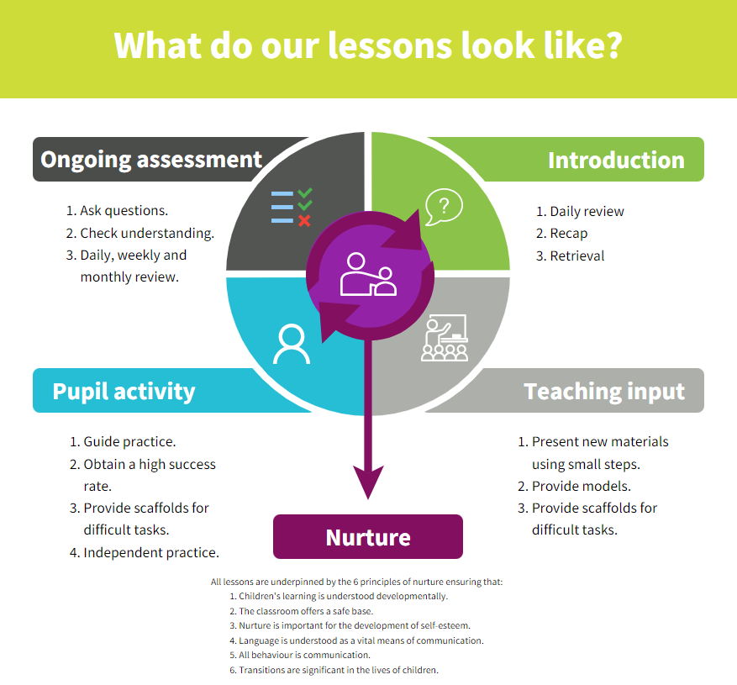
Strategies | What do we expect to see in lessons?
Daily review | Lessons begin with a recap of previously linked learning, retrieval practice or through breakfast assembly discussion.
Present new materials using small steps | New learning is built in small steps at an appropriate level, achievable and repeatable steps to build confidence, competence and retention.
Provide models | Questions are asked to check understanding. A range of questions are asked to challenge children.
Provide scaffolds for difficult tasks | The teacher models the skills first.
Guided practice | Children are given the opportunity to discuss and build on ideas with support.
Obtain a high success rate | Skills are constantly revisited and revised over time to ensure that children achieve age expected skills.
Provide scaffolds for difficult tasks | Teacher provides temporary supports and scaffolds to assist in challenging tasks. Support reduced as children become more confident.
Independent practice | Children have the opportunity to practice regular and independently to transfer the knowledge into their long term memory.
Weekly and monthly review | Constant review through discussion and ongoing assessment, retrieval practice and breakfast assembly as well as in discrete lessons.
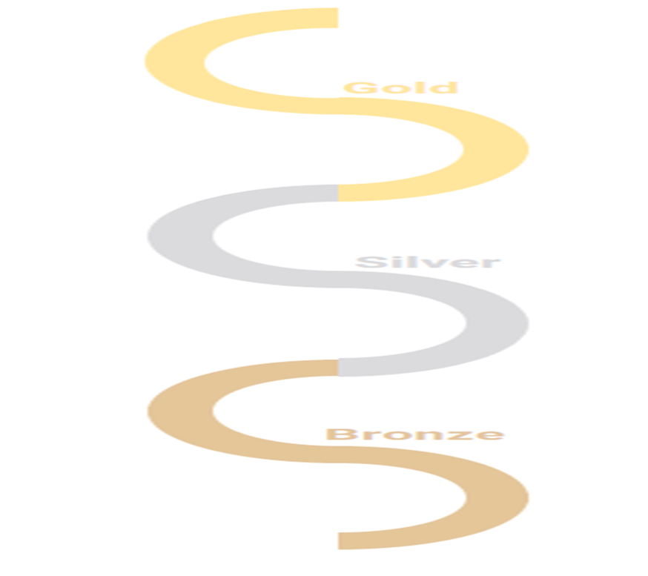
SKILLS PROGRESSION – Health and Wellbeing
 | Beliefs and teachings | Rituals, ceremonies and lifestyles | How beliefs are expressed | Time to reflect and personal growth | Values
Gold | Children can explain how beliefs and teachings can make contributions to the lives of individuals and communities. Children can compare the key beliefs and teachings of various religions, using appropriate language and vocabulary and demonstrating respect and tolerance.  Children can:  - recognise and explain how some teachings and beliefs are shared between religions;  - explain how religious beliefs can shape the lives of individuals and contribute to society. | Children look further at the concepts of belonging, identity and meaning. They understand how certain features of religion make a difference to individuals and communities. Children also explore the rituals and ceremonies which mark important points in life. Moving on from LKS2, children will have the opportunity to explore non-religious ways of life.  Children can:  - explain practices and lifestyles associated with belonging to a faith;  - explain practices and lifestyles associated with belonging to a non-religious community;  - compare lifestyles of different faiths and give reasons why some people within the same faith choose to adopt different lifestyles;  - show an understanding of the role of a spiritual leader. | Children continue to explore the expression of beliefs through books, scriptures, art and any other important means of communication, as in LKS2. Children then move on to exploring a range of beliefs, symbols and actions so they can understand different ways of life and expressing meaning. Children can explain meaning of religious stories, sources of wisdom and the traditions from which they come.  Children can:  - explore religious symbolism in literature and the arts;  - explain some of the different ways individuals show their beliefs;  - share their opinion or express their own belief with respect and tolerance for others. | Children continue to develop their understanding how an appreciation of religion plays an important role in the lives of some people. They make links to expressing identity and belonging, and notice and respond sensitively to different views. Children can then discuss and apply their own and others’ ideas about ethical questions, including ideas about what is right and wrong and what is just and fair.  Children can:  - recognise and express feelings about their identities and beliefs;  - explain their own opinions about tricky concepts and tricky questions that have no universally agreed answers;  - explain why their answers may be different from someone else’s and respond sensitively. | Children continue to develop their appreciation of the ways in which people’s values are an important aspect of their lives. They make links to responsibility and citizenship.  Children begin to understand the concept of shared values and how a community can use shared values. Moving on from their previous learning, children begin to strengthen their capacity for moral judgements.  Children can:  - explain why individuals and communities may have similar and differing values;  - show an awareness of morals, question morals and demonstrate an ability to make choices, understanding the consequences;  - express their own values while respecting the values of others.
Silver | Children can describe the key beliefs and teachings of the religions studied, making some comparisons between religions. Children expand on their knowledge of world religions from KS1.  Children can:  - describe the key teachings and beliefs of a religion;  - begin to compare the main festivals of world religions;  - refer to religious figures and holy books. | Moving on from KS1, children look at the concepts of belonging, identity and meaning. Children understand what belonging to a religion might look like, through practices and rituals, and what it might involve. Children begin to discuss and present thoughtfully their own and others’ views. Children also explore pilgrimages as a part of a religious life.  Children can:  - identify religious artefacts and how they are involved in daily practices and rituals;  - describe religious buildings and how they are used;  - explain religious ceremonies and rituals and their importance for people’s lives and sense of belonging. | Children explore the expression of beliefs through books, scriptures, art and other important means of communication. Children then move on to exploring a range of beliefs, symbols and actions to express meaning. Children can explain the meaning of religious stories and sources of wisdom and the traditions from which they come.  Children can:  - begin to identify religious symbolism in different forms of art and communication;  - looking at holy texts and stories, explain meaning in a story;  - express their beliefs in different forms, with respect for others’ beliefs and comparing beliefs. | Children further explore how an appreciation of religion plays an important role in the lives of some people. They make links to expressing identity and belonging, including links to communities they may belong to. They notice and respond sensitively to different views.  Children can:  - understand that personal experiences and feelings can influence their attitudes and actions;  - offer suggestions about why religious and non-religious leaders and followers have acted the way they have;  - ask questions that have no agreed answers, and offer suggestions as answers to those questions;  - understand that there are similarities and differences between people and respect those differences. | Children develop their appreciation of the ways in which people’s values are an important aspect of their lives. They make links to responsibility and citizenship and choices they make affecting their lives. Children begin to understand the concept of shared values and how a community can use shared values.  Children can:  Make informed choices and understand the consequences of choices;  - describe how shared values in a community can affect behaviour and outcomes;  - discuss and give opinions on morals and values, including their own.
BRONZE | Children begin to recall and name different beliefs and main festivals associated with religions. Children can recognise different religious symbols, their relevance for individuals and how they feature in festivals.  Children can:  - describe the main beliefs of a religion;  - describe the main festivals of a religion. | Children begin to explore daily practices and rituals of religions, identifying religious practices and recognising that some are featured in more than one religion. Children begin to reflect on their own experiences of attending ceremonies.  Children can:  - recognise, name and describe religious artefacts, places and practices;  - explain religious rituals and ceremonies and the meaning of them, including their own experiences of them;  - observe when practices and rituals are featured in more than one religion or lifestyle. | Children explore a range of sources of wisdom and the traditions from which they come. They can suggest some meanings to religious stories. Children begin to recognise different symbols and how they express a community’s way of life.  Children can:  - name religious symbols and the meaning of them;  - learn the name of important religious stories;  - retell religious stories and suggest meanings in the story. | Children look at how an appreciation of religion plays an important role in the lives of some people. They make links to expressing identity and belonging and what is important to them.  Children can:  - identify things that are important in their lives;  - ask questions about the puzzling aspects of life;  - understand that there are similarities and differences between people. | Children look at and appreciate how many people’s values are an important aspect of their lives. Children look at religious stories to understand actions and consequences. Children begin to make connections to their own lives, looking at their own actions and consequences and choices they can make.  Children can:  - look at how values affect a community and individuals;  - explain how actions can affect other people;  - understand that they have their own choices to make and begin to understand the concept of morals.

SKIL

