

Engage Academy

SCIENCE

2025

THE CURRICULUM INTENT AND SEQUENCE

1 | THE INTENT OF THE CURRICULUM
At Engage it is our intention to recognise the importance of science in every aspect of daily life. We ensure the teaching of science is given the prominence it requires with an approach that results in a fun, engaging, high-quality science education that provides children with the foundations and knowledge for understanding the world. Our curriculum will develop the natural curiosity of the child, encourage respect for living organisms and the physical environment and provide opportunities for evaluation. All children will have:
- A wider variety of skills linked to both scientific knowledge/understanding and scientific enquiry/investigative skills.
- A richer vocabulary which will enable them to articulate their understanding of the learning.

2 | THE IMPLEMENTATION OF THE CURRICULUM
 | At Engage Academy, we intend for all children to acquire appropriate subject knowledge, skills and understanding as set out in the National Curriculum but split into bronze, silver and gold across a 2-year cycle. Pupils are taught at a level appropriate for their ability and need. Each year has a long-term plan and will be linked into other topics, where appropriate, to develop children’s knowledge and understanding. It will also ensure all areas of the curriculum are covered in depth. Some objectives taught in a cross curricular approach through English, forest schools and topic lessons.

3 | THE IMPACT OF THE CURRICULUM
 | Children will have developed their scientific knowledge and skills to help them explore, navigate and understand the world around them. Children’s knowledge and skills will develop progressively from their starting points within a real-life context, not only to enable them to meet the requirements of the National Curriculum but to prepare them to become competent scientists in their next step in education. Children will work collaboratively and practically to investigate and experiment, and they will be able to explain the process they have taken and be able to reason scientifically.

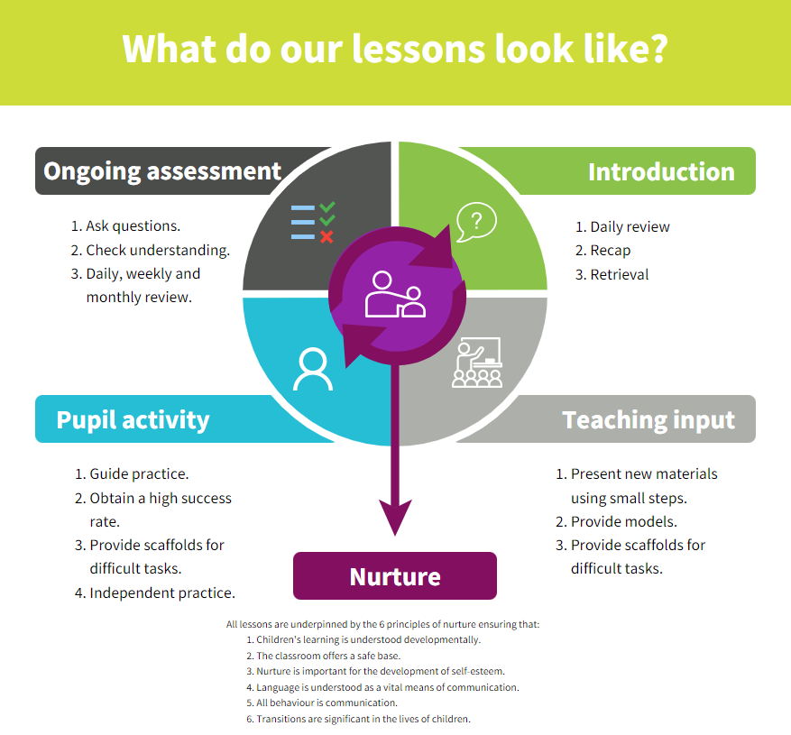
Strategies | What do we expect to see in lessons?
Daily review | Lessons begin with a recap of previously linked learning and retrieval practice.
Present new materials using small steps | New learning is built in small steps at an appropriate level, achievable and repeatable steps to build confidence, competence and retention.
Provide models | Questions are asked to check understanding. A range of questions are asked to challenge children.
Provide scaffolds for difficult tasks | The teacher models the skills first. Success criteria used to support learning.
Guided practice | Children are given the opportunity to discuss and build on ideas with support.
Obtain a high success rate | Skills are revisited and revised over time to ensure that children achieve age expected skills.
Provide scaffolds for difficult tasks | Teacher provides temporary supports and scaffolds to assist in challenging tasks. Support reduced as children become more confident.
Independent practice | Children have the opportunity to practice regular and independently to transfer the knowledge into their long-term memory.
Weekly and monthly review | Constant review through discussion and ongoing assessment.

SKILLS PROGRESSION- Working Scientifically
Gold | - Can plan different types of scientific enquiries to answer questions, including recognising and controlling variables where necessary.  - Can take measurements, using a range of scientific equipment, with increasing accuracy and precision, taking repeat readings when appropriate.  - Can record data and results of increasing complexity using scientific diagrams and labels, classification keys, tables, scatter graphs, bar and line graphs.  - Can use tests results to make predictions to set up further comparative and fair tests.  - Can report and present findings from enquiries, including conclusions, causal relationships and explanations of and degree of trust in results, in oral and written forms such as displays and other presentations.  - Can identify scientific evidence that has been used to support or refute ideas or arguments.
Silver | - Can ask relevant questions and use different types of scientific enquiries to answer them.  - Can set up simple practical enquiries, comparative and fair tests.  - Can make systematic and careful observations and, where appropriate, take accurate measurements using standard units.  - Can gather, record, classify and present data in a variety of ways to help in answering questions.  - Can record findings using simple scientific language, drawings, labelled diagrams, keys, bar charts and tables.  - Can report on findings from enquiries, including oral and written explanations, displays or presentations of results and conclusions.  - Can use results to draw simple conclusions, make predictions and suggest improvements.
BRONZE | - I can ask simple questions and recognise that they can be answered in different ways  - I can use simple scientific vocabulary  - I can observe closely, using simple equipment  - I can perform simple tests  - I can identify and classify  - I can use observations and ideas to suggest answers to questions  - I can gather and record data to help in answering questions

SKIL

Curriculum overview

 | Block 1 | Block 2 | Block 3 | Block 4 | Block 5 | Block 6 | Block 7 |  | Block 8
Bronze | Animals including humans  Can identify and name a variety of common animals including fish, amphibians, reptiles, birds and mammals.  Can identify and name a variety of common animals that are carnivores, herbivores and omnivores  Can describe and compare the structure of a variety of common animals (fish, amphibians, reptiles, birds and mammals, including pets).  Can identify, name, draw and label the basic parts of the human body and say which part of the body is associated with each sense.  Notice that animals, including humans, have offspring which grow into adults  Find out about and describe the basic needs of animals, including humans, for survival (water, food and air)  Describe the importance for humans of exercise, eating the right amounts of different types of food, and hygiene. |  | Everyday Materials  Can distinguish between an object and the material from which it is made  Can identify and name a variety of everyday materials, including wood, plastic, glass, metal, water, and rock.  Can describe the simple physical properties of a variety of everyday materials.  Can compare and group together a variety of everyday materials on the basis of their simple physical properties.  Can identify and compare the suitability of a variety of everyday materials, including wood, metal, plastic, glass, brick, rock, paper and cardboard for particular uses.  Can find out how the shapes of solid objects made from some materials can be changed by squashing, bending, twisting and stretching. |  | Plants  Can identify and name a variety of common wild and garden plants, including deciduous and evergreen.  Can identify and describe the basic structure of a variety of common flowering plants, including trees.  Can observe and describe how seeds and bulbs grow into mature plants.  Can find out and describe how plants need water, light and a suitable temperature to grow and stay healthy. |  | Living things and their habitats  Can explore and compare the differences between things that are living, dead, and things that have never been alive.  Can identify that most living things live in habitats to which they are suited and describe how different habitats provide for the basic needs of different kinds of animals and plants, and how they depend on each other  Can identify and name a variety of plants and animals in their habitats, including micro-habitats.  Can describe how animals obtain their food from plants and other animals, using the idea of a simple food chain, and identify and name different sources of food.
Silver | Animals incl. Humans  Can identify that animals, including humans, need the right types and amount of nutrition, and that they cannot make their own food; they get nutrition from what they eat.  Can describe the simple functions of the basic parts of the digestive system in humans.  Can identify the different types of teeth in humans and their simple functions.  Can construct and interpret a variety of food chains, identifying producers, predators and prey. | Electricity  Can identify common appliances that run on electricity.  Can construct a simple series  electrical circuit, identifying and naming its basic parts, including cells, wires, bulbs, switches and buzzers.  Can identify whether a lamp will light in a simple series circuit, based on whether the lamp is part of a complete loop with a battery.  Can recognise that a switch opens and closes a circuit and associate this with whether a lamp lights in a simple series circuit.  Can recognise some common  conductors and insulators, and associate metals with being good conductors. | States of matter  Can compare and group materials together, according to whether they are solids, liquids or gases.  Can observe that some materials change state when they are heated or cooled, and measure or research the temperature at which this happens in degrees Celsius (°C).  Can identify the part played by evaporation and condensation in the water cycle and associate the rate of evaporation with temperature. | Plants  Can identify and describe the functions of different parts of flowering plants: roots, stem/trunk, leaves and flowers.  Can explore the requirements of plants for life and growth (air, light, water, nutrients from soil, and room to grow) and how they vary from plant to plant.  Can investigate the way in which water is transported within plants.  Can explore the part that flowers play in the life cycle of flowering plants, including pollination, seed formation and seed dispersal. | Sound  Can identify how sounds are made, associating some of them with something vibrating.  Can recognise that vibrations from sounds travel through a medium to the ear.  Can find patterns between the pitch of a sound and features of the object that produced it.  Can find patterns between the volume of a sound and the strength of the vibrations that produced it.  Can recognise that sounds get fainter as the distance from the sound source increases. | Light  Can recognise that they need light in order to see things and that dark is the absence of light.  Can notice that light is reflected from surfaces.  Can recognise that light from the sun can be dangerous and that there are ways to protect their eyes.  Can recognise that shadows are formed when the light from a light source is blocked by a solid object.  Can find patterns in the way that the size of shadows change. | Rocks  Can compare and group  together different kinds of rocks based on their appearance and simple physical properties.  Can describe in simple terms how fossils are formed when things that have lived are trapped within rock.  Can recognise that soils are made from rocks and organic matter. | Forces and Magnets  Can compare how things move on different surfaces.  Can notice that some forces need contact between two objects, but magnetic forces can act at a distance.  Can observe how magnets  attract or repel each other and attract some materials and not others describe magnets as having two poles.  Can predict whether two magnets will attract or repel each other, depending on which poles are facing.  Can compare and group  together a variety of everyday materials based on whether they are attracted to a magnet and identify some magnetic materials.
Gold | Living things and their habitats  Can describe the differences in the life cycles of a mammal, an amphibian, an insect and a bird.  Can describe the life process of reproduction in some plants and animals.  Can describe how living things are classified into broad groups according to common observable characteristics and based on similarities and differences, including microorganisms, plants and animals.  Can give reasons for classifying plants and animals based on specific characteristics. | Animals including humans  Can  Describe  the  changes as  Humans  develop to  old age.  Can identify and name the main parts of the human circulatory system, and describe the functions of the heart, blood vessels and blood.  Can recognise the impact of diet, exercise, drugs and lifestyle on the way their body's function.  Can describe the ways in which nutrients and water are transported within animals, including humans. | Light  Can use the idea that light travels in straight lines to explain that objects are seen because they give out or reflect light into the eye.  Can explain that we see things because light travels from light sources to our eyes or from light sources to objects and then to our eyes.  Can use the idea that light travels in straight lines to explain why shadows have the same shape as the objects that cast them. | Evolution and Inheritance  Can recognise that living things have changed over time and that fossils provide information about living things that inhabited the Earth millions of years ago.  Can recognise that living things produce offspring of the same kind, but normally offspring vary and are not identical to their parents.  Can identify how animals and plants are adapted to suit their environment in different ways and that adaptation may lead to evolution. | Forces  Can explain that unsupported objects fall towards the Earth because of the force of gravity acting between the Earth and the falling object.  Can identify the effects of air resistance, water resistance and friction, that act between moving surfaces.  Can recognise that some mechanisms, including levers,  pulleys and gears, allow a smaller force to have a greater effect. | Properties and change of material  Can compare and group together everyday materials based on their properties, including their hardness, solubility, transparency, conductivity (electrical and thermal), and response to magnets.  Can name some materials that  will dissolve in liquid to form a solution and describe how to recover a substance from a solution.  Can use knowledge of solids, liquids and gases to decide how mixtures might be separated, including through filtering, sieving and evaporating.  Can give reasons, based on evidence from comparative and fair tests, for the uses of everyday materials, including metals, wood and plastic.  Can demonstrate that dissolving, mixing and changes of state are reversible changes.  Can explain that some changes result in the formation of new materials, and that this kind of change is not usually reversible, including changes associated with burning and the action of acid on bicarbonate of soda. | Earth and Space  Can describe the movement of the Earth, and other planets, relative to the Sun in the solar system.  Can describe the movement of the Moon relative to the Earth.  Can describe the Sun, Earth and Moon as approximately spherical bodies.  Can use the idea of the Earth’s rotation to explain day and night and the apparent movement of the sun across the sky. | Electricity  Can associate the brightness of a lamp or the volume of a buzzer with the number and voltage of cells used in the circuit.  Can compare and give reasons  for variations in how components function, including the brightness of bulbs, the loudness of buzzers and the on/off position of switches.  Can use recognised symbols when representing a simple circuit in a diagram.

 | Bronze |  | Silver |  | Gold
 | Year 1 of 2 | Year 2 of 2 | Year 1 of 2 | Year 2 of 2 | Year 1 of 2 | Year 2 of 2
Aut 1 | Animals including humans | Animals including humans | Animals including humans | Animals including humans | Animals including humans | Animals including humans
Aut 2 | Seasonal Changes | Seasonal Changes |  | Electricity |  | Electricity and Light
Spr 1 | Seasonal Changes | Everyday Materials | Rocks | States of matter | Properties and changes to materials
Spr 2 | Seasonal Changes | Plants | Forces and Magnets | Plants | Earth and Space | Evolution and Inheritance
Sum 1 | Seasonal Changes | Plants |  | Living things and habitats
Sum 2 | Living Things and Habitats | Seasonal Changes | Light | Sound | Forces | Living Things and their habitats

